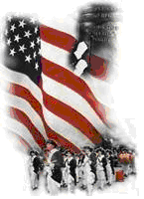 | The Crescent Moon
Fall Issue Number 36 | A publication of the Sons of the Revolution  In the State of South Carolina | November 14, 2018

The South Carolina Society
Second Annual Membership
Election Meeting
Fairfield County Museum
Winnsboro, South Carolina

ELECTED
Tom Weidner
President 2019

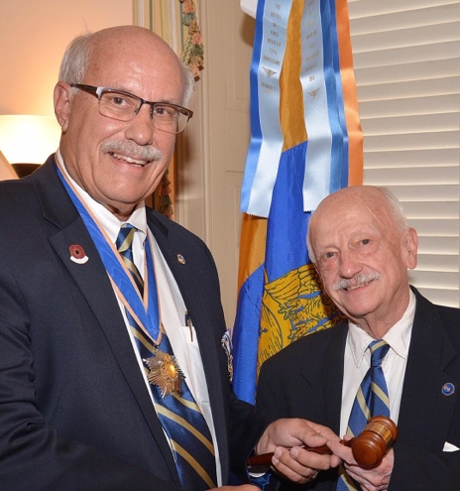
Photo Credit: Tom Hanson

President Ivan Bennett called the meeting to order at 10:00 am
November 10, 2018. The order of the agenda was followed with the invocation by Tom Hanson, Pledge of Allegiance by Dan Woodruff, and Pledge of SR by Tom Weidner.
A period of introductions followed with the ten SCSR members at the table. Time was allowed for the family members and guests to introduce themselves too. The total attendance was twenty held in the Parlor Room 1st Floor of the 1840 original building, Fairfield County Museum. The Director, Pelham Lyles welcomed all of us to this historic day in Winnsboro, SC.
President Bennett reported on the 43rd Triennial October 4-7, 2018 in Nashville, TN. with a display of the Agenda and support reports. South Carolina had two delegates Tom Weidner, VP and Ivan Bennett, President attend.
At the Award Banquet, South Carolina received two awards:

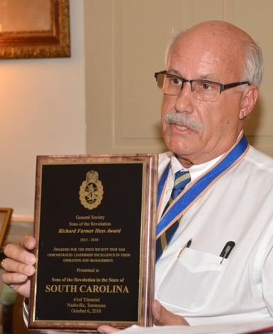
Photo Credit: Tom Hanson

The GSSR Richard Farmer Hess Award 2015-2018 awarded for the state society that has demonstrated leadership excellence in their operation and management.

The second award, the GSSR General President Commendation
Award 2015-2018 for Endeavors in Education awarded for confirming our heritage and commemorating our patriot ancestors inside and outside of the General Society was
Presented to Ivan S. Bennett MEd.

VPWeidner reported on the events
In December: December 2nd the Museum of Revolutionary War Parade in Simpsonville;
November 15th the Wreaths Across America at all
National Cemeteries;
November 16th Durant
Ashmore “The History of Ft.
Lindley” at the Museum
Museum of Revolutionary
War, Simpsonville.
November 17th Battle of
Blackstock Plantation
238th Anniversary, Union.

Secretary and Treasurer
Reports followed. Dan
Woodruff was present to take the minutes and will be
sending to membership.
Ivan Bennett presented the Budget summary for 2018 and will be sending out the
2019 Budget when dues have been collected.
The membership approved
The 2019 Dues of $50. Notices
were mailed to members.
Registrar Chuck Swoope
reported on the roster of
new members for 2018 and
a total of 17 regular and
3 junior members for 2016-2017 of his term as Registrar.
SC 316 Paul Sizemore was
inducted during this meeting.
Registrar Chuck Swoope did
the honors of presenting his
Certificate and Rosette Pin.
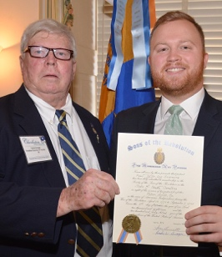
Photo Credit: Tom Hanson

Compatriot Paul Sizemore’s
Ancestor is Peter Acker, Sr. who was born in Nuremberg, Germany
in 1730. He was a resident of Anderson, South Carolina where he passed away in 1815. He served
in the South Carolina 1st Regiment of State Dragoons, under the command of Lt. Col. Wade Hampton I, as a Private and blacksmith.
Paul’s home town is Charleston. He is a graduate of Citadel. His occupation is TSgt. C-17A Loadmaster, USAFR.

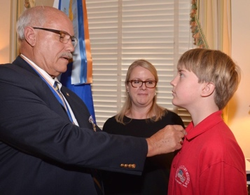
Photo Credit: Tom Hanson

President Ivan Bennett announced
that SC Society maintains a
separate roster of their Junior
Members. The third member to be inducted is Jack Gatlin. Jack
is a member of the Hilton Head
Island Society of CAR, very active
in reenactment events for CAR and the Heritage Library. He is 11 years of age and attends HHI Middle School. In this photo he is accompanied by his mother, Jennifer Gatlin.

Board action followed with the approval of an amended Bylaws
and Corporate Governance Manual (Rev: Matthew Breen, Esq. Solicitor SCSR).

An amazing website presentation by Webmaster Samuel Whatley II was performed. The Board appreciated the presentation by our nineteen year old student, soon to be enrolled at Univ. of North Carolina Graduate School!
Thank you Samuel.
The website, www.srsc1776.org
is currently updated for our membership to view the action items of the November 10 Meeting
(2019 Directory, Bylaws and Corporate Manual, 2019 Dues Notice, Photos of the Meeting (25 photos by Tom Hanson) can be viewed on the SCSR Facebook,
www.facebook.com/srsc1776)

The last action by the Board was the report by President Emeritus Chuck Swoope. The report was approved and new member, Paul
Sizemore conducted the oath of induction to the eight members present.

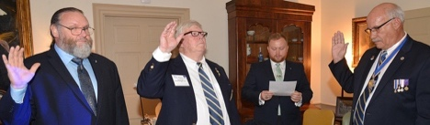
Photo Credit: Tom Hanson

The 2018 SCSR Membership
Election Meeting was adjourned
by President Ivan Bennett as his
last official act as President 2016-
2018. President Bennett presented
to Tom Weidner and Tom Hanson
and John FitzGerald, in absentia,
Certificates of Appreciation for
their contributions to the Society.

2019 President Tom Weidner
Presented to outgoing President
Ivan Bennett a frame collection of
arrow heads from an area
around Simpsonville of Cherokee
Indians archeology digs.
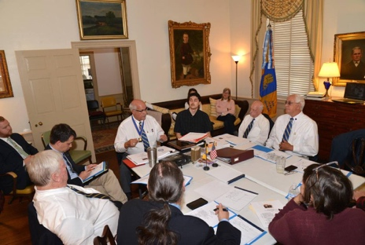
Photo Credit: Tom Hanson

Thank You to the Board of Directors and their family
and guest who traveled to Winnsboro, SC.

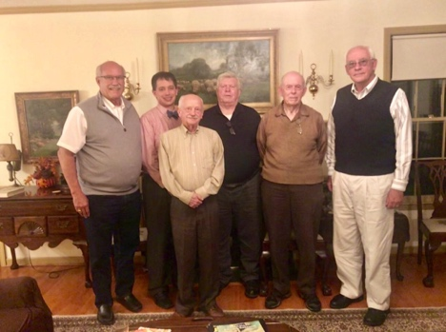
Photo Credit: Jeannie Futrell

Thank You to Past President SCSR (circa 2010) Dr. Jack
Meyer, PhD. and his wife for
Hosting the Social at their residence in Winnsboro, SC
on November 9, 2018.

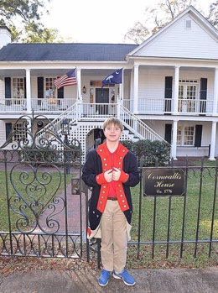
Photo Credit: Tom Hanson

Our day ended with lunch at the Cornwallis House Tea Co. and a Tour 1776 Cornwallis House (Host: Don and Jenny Praser, Owners).

