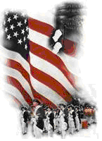 | The Crescent Moon
Summer Issue Number 22 | A publication of the Sons of the Revolution  In the State of South Carolina | September 1, 2017

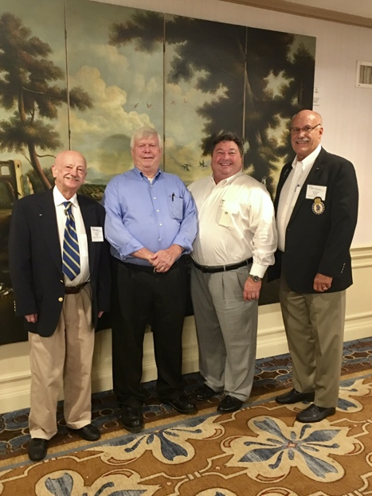
Photo: Susan Bennett
South Carolina Society
And General Society
BOM Preparation
Francis Marion Hotel
Charleston , SC
~ L to R Tom Weidner, Regional VP, Chuck Swoope, Immediate Past President, Mitchell Bush, President GSSR and Ivan Bennett, President

Friday, September 1, 2017

On Thursday August 31 – Friday September 1, the members who live the furthest, traveled to Charleston to enjoy the social aspect of our state society. They worked hard to review the Board of Manager Meeting details of consensus, conflicts and mutual differences to form a schedule for the four days of the GSSR Board of Manager Meeting. Everyone arrived at the Francis Marion Hotel about the same time and began to relax with dinner at the King Street MacIntosh Restaurant.
The SC group of Chuck and Pat, Tom, and Susan and I retreated to the Swamp Fox Bar for a sample of the SCSR signature cocktail, “Swamp Fox”.
After a comfortable night in our Deluxe Rooms we all convened in the restaurant for breakfast to review the final “act”, the hotel Banquet Event Orders (BEO’s) provided in folders to each member.
The Sales Representative walked us through each day, event, catering, banquet, AV rental and logistics. At the end of that meeting, President Bush provided his signature to the BEO’s.
The sales representative then walked all of us through the meeting rooms, banquet room and other spaces over the three day BOM Meeting on Sept. 28-Oct. 1.
At 11:00, all of us checked out and departed the hotel. Susan and I remained for a meeting with the Chair of the College of Charleston History Department. She only had a short walk from her office on the campus of the college. The History Department is providing four graduate students to assist us in the registration for Meeting Attendees on Friday 9-5. In the same space of registration we have two exhibitors who will set up for that period.
Tom Weidner, Director of the Museum of American Revolution in Simpsonville and the Three Rivers Geological Society in Lake City. Both will take advantage of our registration setting for the BOM.
SCSR Treasurer, John FitzGerald also stopped in the lobby to provide some treasurer business with me.
Membership in the South Carolina Society increases by 10 from January to September, 2017
The SC SR Membership Certificate has just been mailed to Bradly Hudson (HI) #303. By the end of September two new members will receive their membership certificates, #304 and #305. The members are father and son. David Overton lives in NC and his son, Chris Overton lives in SC (Lexington). They are transferring from the TNSOR. In addition to gaining two new members, they have registered for the BOM Meeting and rooms at the Francis Marion. The SC Society will have six members registered for the Board of Managers Meeting. Fourteen of the 28 state societies are sending delegates to the Board of Managers.
Events and Wreath Laying Programs
August through September
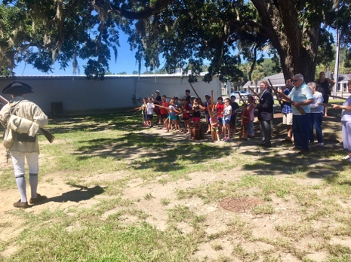
Photo: Morris Center

On August 1, a program presented by the Morris Center for the Low Country Heritage, South Carolina in the American Revolution with Aaron Bradford received a huge turnout in this small town Ridgeland, SC. Our South Carolina Society Regional VP/ Color Guard Captain Mike Kelley, USMC LCpl, attended and was given the opportunity to promote SCSR and encourage membership. Mike is the one in the blue blazer on the right in the photo.

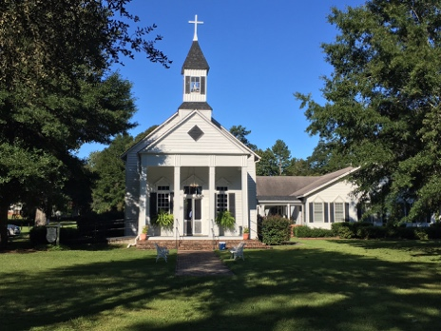
Commemorating the 236th Anniversary of the Battle of Eutaw Springs
Saturday September 9, 2017

I have been invited by the SCSSAR and Battle of Eutaw Springs Chapter to the events of the 236th Anniversary. Organizer Doug Doster has granted me the opportunity of bringing Greetings from the SCSR and the Salute to the SC State Flag in the patriotic service at the Historic Church of the Epiphany. This will be my first year as President to participate.
After the service, we move to Monument Park of the Battle in Eutaw Springs for the wreath laying program. A traditional lunch will be open to all those attending at nearby Sweatman’s BBQ!
The afternoon will not be complete until anyone interested joins the procession to the Tomb of General Francis Marion at the Belle Isle Plantation in Pineville. There a traditional wreath laying will draw the day’s events to a close.

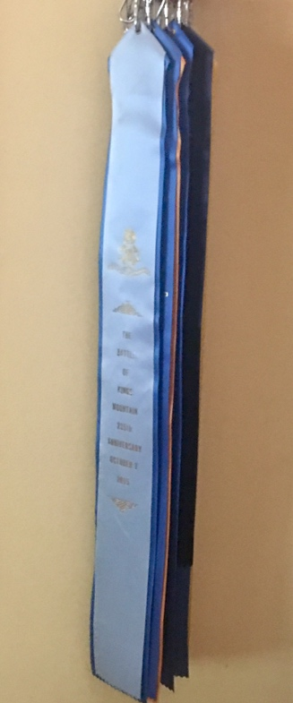
Eight Ribbons Decorate our SC Flag beginning from 2014 – 2017

During the September 9, 2017 Wreath Laying in Eutaw Springs, the South Carolina Society will collect a second flag for participation.

The flags represent the following:
2014 Kings Mountain
2015 Kings Mountain
2015 Cowpens
2016 Cowpens
2017 Cowpens
2016 Great Cane Brake
2017 Great Cane Brake
2016 Eutaw Springs
2017 Eutaw Springs
2017 Bufford’s Massacre
_________________________
According to the January 1, 2017 By-Laws of the SCSR
Article V Committees
Section 6 Committee on Nominations

“Not less than 60 days prior to the annual membership meeting, the President shall appoint a committee on nominations. Such a committee shall be composed of five regular members of the Society.”

It has been announced in previous correspondence that our Annual SRSC
Membership Meeting is scheduled for Saturday,
November 11, at the Simpsonville Museum of the American Revolution.

More information and agenda will follow but for this issue let it be known I am appointing Immediate Past President Chuck Swoope as the Chair of the Nomination Committee.

If you are interested in serving on the committee please contact Chuck.

The By Laws are published www.srsc1776.org
Information Page.

Editor: Ivan Bennett

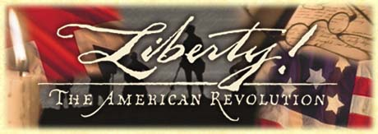

Please plan to attend the GSSR BOM September 28-October 1 in Charleston at the Francis Marion Hotel.

