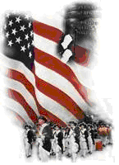 | The Crescent Moon
Summer Issue Number 33 | A publication of the Sons of the Revolution  In the State of South Carolina | August 4, 2018

SRSC Co-Host 238th Anniversary of
The Battle of Huck’s
Defeat
With The Local SAR Chapter
July 14, 2018

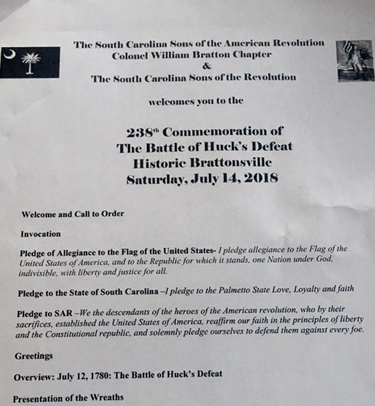

The South Carolina Sons of the American Revolution Colonel William Bratton Chapter and
The South Carolina Society
Sons of the Revolution,
for the first time, held a joint
ceremony at Historic Brattonsville.
SAR Chapter President Bret Reed and Chapter Secretary Adam King kicked off the event with typical SAR Protocol Invocation, Pledge to the American Flag, Pledge to the State of South Carolina Flag and the SAR Pledge.
Greetings were in order from the SC Society of Sons of the Revolution, SC Society of the Children of the Revolution followed by local SAR, DAR and CAR Chapters.
Secretary Adam King gave an overview of the July 12, 1780 Battle of Huck’s Defeat.
SC SR Registrar Chuck Swoope presented the Society Wreath. A special unveiling of portraits and presentation by York County Historical Society Historian (Portraits were of Col. William Bratton and Lt. Col. Banastre Tarleton) and their local artist.
The weekend was filled with a busy schedule of events.
Prior to the noon Wreath Laying, Vice President Tom Weidner, Registrar Chuck Swoope and President Ivan Bennett held the Mid-Year Annual Meeting on the 2nd Floor of the Visitor Center from 10-11:30 The agenda and subsequent notes were published in previous emails to membership.
We wish to express our deepest gratitude to Brett Reed and Adam King for including the SCSR in their annual ceremony. We have been invited to continue the tradition next year with SAR.
Photo Gallery

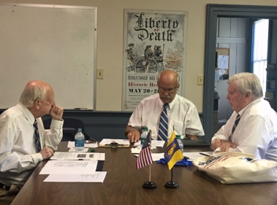

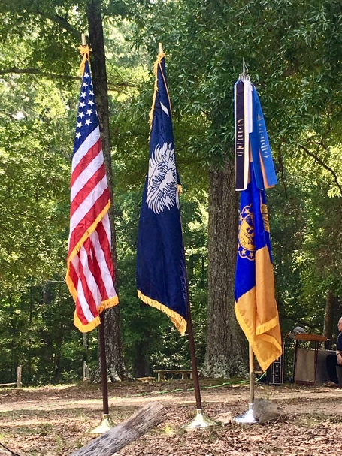

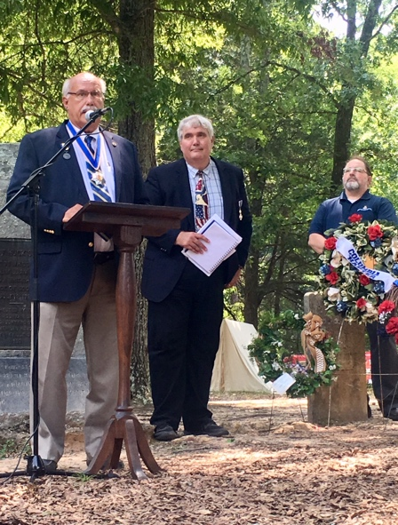

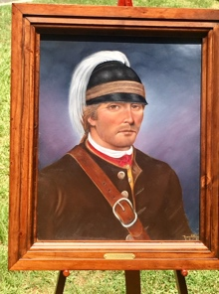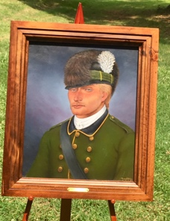

Photos by Susan Bennett
Ivan Bennett,Editor The Crescent Moon
An Evening with LeighAnn Snuggs:
Simpsonville Library and Museum of Revolutionary War
History (6/15/2018)
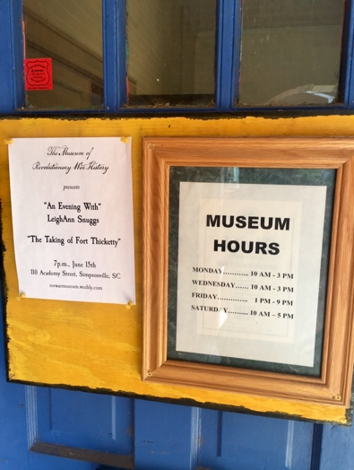
An Evening w/ LeighAnn Snuggs

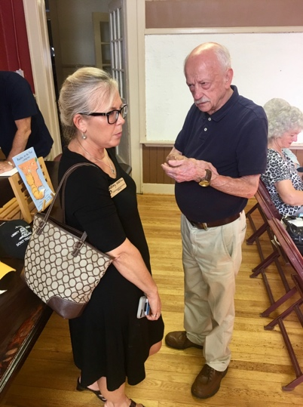
SRSC VP Tom Weidner, Dir Museum

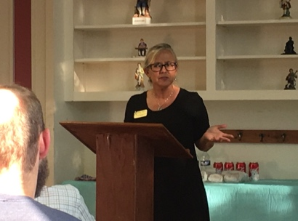
LeighAnn Snuggs, City of Gaffney

At the November 2017 SRSC Annual Membership Meeting,
SRSC VP Tom Weidner offered the idea of our Society hosting a 2018 Inaugural Event for Ft. Thicketty south of Gaffney in Cherokee County, Membership at the meeting were very supportive of this novel idea.
The vision was to host a small event and hopefully in years, SRSC could build it to the magnitude of the SAR events we attend for wreath laying and commemoration of historic battles and skirmishes in South Carolina.
I am confident the planning meetings that Tom Weidner was involved in between November 2017 and July 2018 were many more than I have notes on. Tom provided me with summaries from meetings with stake holders on April 19 and June 26.
The group grew at every turn.
It began with LeighAnn Snuggs, Director of Marketing and Tourism for the City of Gaffney and evolved including representatives from National Park Service, Overmountain Valley Trail Association, Cherokee History and Preservation Society (CHAPS),
and SC Rangers Spartanburg.
The role of the SRSC was to convert Tom’s Agenda for the July 28th Celebration of the Taking of Fort Thicketty and recruit other societies to participate in the presentation of wreaths and greetings. Our resource of Hanson Communications and Publications, Honoree Member Tom Hanson, produced a product that rivals any state ceremony I have witnessed. Tom Hanson published a “flash card” handout with the agenda on the front and information on the back (Pledge to the SC Flag, Pledge to SR, Map, Directions and details to those attending such as parking, chairs, water and mosquito spray).
We asked Tom to publish 100 copies. Tom, LeighAnn and I divided the copies and ended up with 20 left for archives.
In other words, 75 to 80 compatriots, history lovers and children attended this SRSC Inaugural Event on Saturday July 28, 2018!
As is obvious on the agenda photo below, the Sons of the Revolution was the host. Because we had Dan Woodruff, a member of SRSC, present in his newly elected position (NSSAR) as the South Atlantic District VP General, our event also became a NSSAR District recognized Event. Other Societies were: SCSCAR, Daniel Morgan SAR, Andrew Pickens SAR, James Williams SAR, Robert Anderson SAR, Maj. Robert Crawford SAR, Elizabeth Hutchinson Jackson DAR, Martha Bratton CAR, Col. James Williams CAR.
In addition Gaffney Mayor Henry Jolly attended for his Cameo Appearance. Thank you SCSCAR (PR) and The Gaffney Ledger (7/26/18).
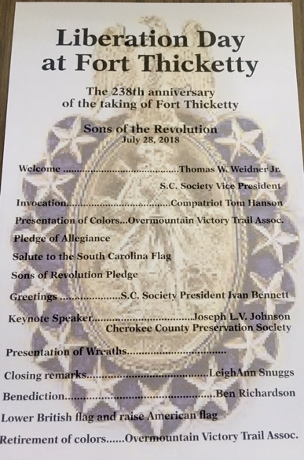
HansonCommunications.org

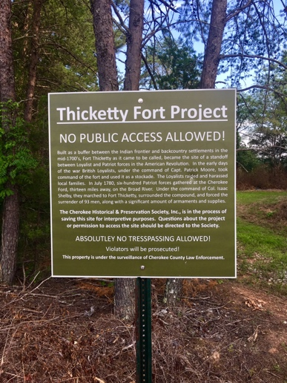
CHAPS Signage

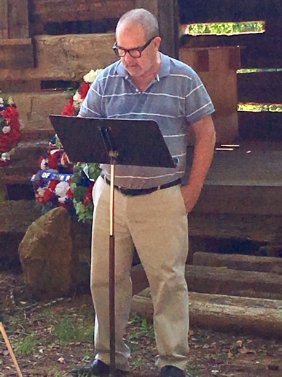
Compatriot Tom Hanson Invocation

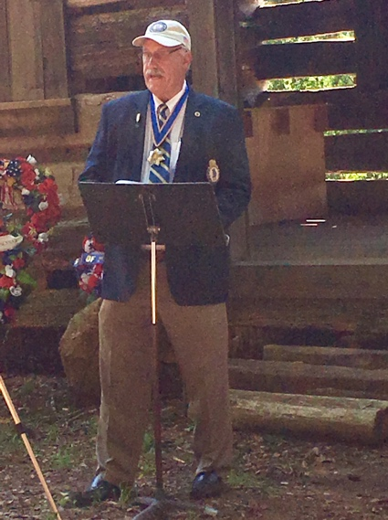
Ivan Bennett, SRSC Pres. Greetings

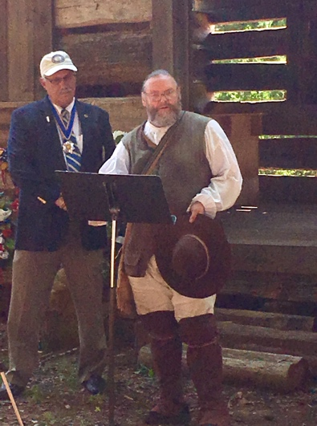
SRSC Member Dan Woodruff
Greetings as NSSAR District VP Gen.

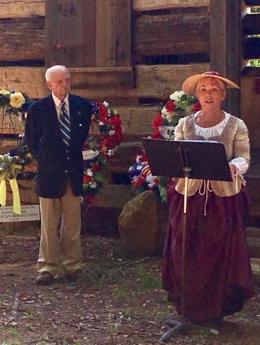
LeighAnn Snuggs, Director of
Marketing and Tourism Gaffney
SRSC VP Tom Weidner MC

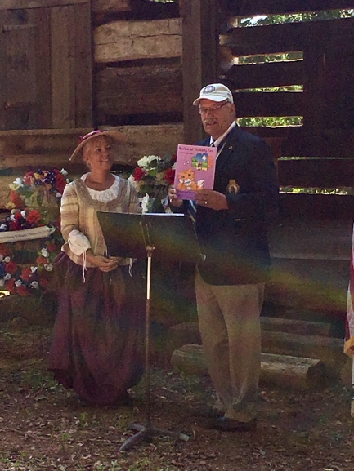
Ivan Bennett displaying LeighAnn’s
“Peaches, at Thicketty Fort” a coloring
Book edited by LeighAnn Snuggs.

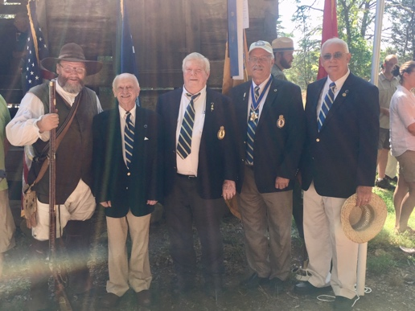
SRSC Members Present at the Inaugural Liberation Day at Ft. Thicketty Event: Dan Woodruff, Tom Weidner, Chuck Swoope, Ivan Bennett,
Albert Futtrell (Tom Hanson behind the camera lens).

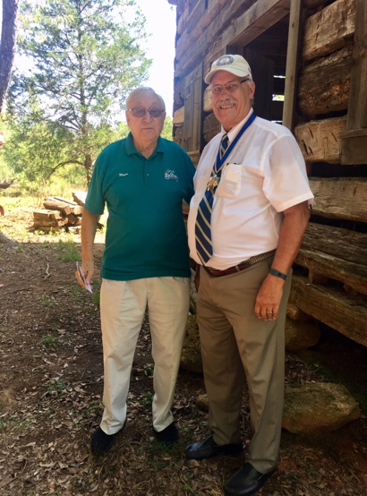
Gaffney Mayor Jolly and Pres. Bennett

