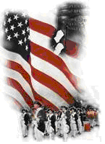 | The Crescent Moon
2019 Quarterly Number 1 | A publication of the Sons of the Revolution  In the State of South Carolina | March 1, 2019

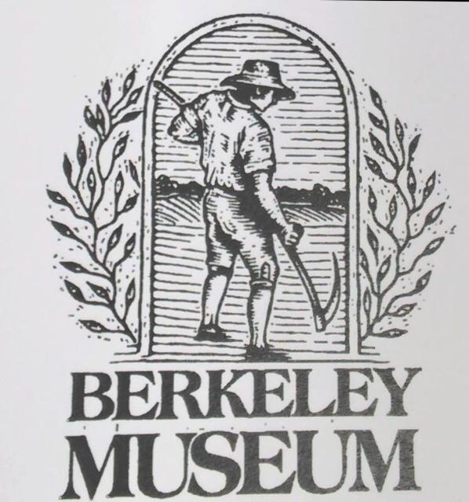

South Carolina Society
Sons of the American Revolution
2019 Quarterly Meeting
March 16-17, 2019
~ Berkeley County Museum and Heritage Center
950 Stony Landing
Moncks Corner, SC 29461

President Weidner has called a quarterly meeting of the membership to be held in the Coastal Region. The schedule is over two days March 16-17. The Meeting is scheduled on Sunday, St. Patrick’s Day, beginning at 10:00 am at the Berkeley County Museum and Heritage Center.
Executive Director Michael Coker has agreed to open the normally closed Center for our meeting. The agenda details from President Weidner is attached to this email.
On Sunday, after the meeting, everyone is invited to attend a St. Patrick’s Day lunch of Corn Beef and Cabbage at the Barony House nearby. The restaurant is opened 11:00-2:00. The owner suggest we arrive before Noon before the crowd.
Some members from the Upstate will arrive Saturday for a planned tour of Ft Fair Lawn and the Museum in the afternoon. The motel they have selected is the Moncks Corner Inn, just a mile from the Museum. The information for reservations: $105 Night, Check in is 5:00, Phone number is 843-761-5900
The Fair Lawn Plantation Battle was November 17, 1781. The Patriot Commander was Lt. Col. Hezekiah Maham. The British Commander was Captain Murdock MacLaine. The number captured by the Patriots in this win was 150.
British Captain MacLaine was sent with fifty men of the 84th Regiment of Foot to relieve the post at Fair Lawn Plantation, described as a “strong brick house known to have been constructed for defense as well as for comfort”, and protected by considerable abates. This plantation protected a good landing on the Cooper River.
Brigadier General Francis Marion had an advantage of the turnover of personnel and sent Lt. Col. Maham with 180 of his men plus 200 men from Col. Isaac Shelby (NC) and Col. John Sevier (NC), which had just been assigned to his command thanks to a request from Major General Nathanael Greene.
The Patriots considered the main house at Fair Lawn Plantation too formidable to take, so they decided to attack one of the outbuildings, which was a British hospital. Col. Shelby and his riflemen covered the redoubt while Lt. Col. Maham and his cavalry rode up to the building and demanded its surrender. The medical defenders offered no resistance at all.
Lt. Col. Maham captured 300 stands of arms and other goods. About 150 patients and staff were made his prisoner. Eighty prisoners could walk and were taken back to Brigadier General Marion’s camp, the rest were paroled. Capt. MacLaine’s garrison watched all of this happen, but did mothering. The hospital was burned and the Patriot’s rode away.
(www.carolana.com)

The Crescent Moon Newsletter in 2019 will be published quarterly. Anyone is encouraged to submit news and photos.

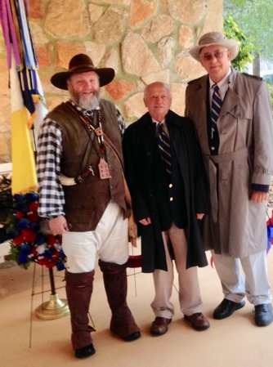
Battle of Great Cane Brake
Historic Hopkins Farm December 1, 2018 outside Simpsonville, SC
SCSR was represented at the Annual Battle of Great Cane Brake by Dan Woodruff, Secretary Tom Weidner, President and Albert Futrell, Vice President
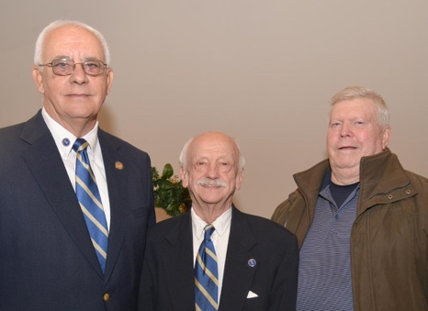
238th Anniversary of Battle of Cowpens
January 19, 2019
Wreath Laying Ceremony Due to Federal Shutdown was held in Gaffney at Cherokee Co. Museum
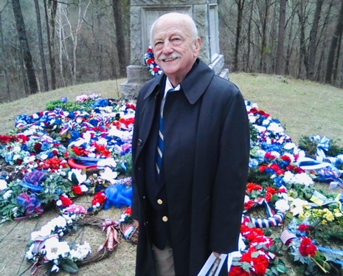
240th Anniversary of the Battle of Kettle Creek Revolutionary Days
February 9, 2019 Washington, Wilkes County, Georgia

A short drive from Simpsonville, SC President Weidner and Vice President Futrell travelled to Washington, Georgia to attend the wreath laying at the 240th Anniversary of the Battle of Kettle Creek.
Pageantry at the Kettle Creek Battlefield included Continental Army, Georgia Militia, Musket volley salutes, Wreath Presentations, SAR/DAR/CAR/SR, Hereditary Organizations, Local, State and National officials, High School JROTC, students and public, placed wreaths to honor the Heroes of the Hornets’ Nest—
The Wilkes County Militia for their 1779 Victory at Kettle Creek.

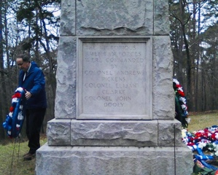

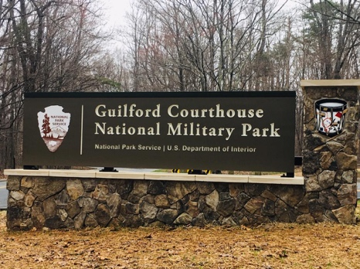
Guilford Courthouse National Military Park
North Carolina

Returning from the Annual North Carolina Sons of the Revolution’ George Washington Birthday Lunch and Meeting in Winston Salem, my wife and I went a few miles further to visit the Guilford Courthouse Battle field (outside Greensboro).
The weather on March 3rd was cool at 40 degrees, the overcast skies and damp ground gave us the feeling that reminded us of March 15, 1781, the date of the last major battle in the South before Yorktown, VA. On that date, though it was clear and cold. A light frost had disappeared under the first rays of the Sun. the ground underfoot was still spongy from winter rains and snows. The trees had lost all of their leaves and the canopy was deep with those fallen leaves. In those damp woods west of Guilford Courthouse, hub of an isolated little farming community on the main road through North Carolina, some 4,400 American troops waited for battle.
Three lines of defense by the North Carolina Militia, Maryland and Virginia Militia and the last line, the Continental Line gradually lost ground as the British Troops kept advancing. Beginning at 12:30 and ending at 5:00, it was the worst loss of life in any Battle. The British lost 25% of their troops, a number along with arms and munitions, they would not make up and it added to the attrition going forward to the final stand at Yorktown, VA.
The Americans lost 10% of their troops. The wounded on both sides were tended to and cared for by local villagers, Quakers, in the area of New Garden. I recommend at visit.

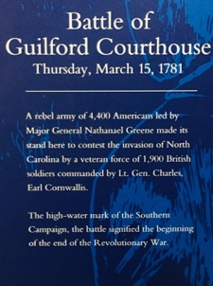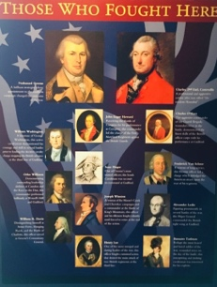

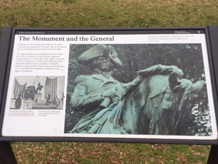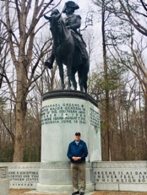

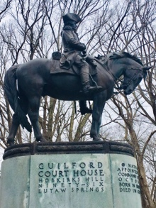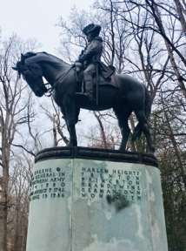
Editor: Ivan Bennett

