 | The Crescent Moon
Fall Issue Number 35 | A publication of the Sons of the Revolution  In the State of South Carolina | October 8, 2018

South Carolina Society
Receives Awards
At The
43rd Triennial Banquet
October 6, 2018
The Cool Springs Marriott
Franklin, Tennessee

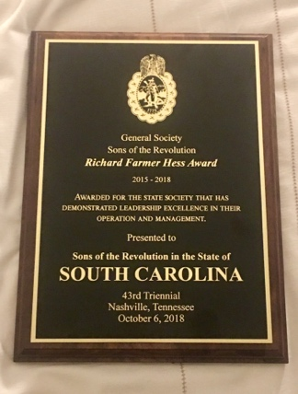
Richard Farmer Hess Award

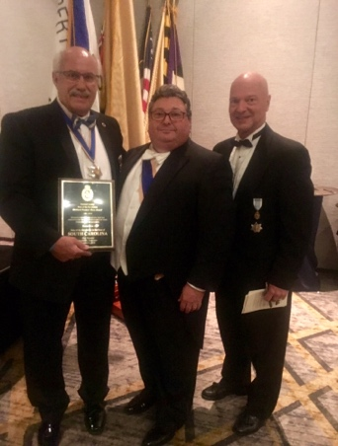
Ivan Bennett, President SC
Mitchell Bush, General Pres. GSSR
Jeff Lambert, Ex Dir. GSSR

South Carolina Society VP Tom
Weidner and Pres Ivan Bennett
represented the society as
delegates to the 43rd GSSR
Triennial October 4-7, 2018.
The conference advertised as
Nashville, TN. but physically
hosted at the Cold Springs
Marriot in Franklin, TN.
A full agenda can be viewed on
our website, www.srsc1776 .org
Home Page. Thursday night
was the kick off with the full
pageantry by the PA Society
Color Guard at the Opening
Reception at the University
Club at Vanderbilt Univ.
Friday morning was the opening
of the GSSR Business Meeting in
the Marriott Hotel including the
acceptance of the agenda and
minutes of the 2015 Triennial
in Williamsburg, VA and the
2017 Board of Managers in
Charleston, SC. The 2016 BOM
at Valley Forge, PA was not
recognized meaning our SC
Society Hosted event was the
business event between the
Triennials. Tom and I received
many accolades for our BOM
Meeting September 27-
October 1, 2017.
The agenda included General
Officer Reports (e.g. General
VP Region 1 through 6) and
Secretary Dr. Larry Simpson
Treasurer Matson Roberts.
The State President Reports
were called on. Eleven states
were present who offered their
presentations. Twenty Three
states submitted reports to be

included in our packet. Three
states did not submit nor
were they present.
The SC Society Three
Year Report is attached to
this email for your
review.
At the conclusion of the state
reports, the meeting was
adjourned, box lunches
were distributed for delegates
and their spouses as we
boarded our three charter buses.
The Society followed tours
in Nashville of the State
Capitol and the Hermitage
Home of Andrew Jackson.
Dinner was on their own for
some delegates and others
returned to the hotel for
a GSSR paid dinner.

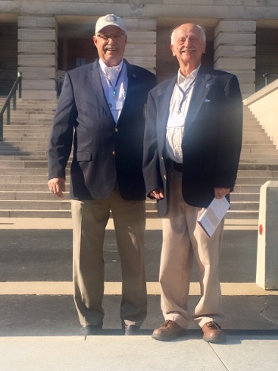
Tom and Ivan TN State Capitol
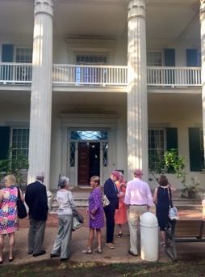
Susan Bennett at Hermitage AJ Home
On Saturday, we picked up
with Committee reports: Finance,
Forms and Services,
Headquarter Facilities,
Publications and Awards.
Special Committee and
Standing Committees finished
up the agenda that morning.
In this category, President
Emeritus Curtis Cheyney, Esq.
Reported on his Nominating
Committee for the years of
2018-2021. The Executive
Committee were presented.
The General President will be
the current General Sec. from
New York, Dr Laurence
Simpson, DDS. A new
General Vice Presidents was
Region 3 (NC,SC,Ga,Fl,Al)
Ivan Bennett. In Curtis’s
comments he reminded
everyone of the great job SC
did in hosting the 2017 BOM
in Charleston at the Francis
Marion Hotel.
Old Business included Society
Of ‘83, Drumbeat advertising
sales and promotion and
discussion of creating a Deputy
General President.
New Business included the
Triennial Site for 2021 and
a reference to the former
Sales Associate at the Francis
Marion Brittany O’Shaughnesy
business of locating hotels for
our Triennials. The BOM
site for 2019 was announced
for Williamsburg, VA. The dates
of October 25,26,27.
After adjournment of the
Saturday Session and a break,
the delegates participated in the
traditional Memorial Service,
conducted by Rev Clayton
Ames, General Chaplain.
We all appreciated the free
time for the rest of the afternoon
until the 6:00 pm Reception and
Formal Dinner at the Marriott.

43rd Triennial Banquet
Saturday October 6, 2018
The Cool Springs Marriott
Franklin, Tennessee

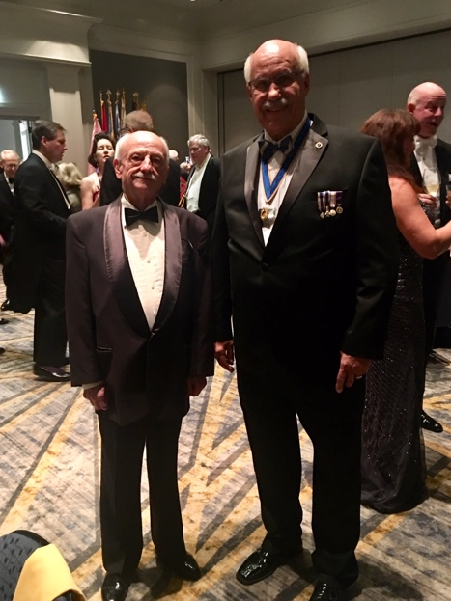
Tom and Ivan Delegates to the GSSR

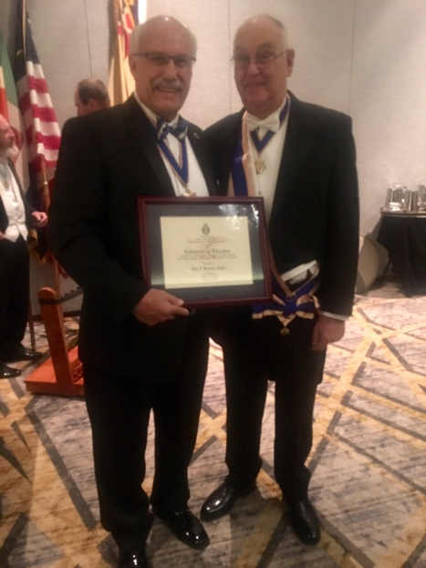
Ivan and Dr. Simpson, General Pres.
2018-2021

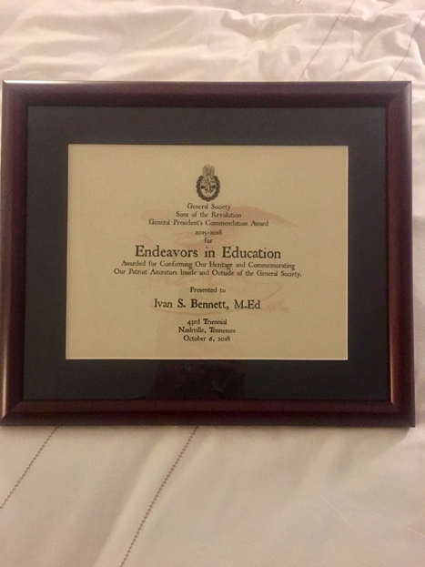
General President Commendation
Award 2015-2018
Endeavors in Education

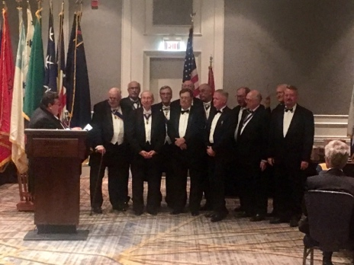
General President Bush 2015-2018
Induction of the Executive Committee
General Society of the Sons Revolution

Editors Note:
The first issue of
The Crescent Moon
Was November 11, 2015

The last issue in this monthly format the past
three year will highlight
the November 10, 2018
Annual Membership
Meeting in Winnsboro SC

Ivan Bennett, Editor

