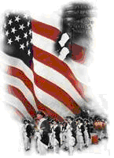 | The Crescent Moon  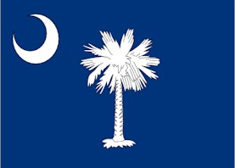
Summer Issue Number 10 | A publication of the Sons of the Revolution  In the State of South Carolina | September 4, 2016
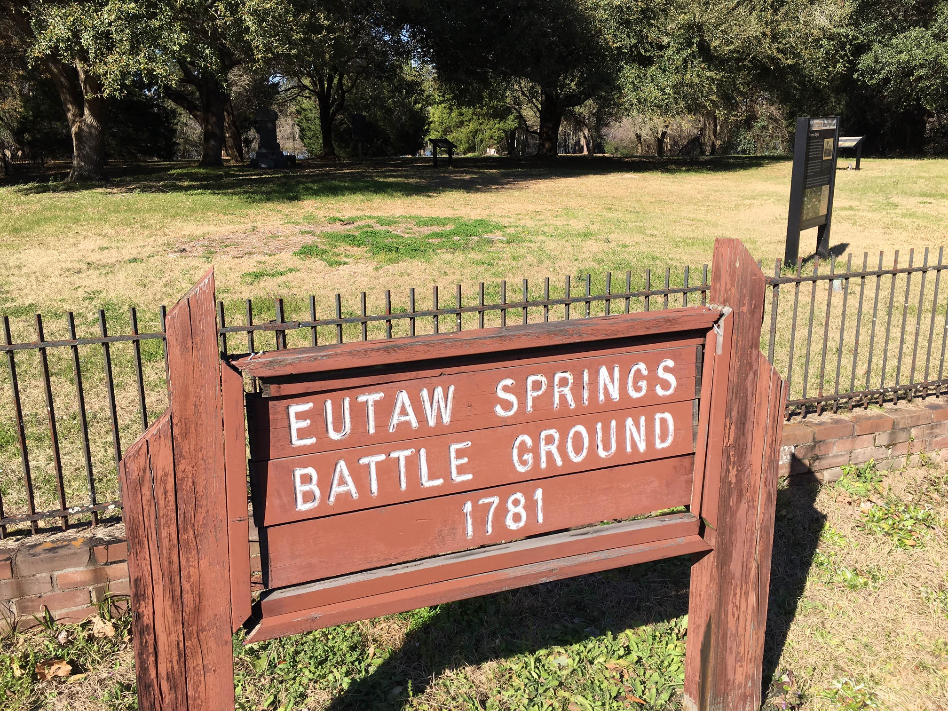
The 235th Anniversary of the Battle of Eutaw Springs
September 3, 2016
~ Hosted by Eutaw Springs Chapter SAR

On September 8, 1781, one of the most important battles of the American Revolution was fought in the Eutaw Springs community of what is now eastern Orangeburg County. The 235th anniversary of the last major battle in South Carolina in the Southern Campaign under General Nathanael Greene was organized by Past State Society SAR President Doug Doster (2009). Doug is currently V.P./Secretary of the Battle of Eutaw Springs Chapter.
The previous day with Hurricane Hermine crossing the mid-section of South Carolina, there were nervous times for the weather cooperating on September 3rd. The weather cleared and it was a cool and sunny day.
The commemorative events started with a patriotic service at the Historic Church of the Epiphany in Eutawville at 10:00 am.
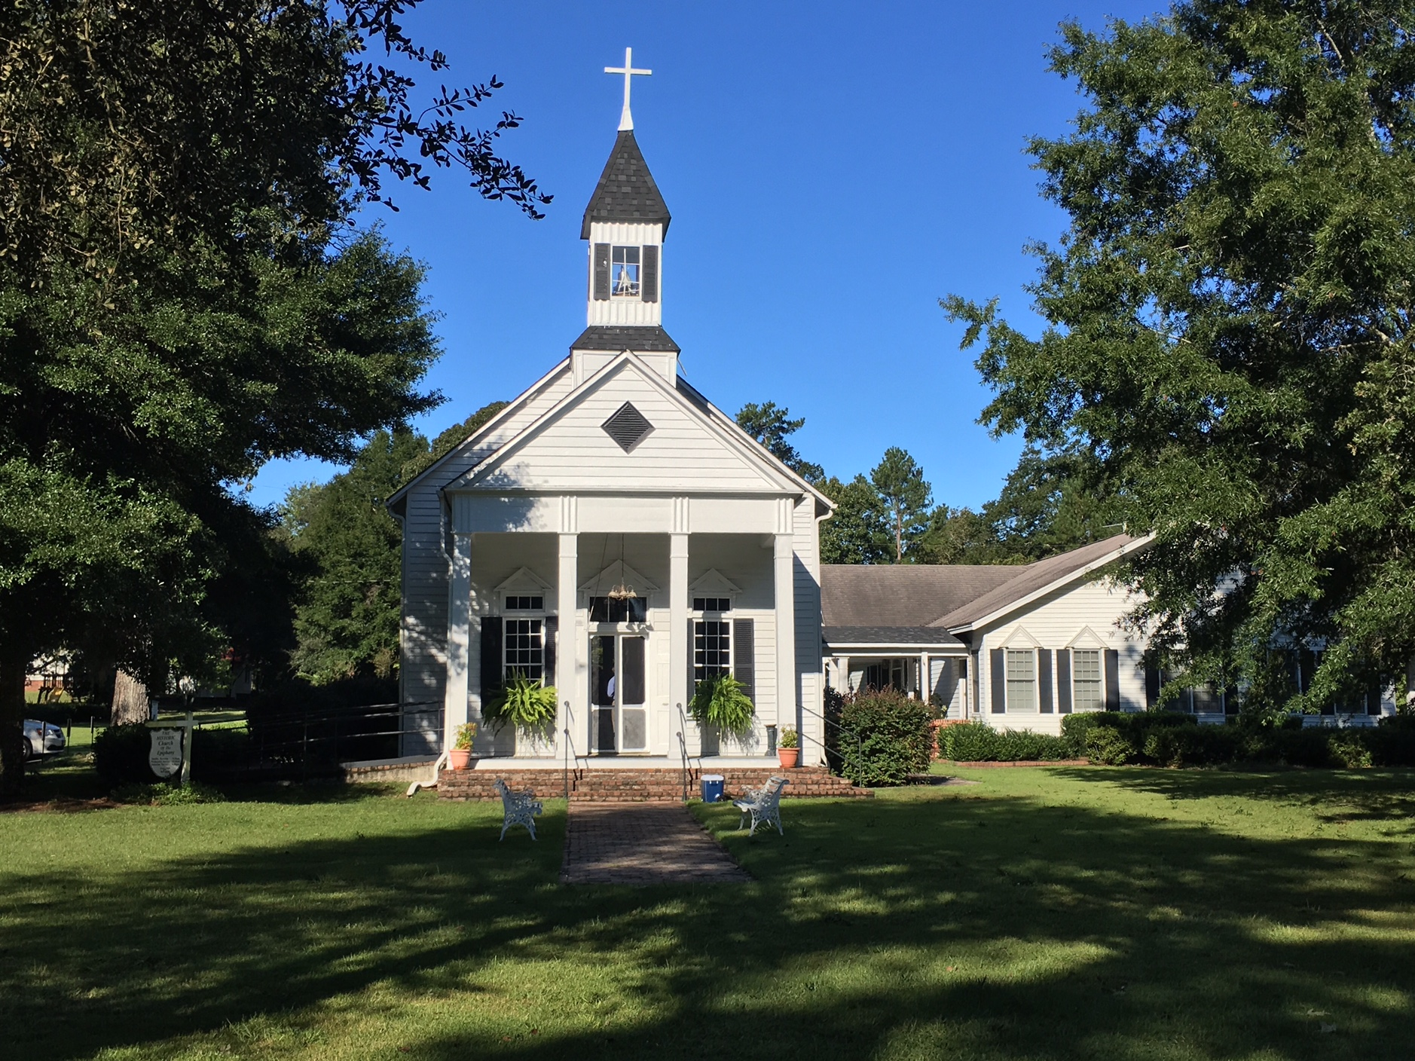

The SCSSAR Color Guard presentation was followed by recognition and greetings from the President of the SAR, DAR, CAR and Secretary of SC SR. The standing room only was a testimony of the turnout for this anniversary. 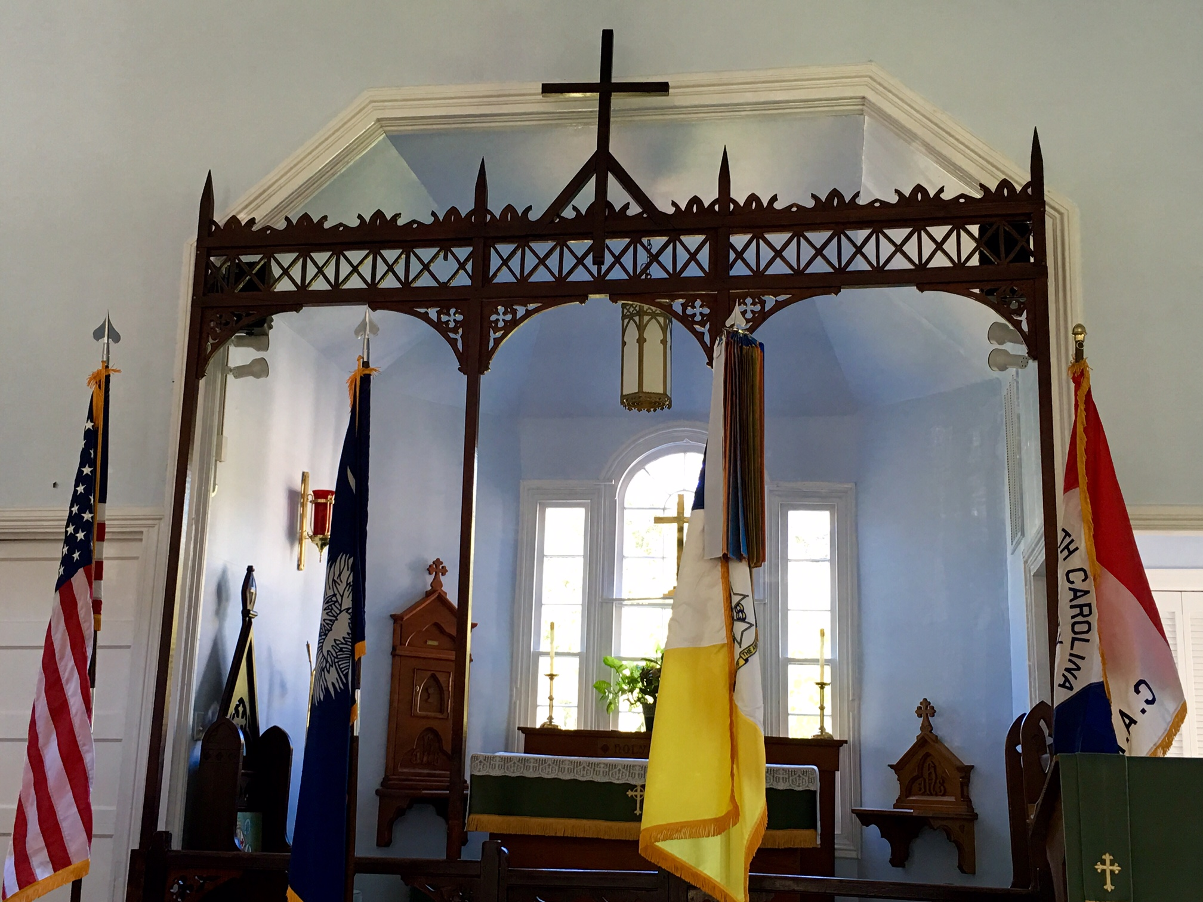
Dr. Jim Piecuch, author of several American Revolution centered books and professor at Kennesaw State University (GA) gave this year’s address. Dr. Piecuch entertained the 150 in attendance with “Light Horse Harry” Lee. Though young when he joined the Continental Army, Lee corresponded directly with Commander in Chief Washington while serving in the North, and with the Commander of the Southern Army, Nathanael Greene after he transferred to the to the South in 1781. Lee was in the saddle and in the presence of the enemy almost every day for the six long years between 1776 and 1782. He was the only American soldier below the rank of general to be awarded a gold medal by Congress during the Revolution. A son named Robert E. Lee was born to Henry Lee and his second wife in 1807, just a few days short of the old soldiers fifty first birthday and long after the guns of the Revolution had gone silent. Colonel Lee was elected to the Continental Congress when the war was over, then as Governor of Virginia, and finally to the United States Congress. He was selected by Congress to write and deliver the funeral oration for George Washington. In it he coined the famous phrase, “First in war, first in peace, and first in the hearts of his countrymen.”

Following the service at the “chapel”, the events and wreath laying ceremony moved to the battle monument site two miles from the church. At 11:00 am the Washington’s Light Infantry detachment from Charleston presented the colors which included a replica of the Eutaw Flag.
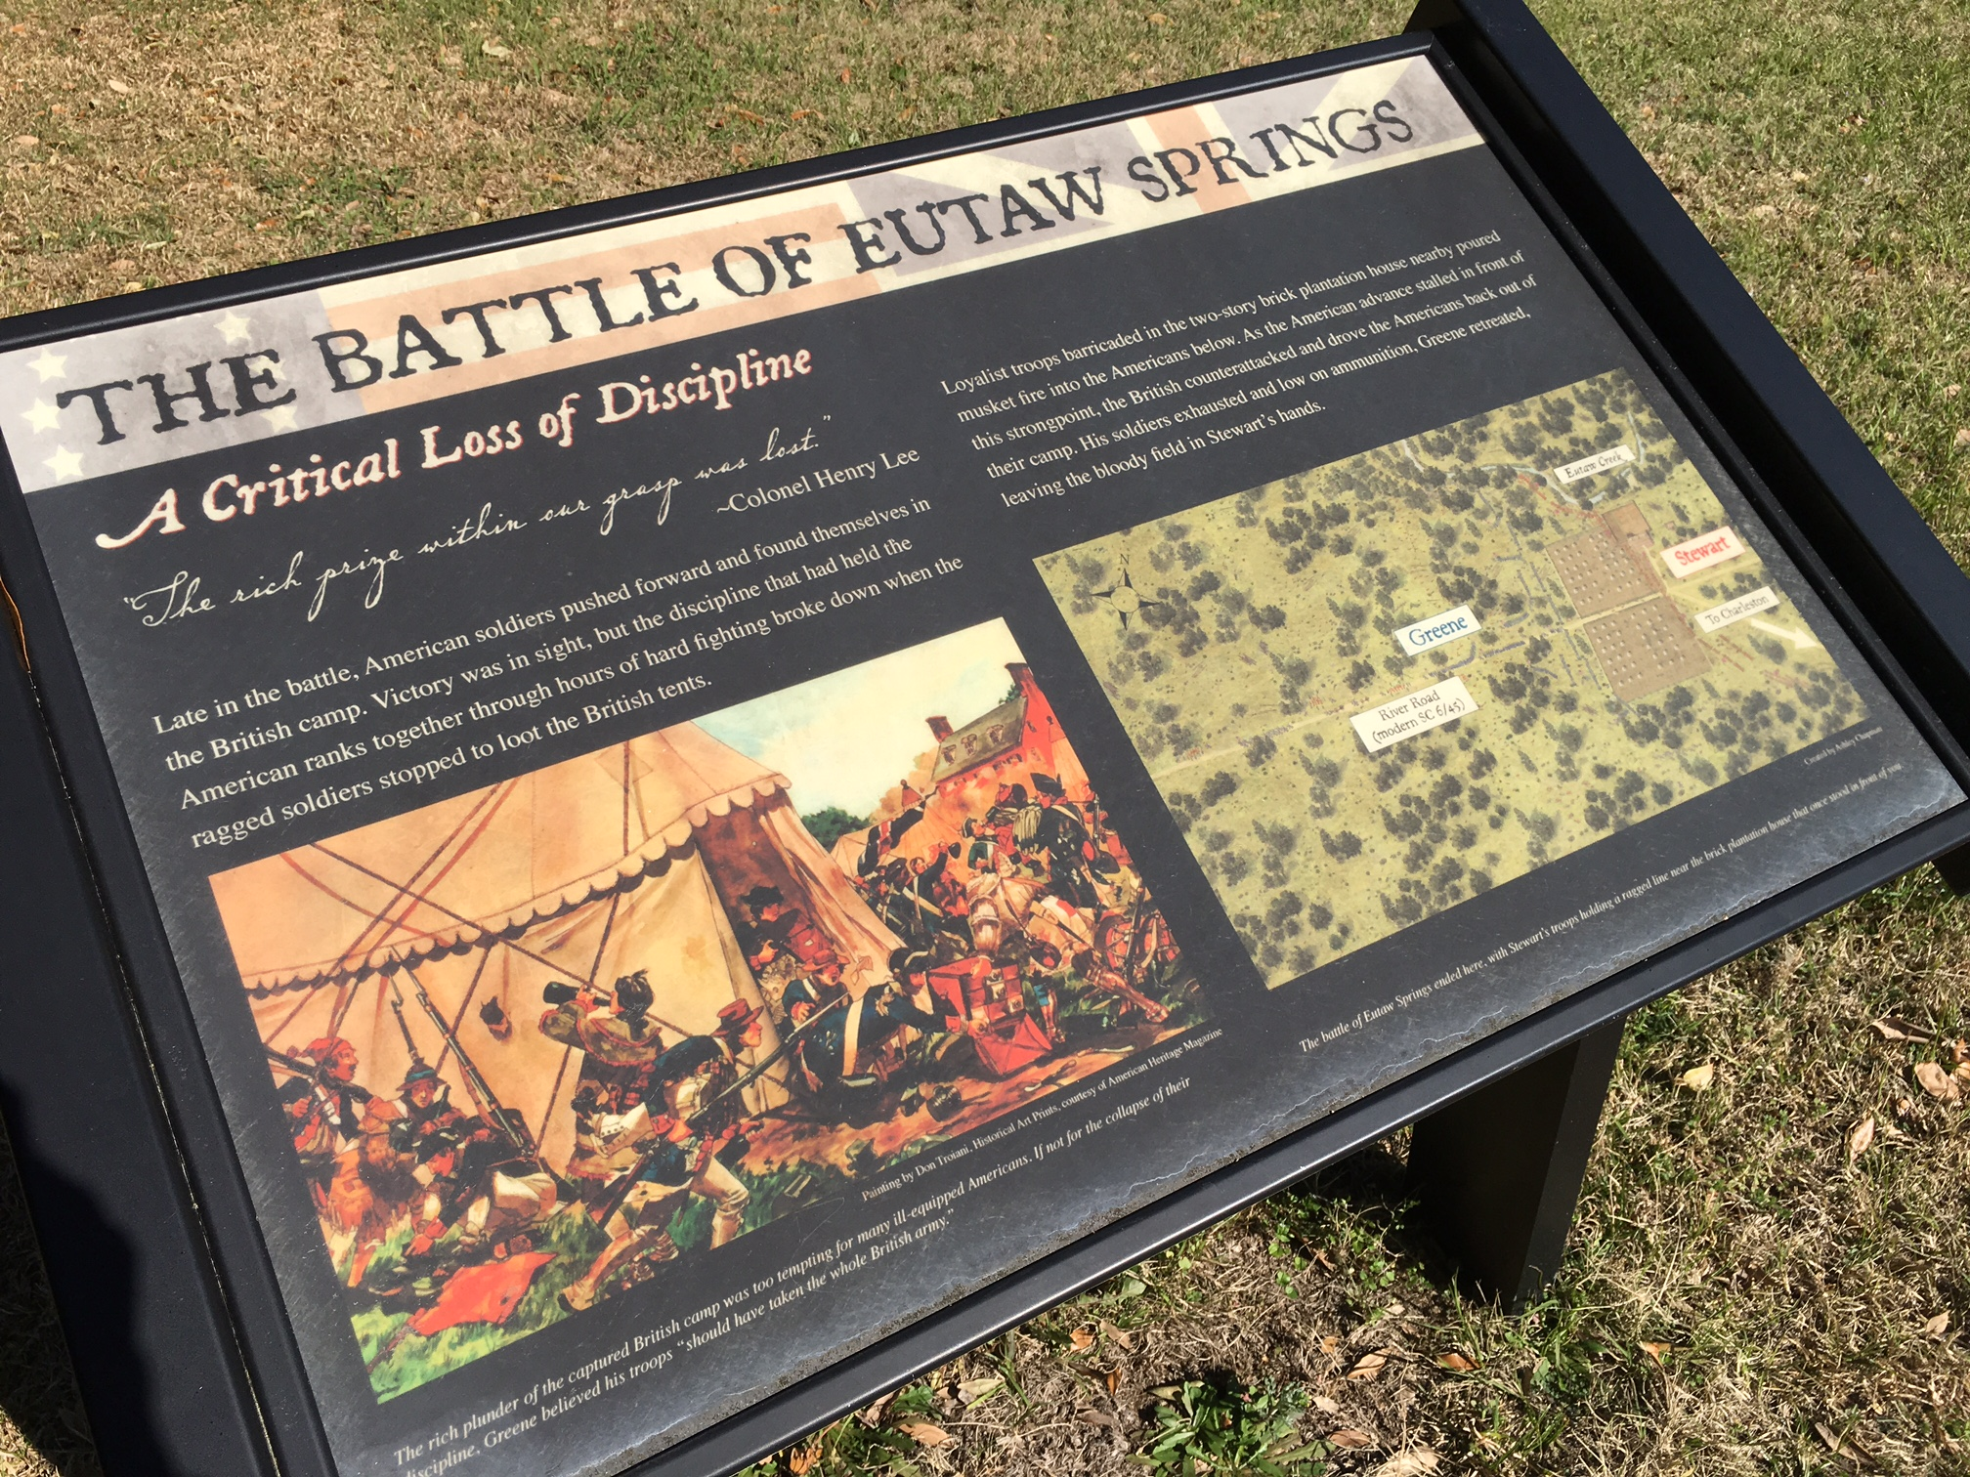
A brief address was made before the wreaths were presented according to the NSAR protocol. In the photo below are Presidents of the SCSSAR Wayne Cousar and SCSDAR Diane Culbertson. These were followed by the speaker, Mike Brimer who traveled from LA Calif. and a member of the TN SAR. Mr. Brimer presented a well-researched and documented story of his descendent Patriot Joseph Brimer, who fought at Eutaw Springs.
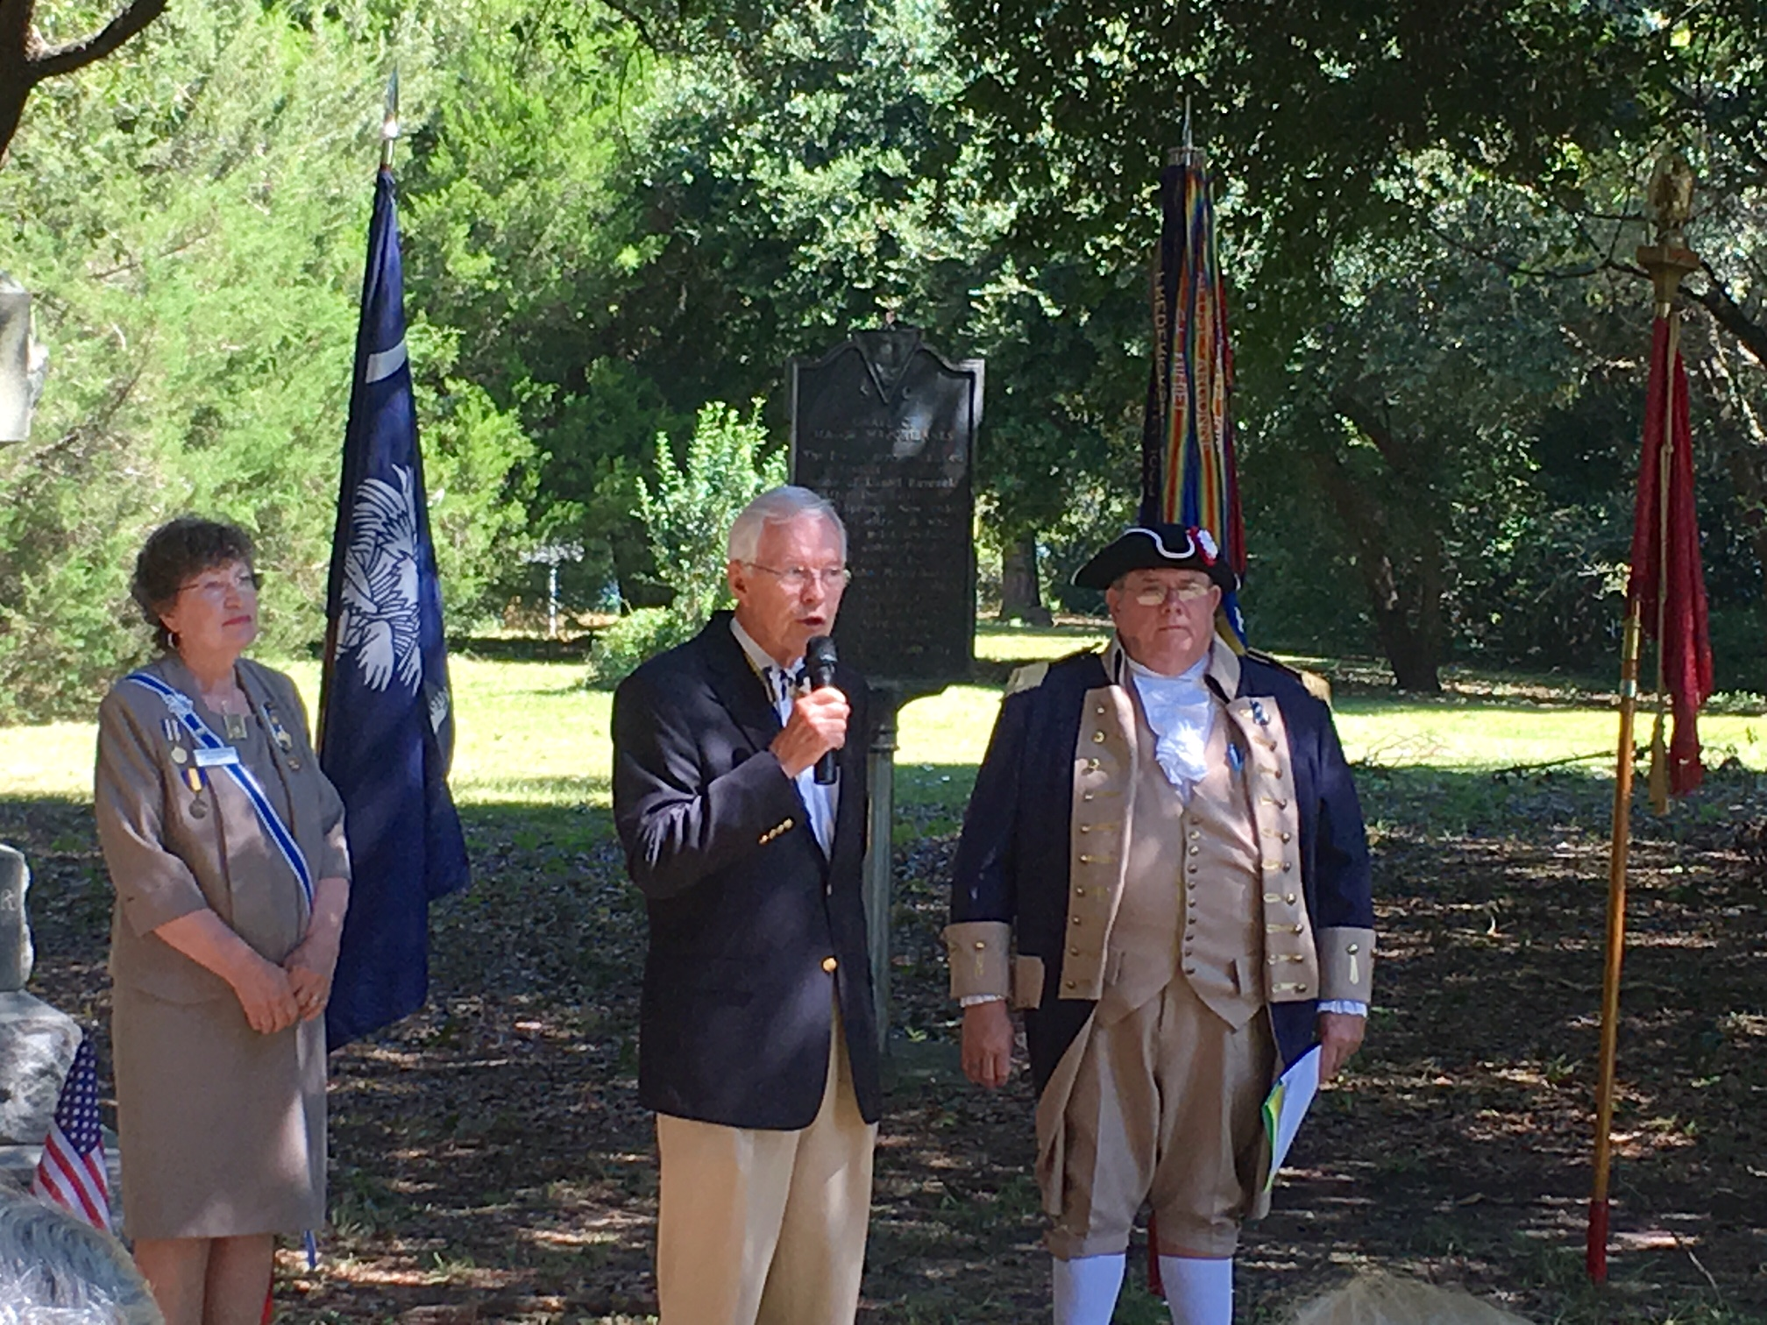
There were 150 individuals in attendance, a record number from chapters in SAR, DAR and four societies of CAR. There were 20 wreaths set up for the ceremony.
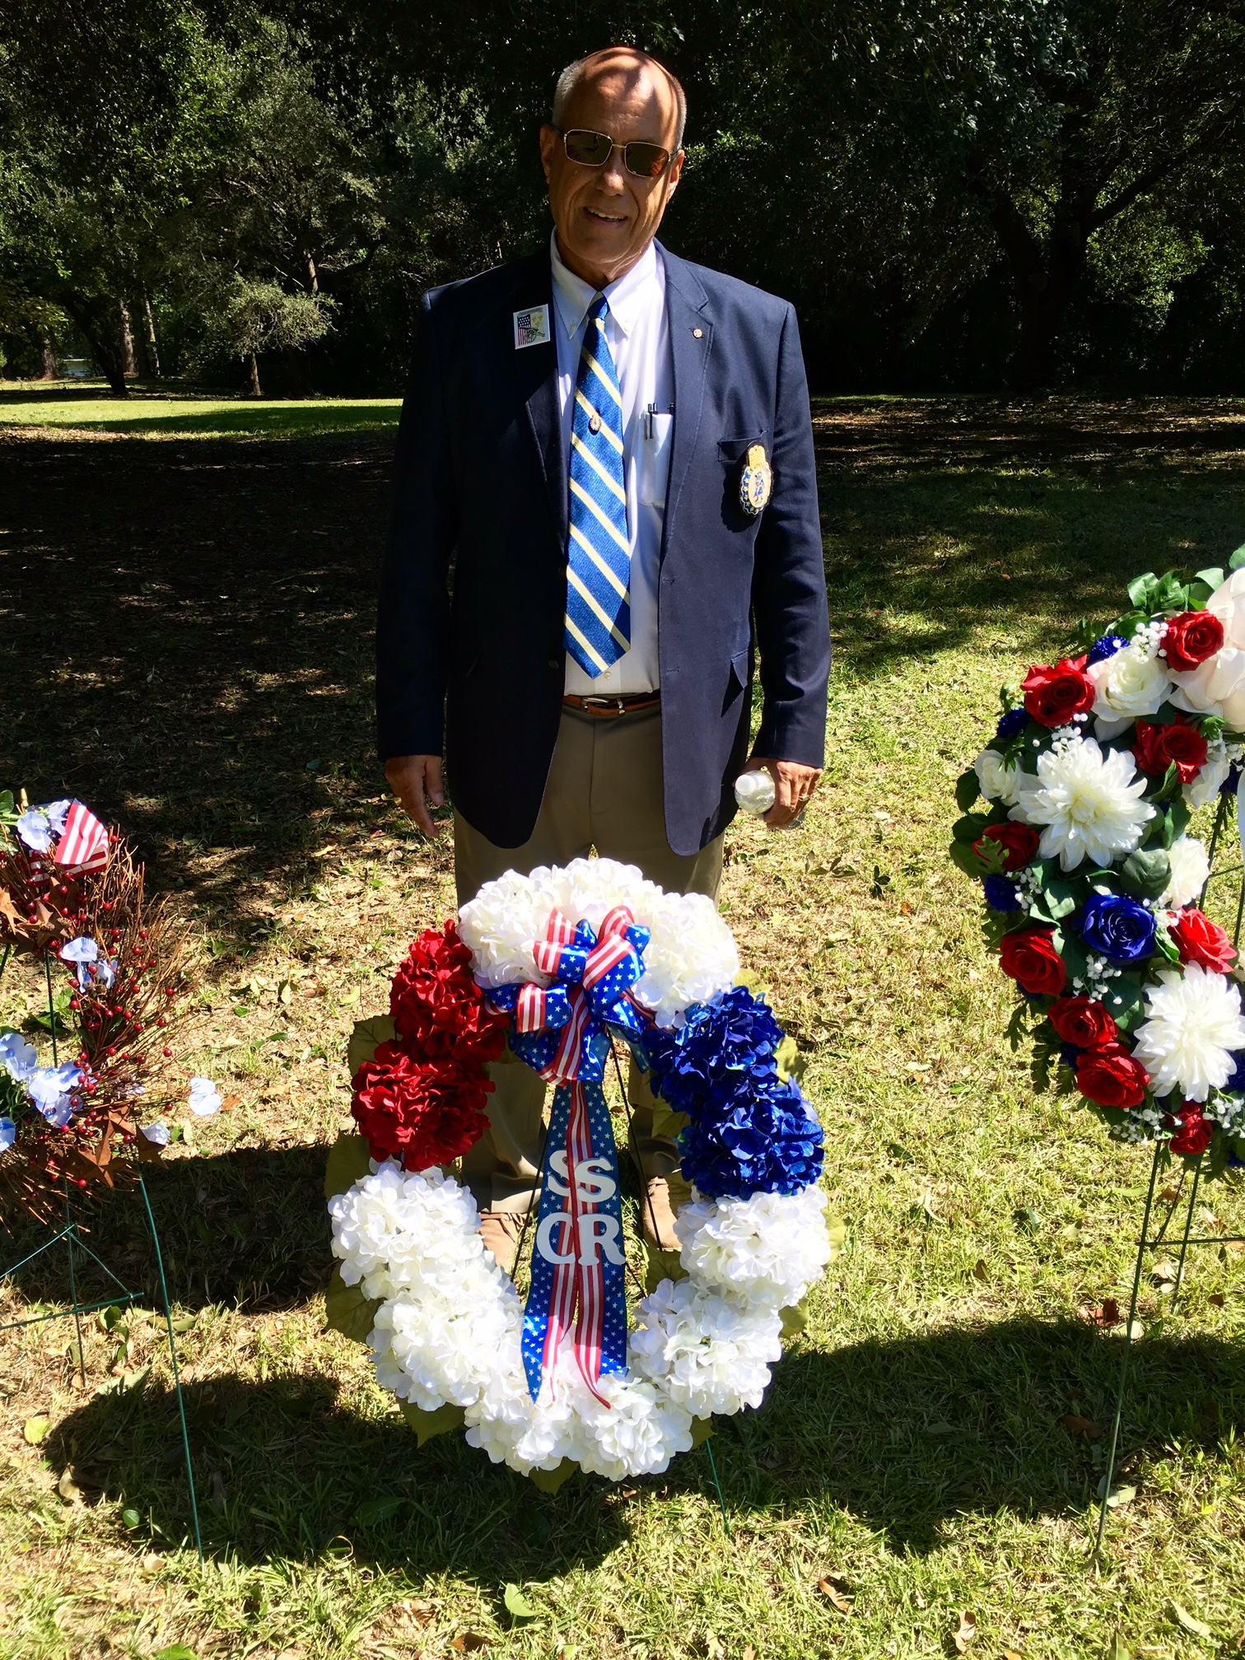
Representing the South Carolina Society of the Sons of the Revolution, I received an early call to step forward. It was an honor to pay tribute to the fallen heroes among so many compatriots representing the societies that traveled to this event. The ceremony ended with a musket volley given by the SCSAR Color Guard and followed by Taps. The colors were retired.
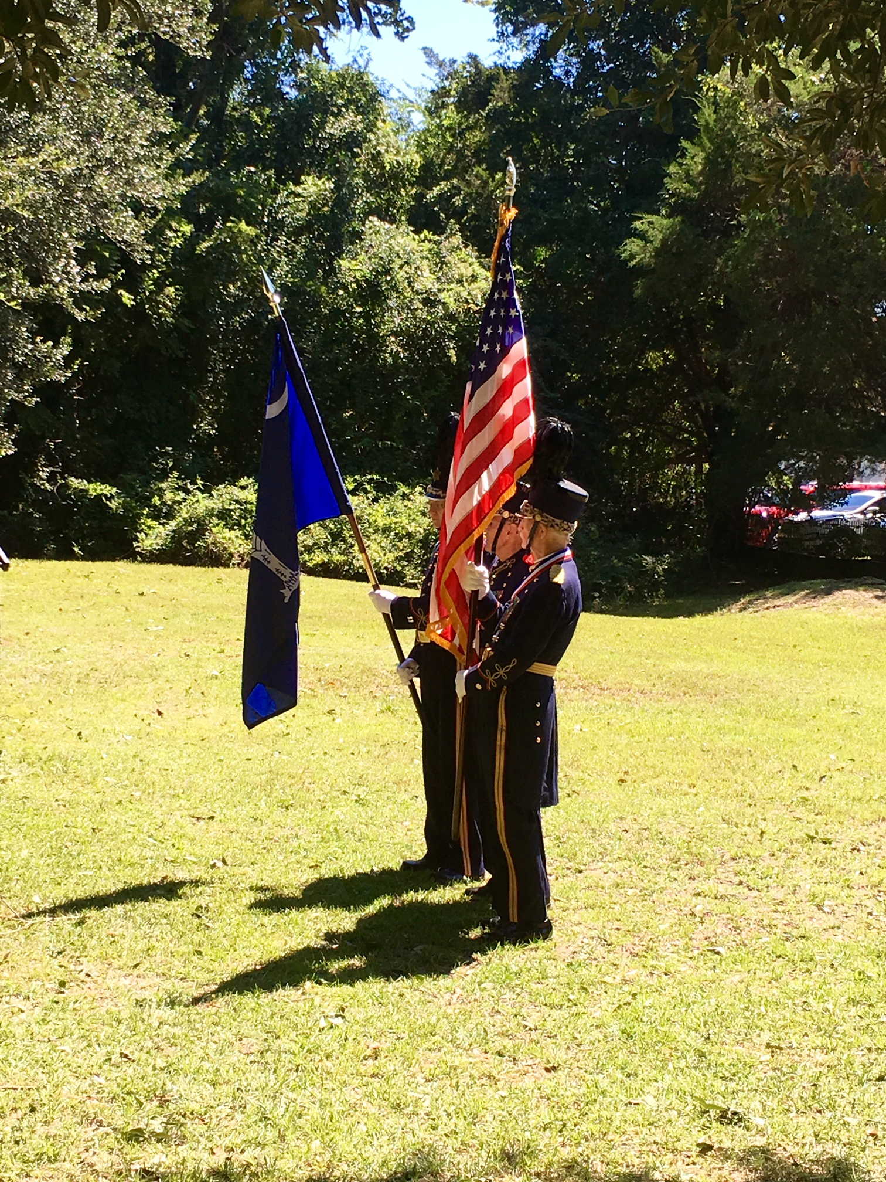
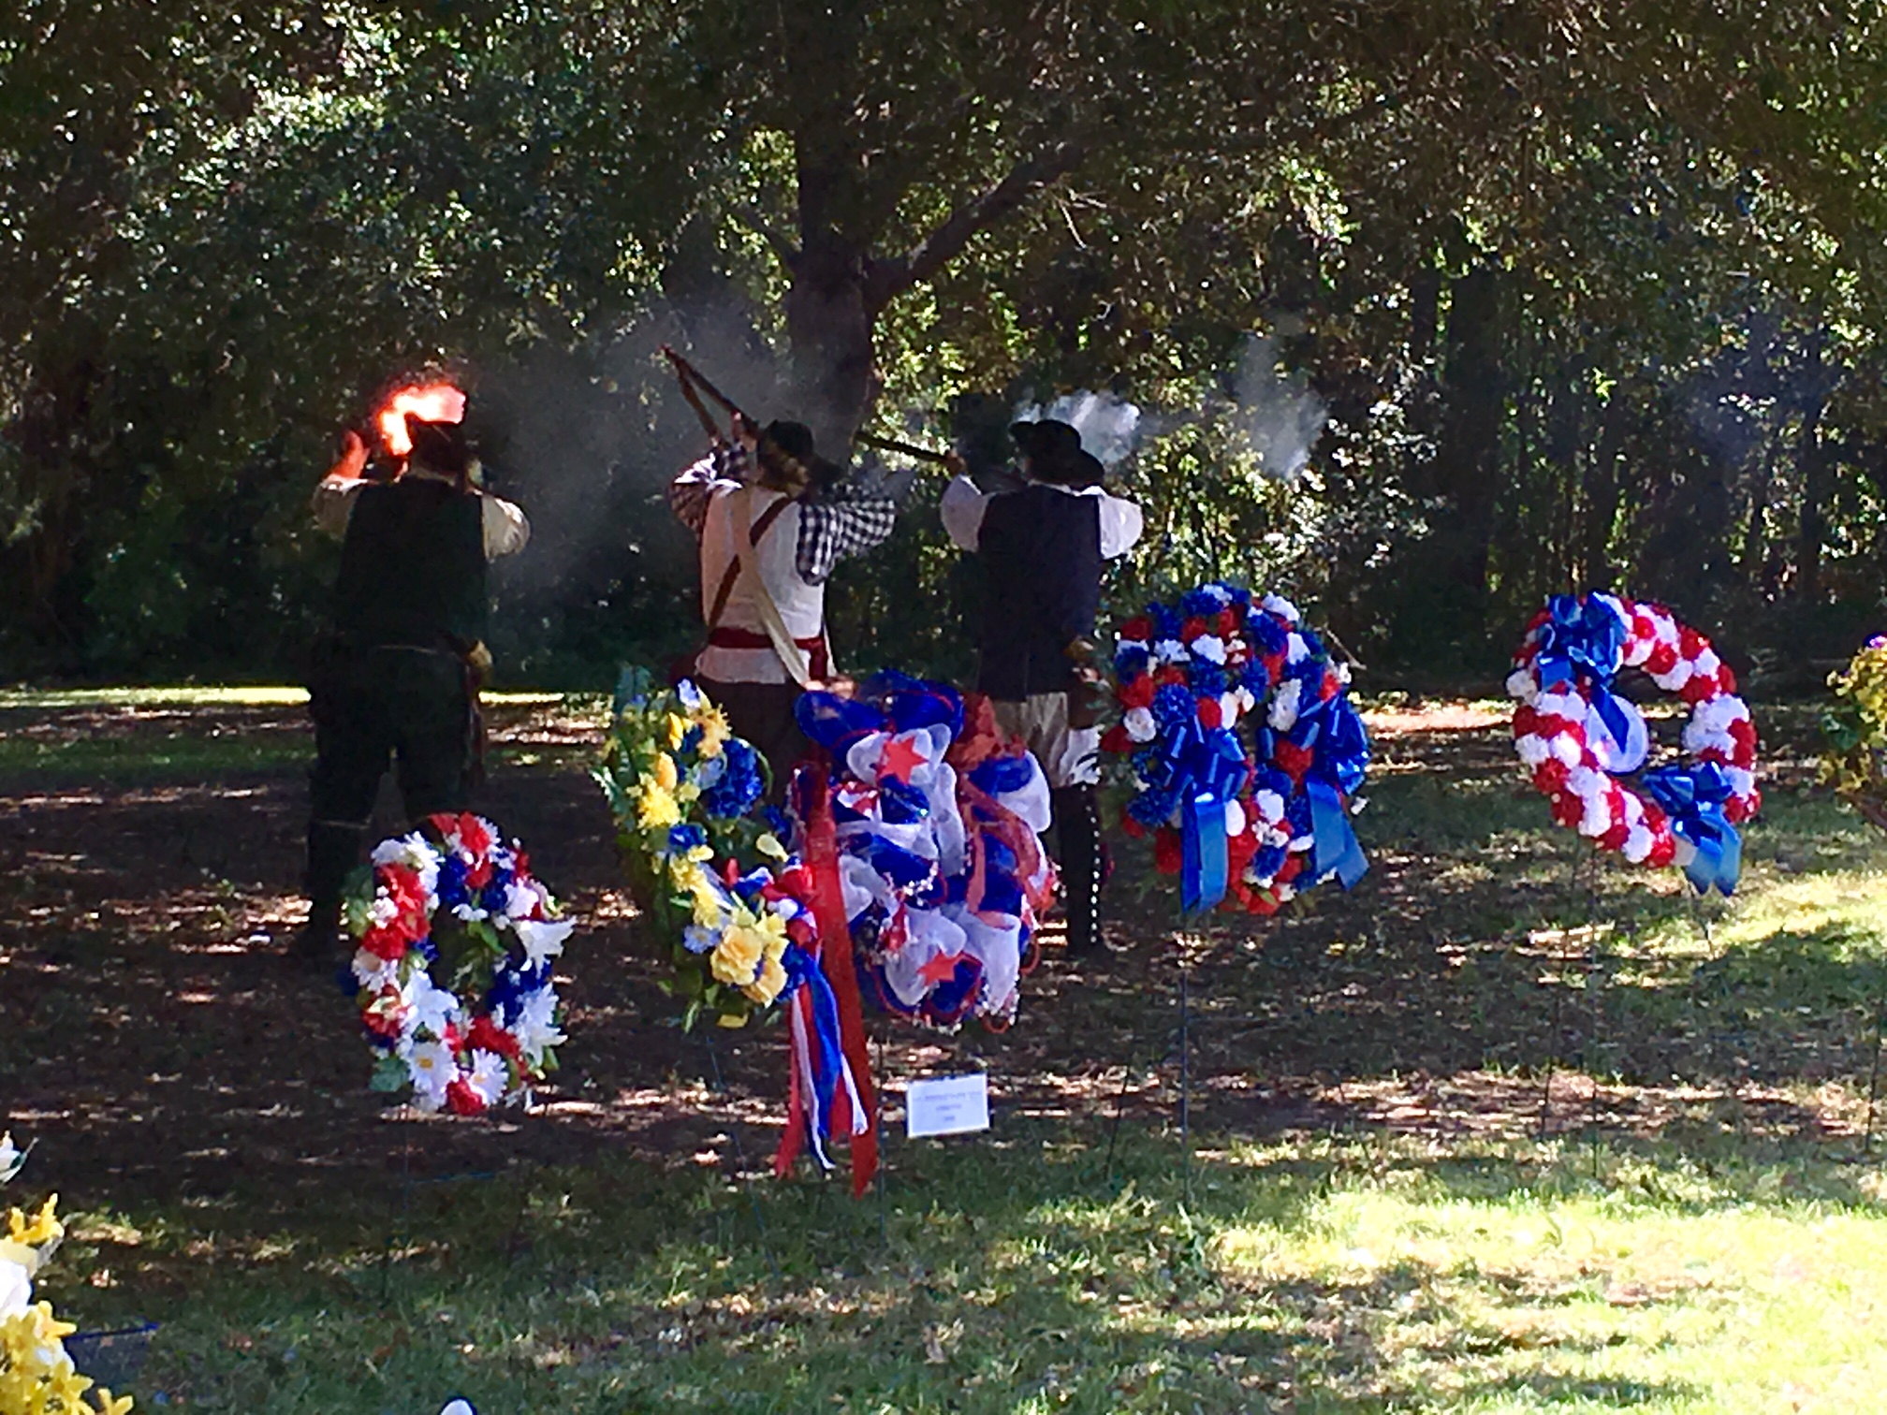
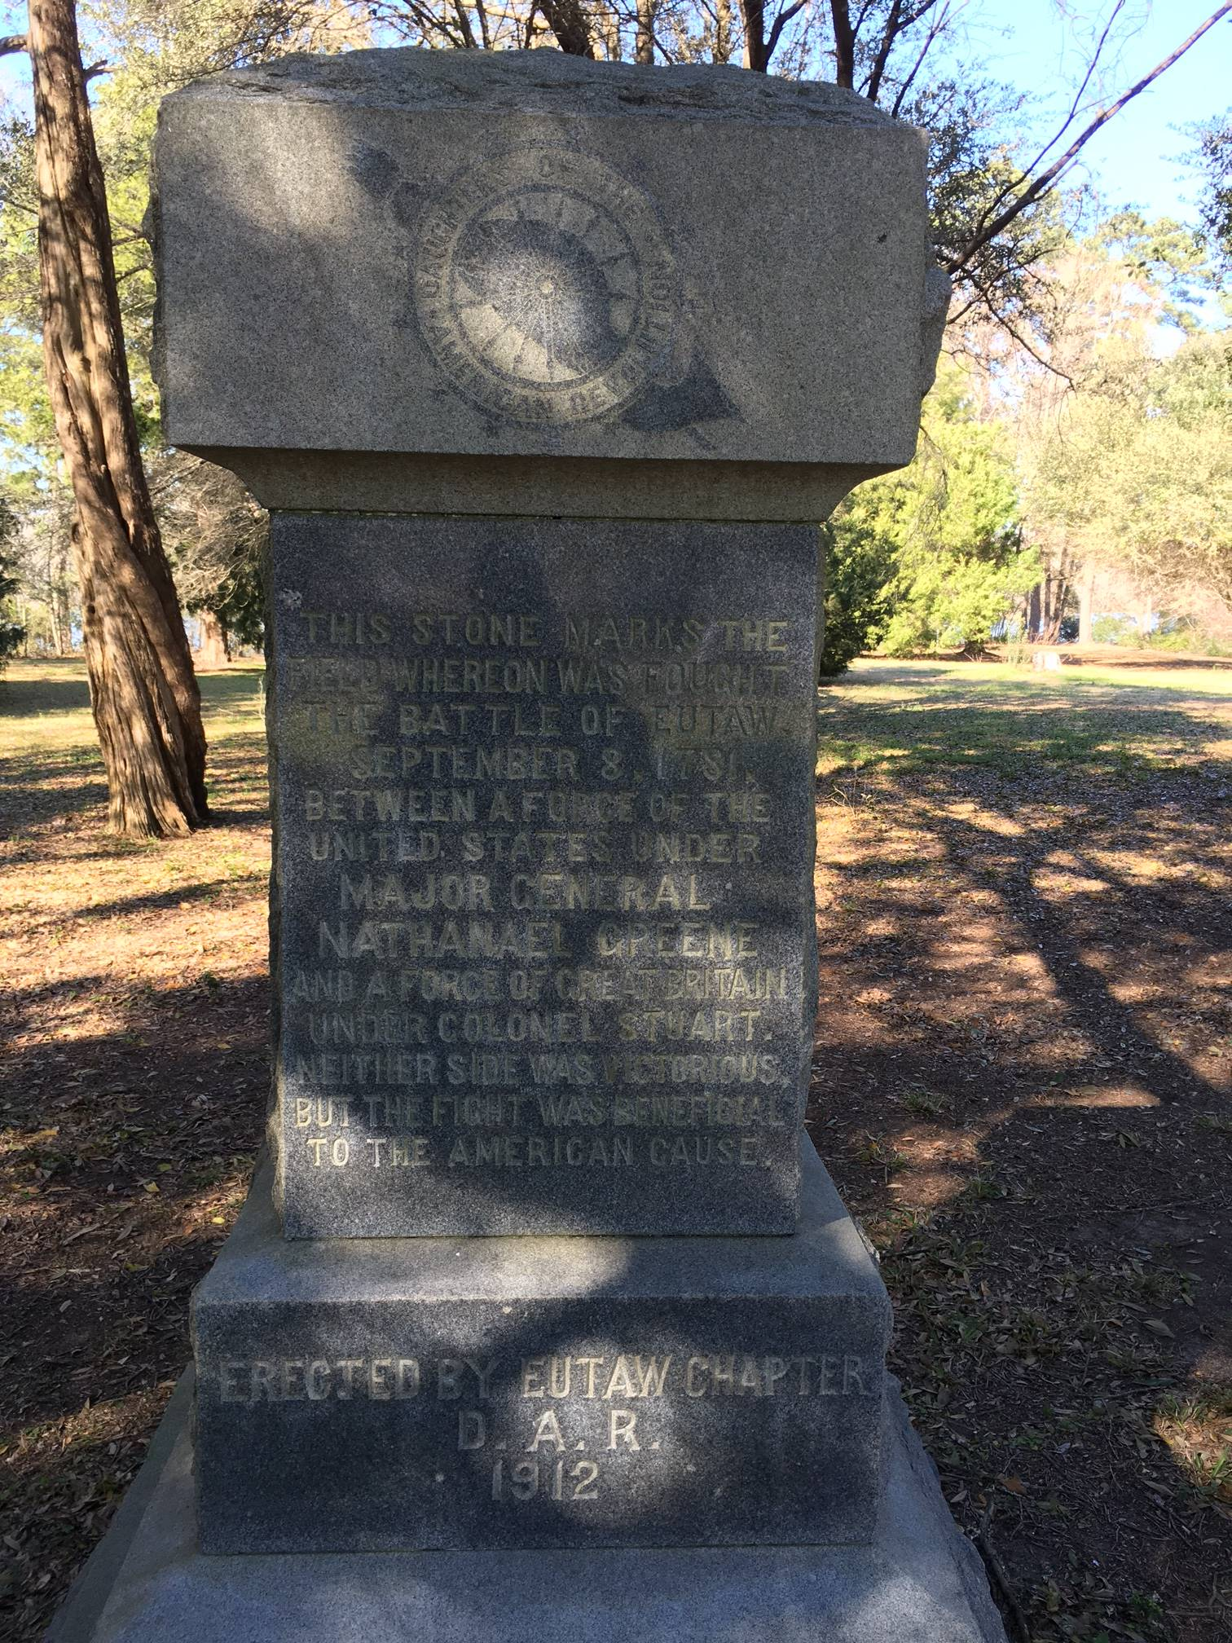
At the conclusion of the 235th Anniversary, everyone in attendance received if representing chapters/societies, a flag ribbon commemorating the anniversary of the battle. The sixteen children and senior leaders from CAR also received a commemoration for their attendance. I represented Hilton Head Is.
Lunch at the famous Sweatman’s BBQ was the last stop on the day’s agenda. Doug Doster did a superb job in organizing this event, the 15th year his local chapter has scheduled it. A large room was reserved for all those that completed the day with fellowship and socializing at lunch.
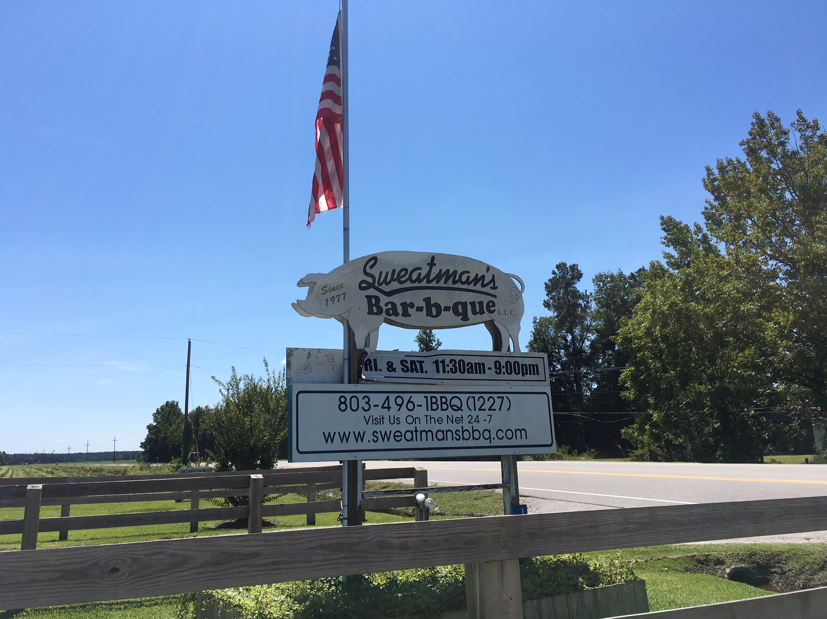

A Special Message
From the Editor
The South Carolina Society of the Sons of the Revolution have several “irons in the fire” at the time of this writing.
First, this month of September will see the following additions:
- The transfer of a new member, John Fitzgerald, from the GA Society SR. John is currently living in Charleston with his family. He is Vice President -TD Wealth. His father and grandfather were/are members of GSSR.
- The creation of a web site for the SC SR. Under construction during this month, but operational in October, the site is the creation of our compatriot member, Sam Whatley, Jr. Sam was awarded an Eagle Scout Award from SCSR for his web site, a walking tour in Charleston, SC. The web site www.srsc1776.org is similar to the GSSR site www.sr1776.org.
- There is a movement from our members in the Charleston and the coastal region, to investigate a chapter (our first) with a new charter in that area.
- Finally, a planning committee of members in Charleston have submitted a letter of interest to GSSR Board of Managers, SCSR wants to host the GSSR Board in October, 2017. A RFP has been submitted with the Charleston CVB.

