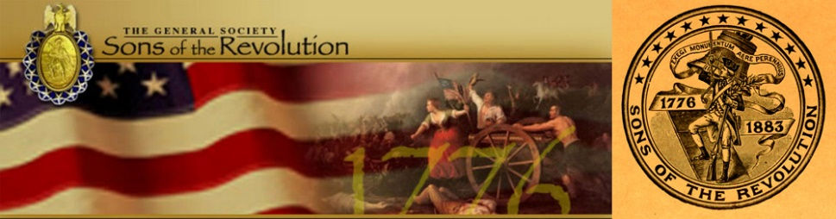
In The State of South Carolina

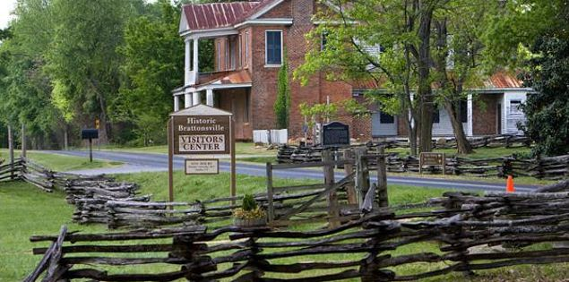

South Carolina Society Sons of the Revolution
Special Meeting
(Membership Invited)
Where: Historic Brattonsville Visitor Center (Route 221)
When: Saturday July 15, 2017 (1:00-3:00 Visitor Center House, 2nd Floor)
This special meeting for the purpose of planning the South Carolina Society function (role and responsibility) during the GSSR Board of Managers Meeting at the Francis Marion Hotel, Charleston, SC (9/28-10/1).
The registration and agenda information is located on the South Carolina Society Sons of the Revolution website on the Membership Page www.srsc1776.org
SRSC will participate in the July 15 Wreath Laying at Hucks Defeat in Historic Brattonsville beginning at 10:00 am. The wreath laying is scheduled for 11:00 am. Members will partake of the concession at the park before proceeding to the Visitor Center for our Special Board Meeting.
The battle of Huck’s Defeat at Williamson’s Plantation pitted Captain Christian Huck (Philadelphia Loyalist) on a mission to rid the country of rebels, against Col. William Bratton, a “rebel”. On July 12, 1780 with a recent win for the Patriots at Kings Mountain, Cols. Bratton, Andrew Neel, William Hill and Edward Lacy, surprised the Loyalist at day break. Col. Bratton with 100 militia defeated the Loyalist with one death for the Patriots and estimate of 25-50 deaths for the Loyalists, Captain Huck among them. Twenty five Loyalist escaped the battle.
In 2002, Brattonsville was selected as the site for a portion of “The Patriot” movie starring Mel Gibson.
Please join us for this historic battle site, the commemoration of the July 12, 1780 battle and the discussion of the SRSC hosting the Fall GSSR BOM.
Agenda
Welcome- President Ivan Bennett
Invocation- Tom Weidner, Regional VP Upstate
Pledge of Allegiance- Charles Swoope, Immediate Past President
Treasurer Report- Ivan Bennett f/ John Fitzgerald
Secretary Report- Ivan Bennett, Secretary
Registrar Report- Charles Swoope, Registrar
- State # 303 Bradley Hudson (Transfer) $25 Processing Fee 7/1/17
- Genealogist Prospects
The Crescent Moon Newsletter Report- Ivan Bennett, Editor
SCSR Website (www.srsc1776.org) Report- Ivan Bennett f/ Samuel Whatley
Regional VP Reports-Tom Weidner, Upstate Region
New Business
- GSSR BOM September 28-October 1 Roles and Responsibilities of Members
- Registration September 28-29
- GSSR Business Meetings
- GSSR Receptions
- GSSR Banquet
- SRSC Hospitality Suite
- SRSC Budget: Registration Goodie Bags (@3.75) Labels (@$1.00); SC Wedgewood Plates Gifts ($92 Pd); Program for Banquet $TBA
- Speaker for Friday Session Guests and Spouses $250 and Keynote Speaker for Saturday Banquet (Blacktie) $250
- Hospitality Suite Setups and Booze $TBA
- Saturday Reception Toast (Etched Glasses Pd by GSSR) Swamp Fox
- Sponsors? Of Speaker Events e.g. New York Life or TD Bank or others?
- Current Accounting of Room Reservations and Registration- Ivan
Old Business
- Membership into Palmetto Society of Charleston and Participation in Annual June 28 Carolina Day
- Plan TBA Social in Charleston c/o John FitzGerald for prospective members and friends in the interest of forming a Chapter in Charleston
- Articles for monthly issue of The Crescent Moon (August: Hucks Defeat Brattonsville Wreath Laying and SRSC Board Special Meeting)
- Suggestions for www.srsc1776.org website
- Annual Membership Meeting November 4, 2017 at Camden Archives and Museum, Camden, SC (Dues, Elections, comply with By Laws)
- Other Events for remaining 6 months in 2017: Revolution War (Aaron Bradford) at Morris History Center, Ridgeland, SC- Mike Kelley, Battle Eutaw Springs 9/8-9 Ivan Bennett and Mike Kelley, Kings Mountain October, Special Meeting and Winter Social in Simpsonville at Museum of Rev War TBA
- Next Meeting Date- TBA

Adjourn
