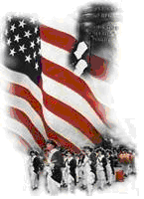 | The Crescent Moon  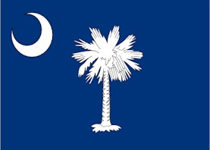
Spring Issue Number 17 | A publication of the Sons of the Revolution  In the State of South Carolina | April 3, 2017
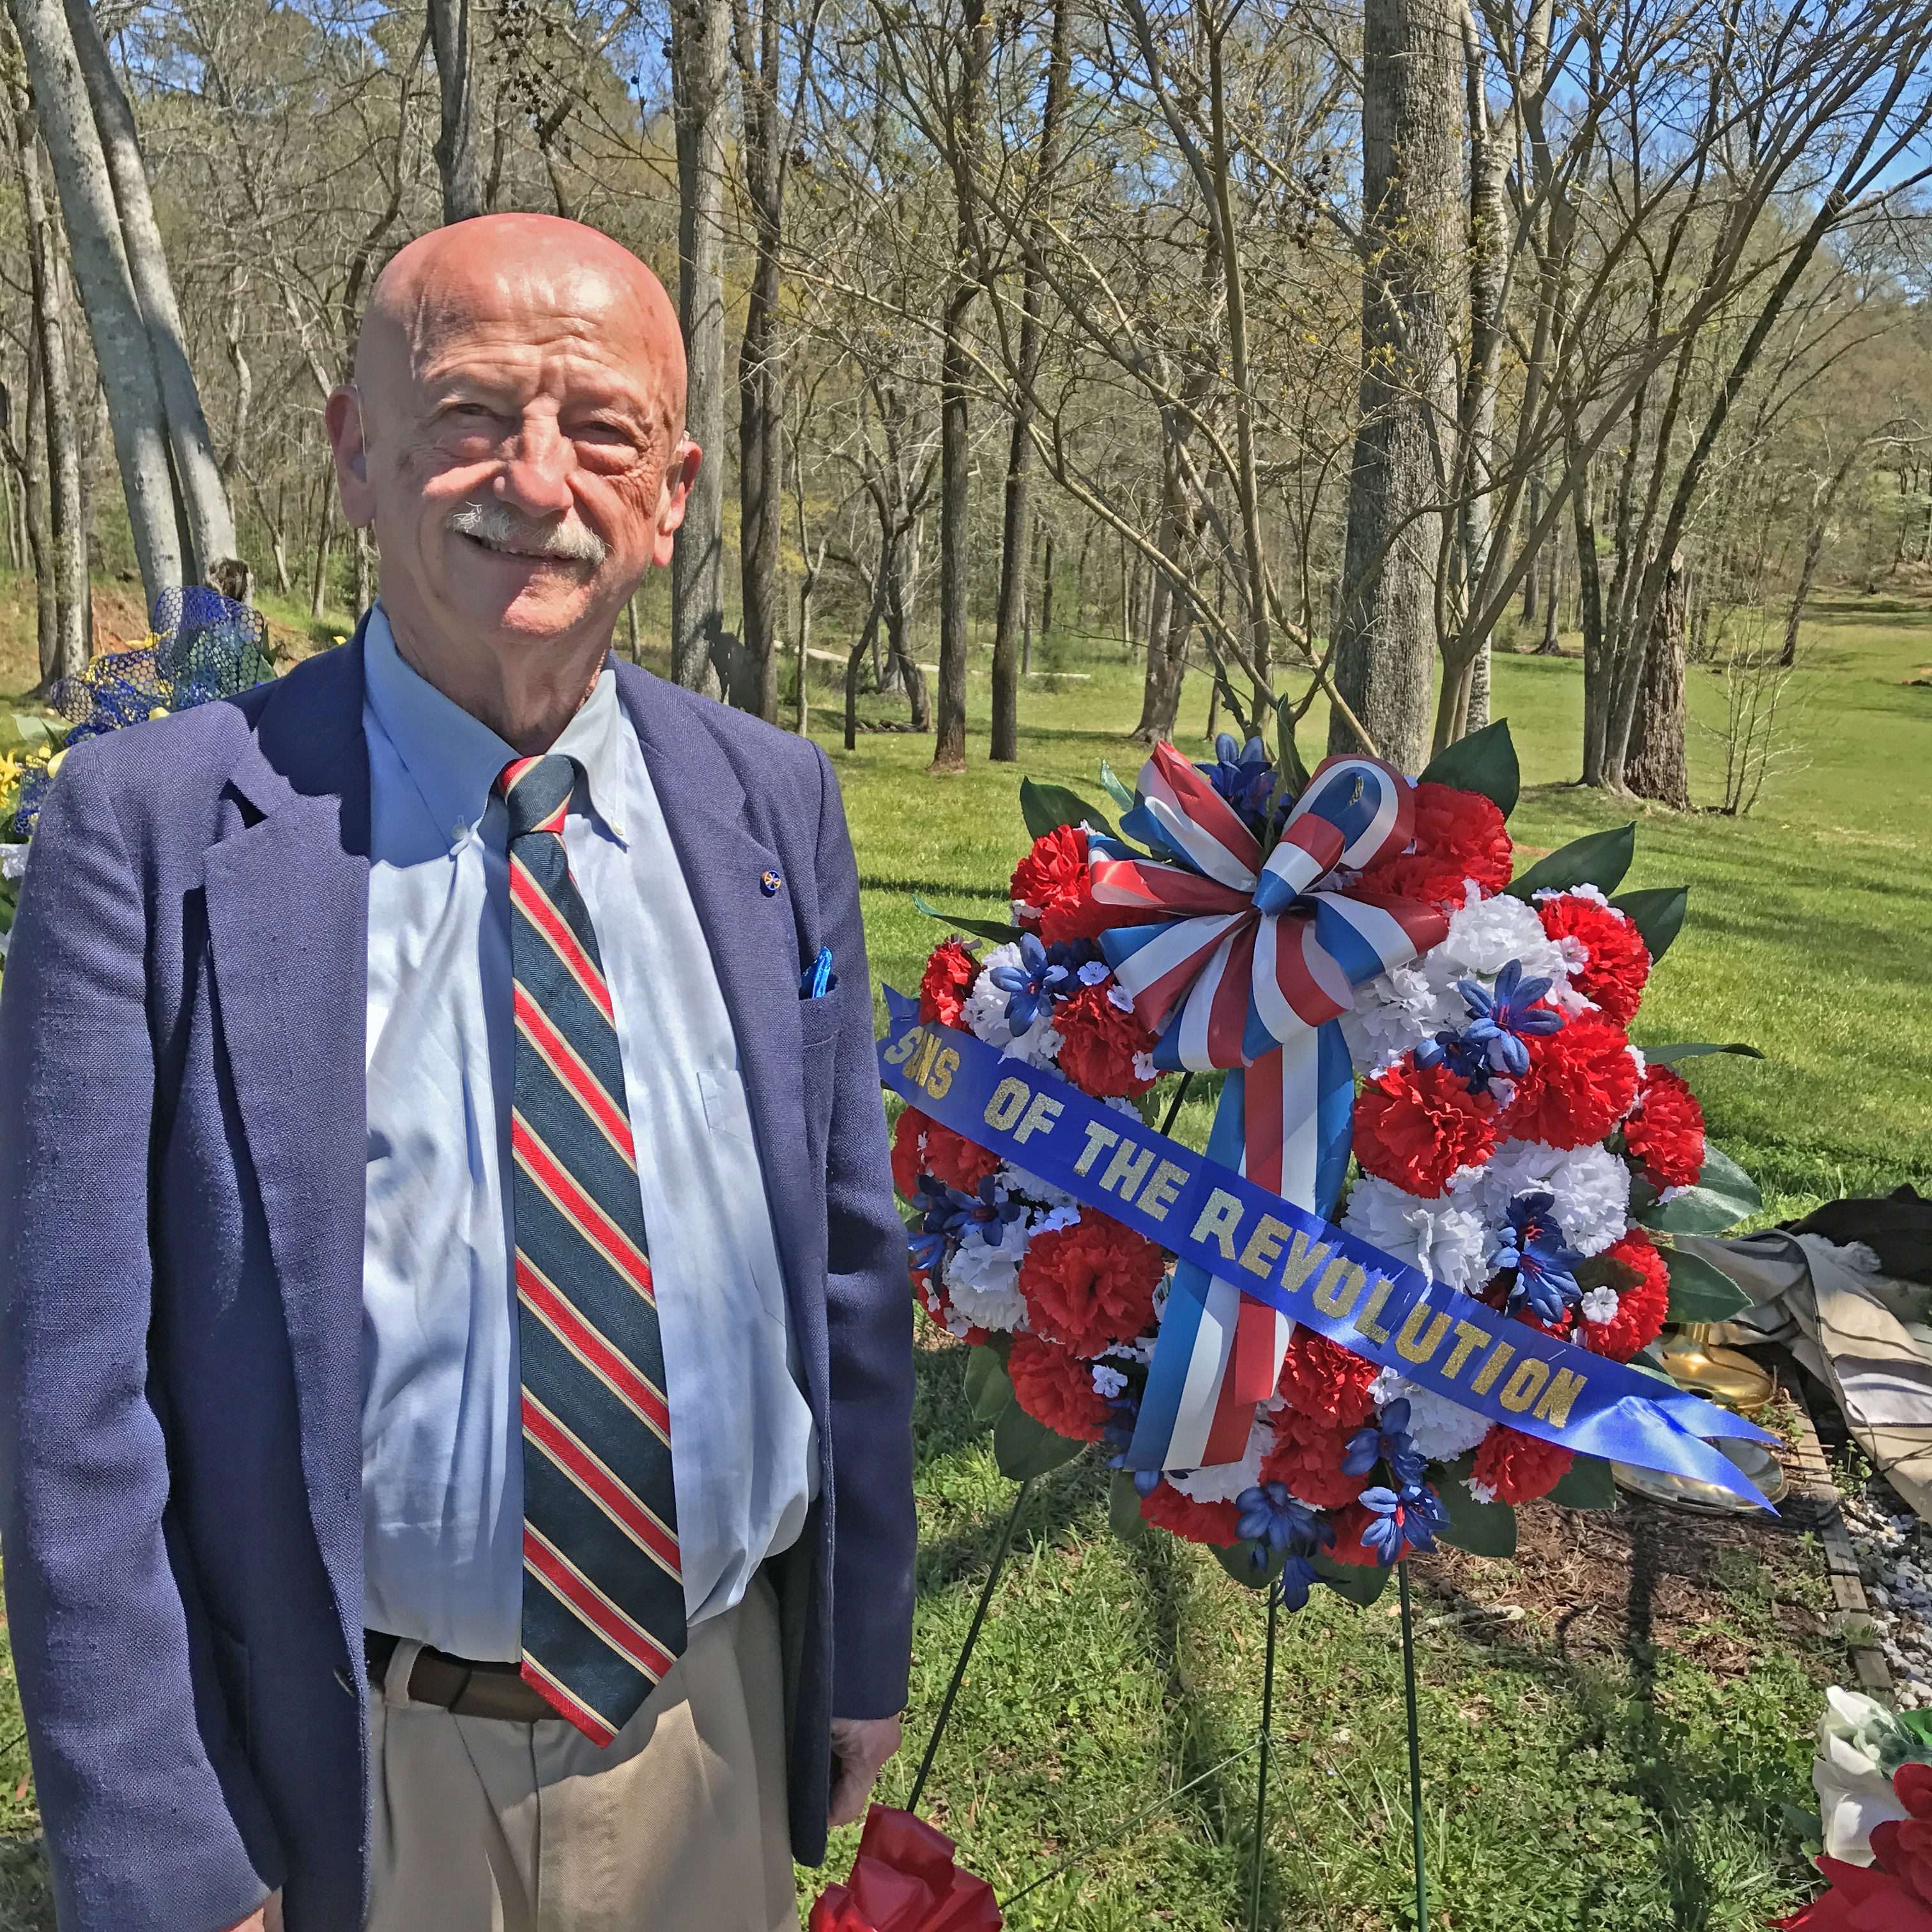

Ninety Six National Historic Site
Ninety Six, South Carolina
April 1, 2017

The South Carolina Society of the Sons of the Revolution were represented by Tom Weidner, SRSC VP Up State on April 1. The ceremony was very well attended by local SAR, DAR and the National Park Service for the annual wreath laying at the Private James Birmingham Monument. Private Birmingham was the first patriot to fall in the American Revolution War Southern Campaign.
In the photo Tom poses next to his SRSC Up State Wreath under a beautiful sunny and clear day last Saturday.
The Society is very grateful to Tom for being able to represent SRSC
in the program for the festivities that weekend of April 1 and April 2.
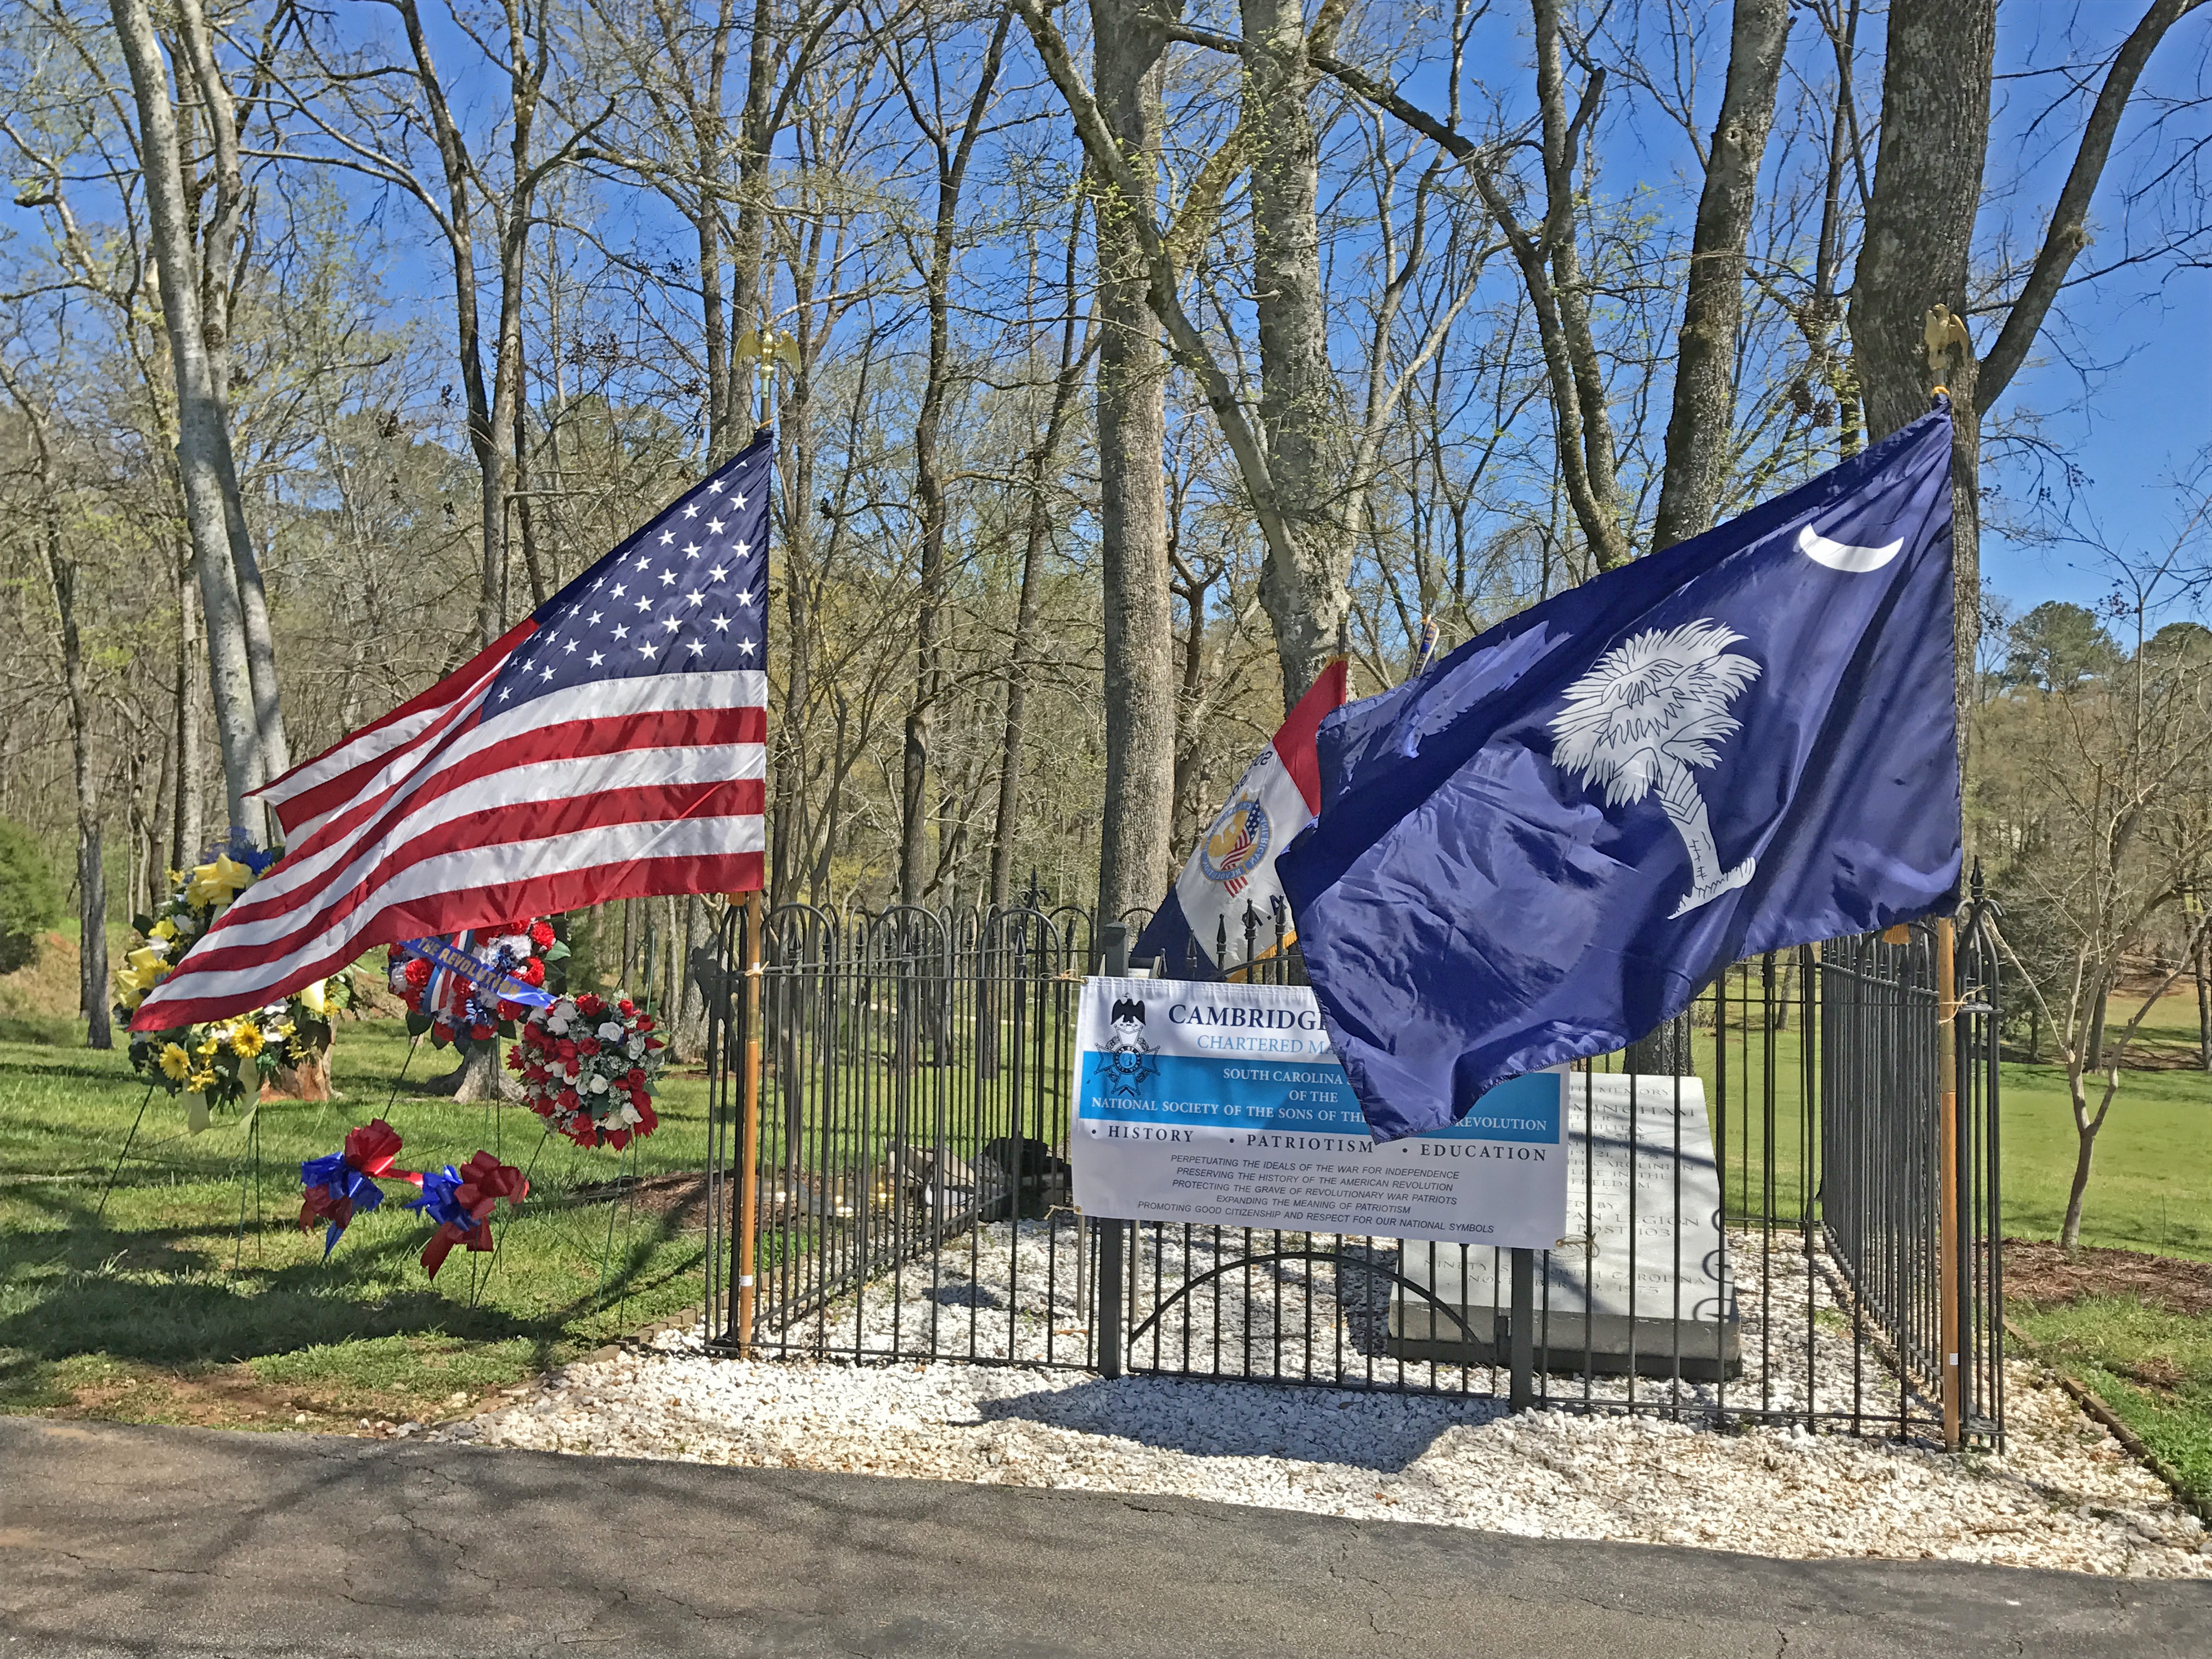

A Special Message from the President
On Thursday, March 30, 2017, it was my distinct pleasure to represent the South Carolina Society of the Sons of the Revolution at the American Revolution Museum at Yorktown (VA) Grand Opening Celebration. The day was South Carolina Day.
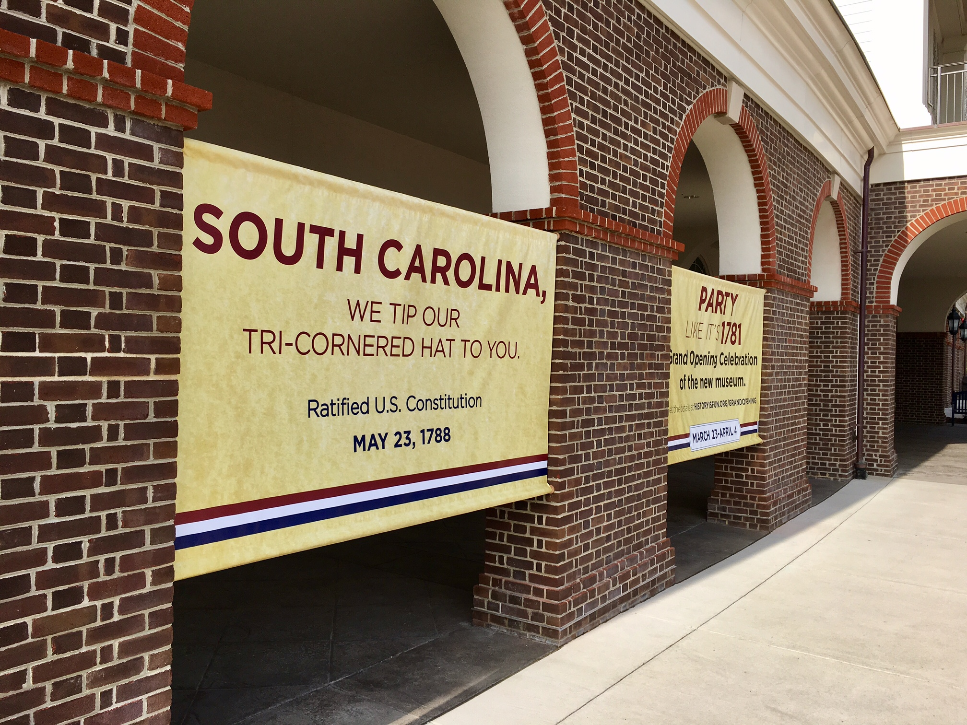
I arrived early in the morning and parked in a full parking lot of cars and eight tour buses of school age children on a patriotic field trip to a premier Revolutionary War Museum. Inside I was greeted by GSSR Executive Director Jeff Lambert who ushered me to the GSSR/SRSC Table at the head of the long hall of time lines for the 26 years from one Treaty French and Indian War to the Revolutionary War Treaty in 1783. There I met Assistant Ex. Dir. Tony Riva. Each of the 13 days of celebrating a state in order of approving the Constitution had a placard card with the history of the state and on the back, a list of the planned and organized welcoming ceremony and afternoon activities. In addition each evening was scheduled a relevant speaker.
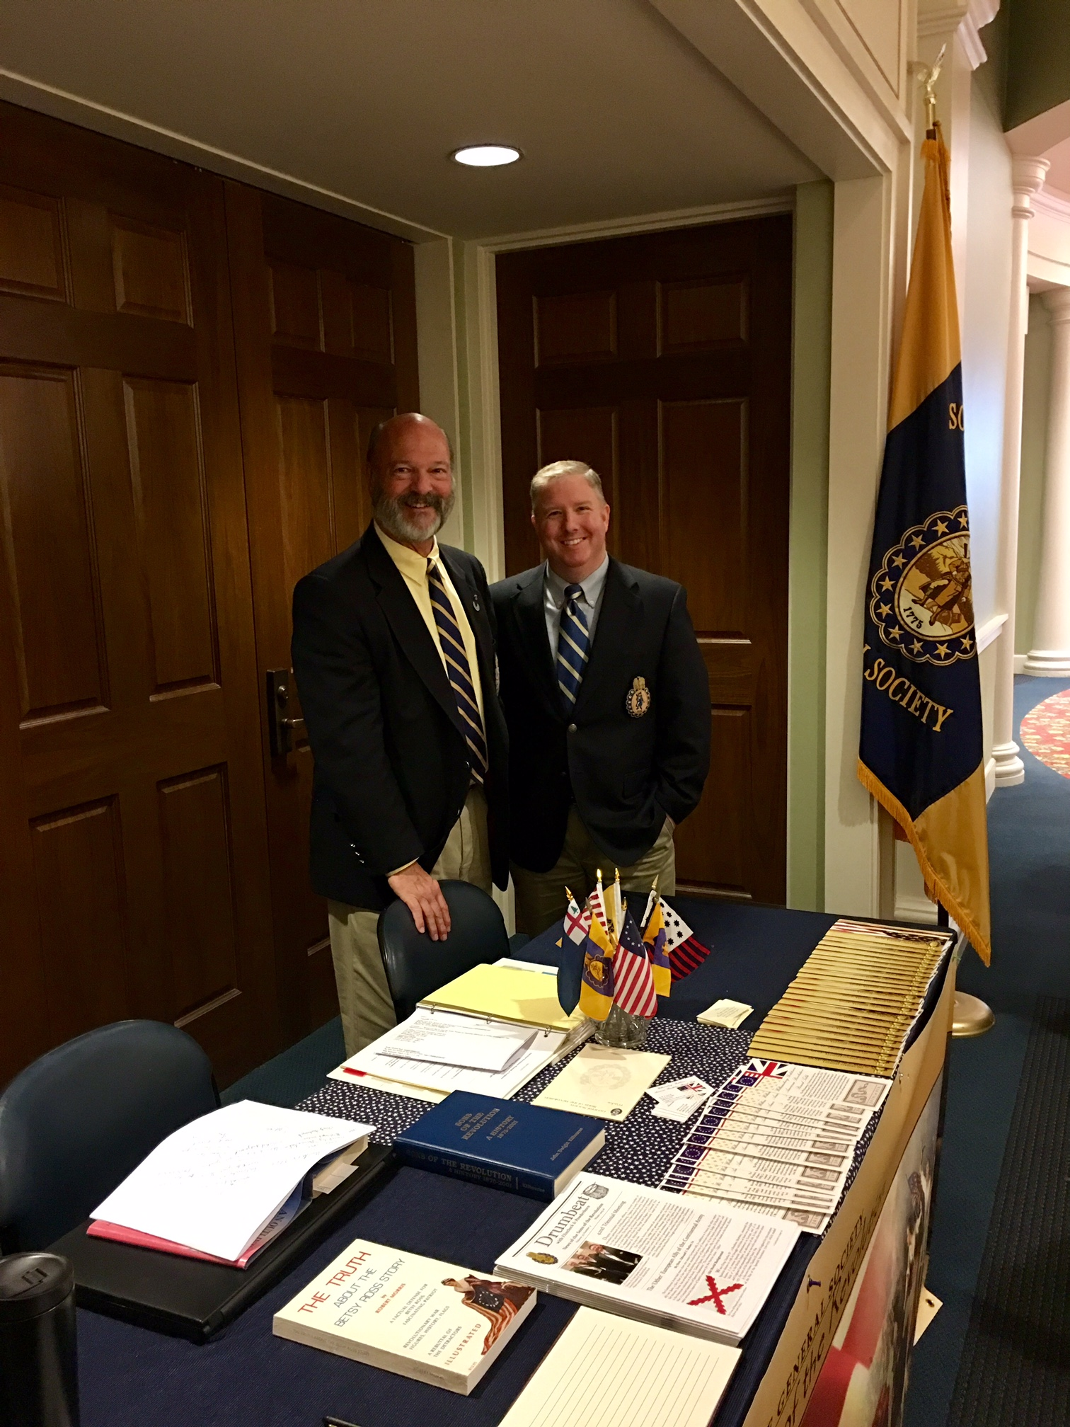
I continued to be their center of attention along with state representatives from SC for DAR, Colonial Dames and Heritage Society. I was introduced to Directors of the ARMY Museum. Mrs. Julie Basic, Director of Development, personally gave our group of 10 a personal tour of the Exhibition Galleries and an introductory film, Liberty Fever in the museum theater that if you are in the first two rows the IMAX effect is three dimensional with a water spray from the York River/Atlantic Ocean Naval Battle!
Next on the schedule was a distinguished list of presenters and dignitaries welcoming the est.50-60 SC residents in the audience? This occurred outside in the Artillery Amphitheater. The SC flag was rolled out and hoisted on a flag pole for the day.
The Color Guard from Greenville, SC and two students at the Greenville Charter School reciting the Constitution were a hit with the crowd! “Awesome” Tony Riva
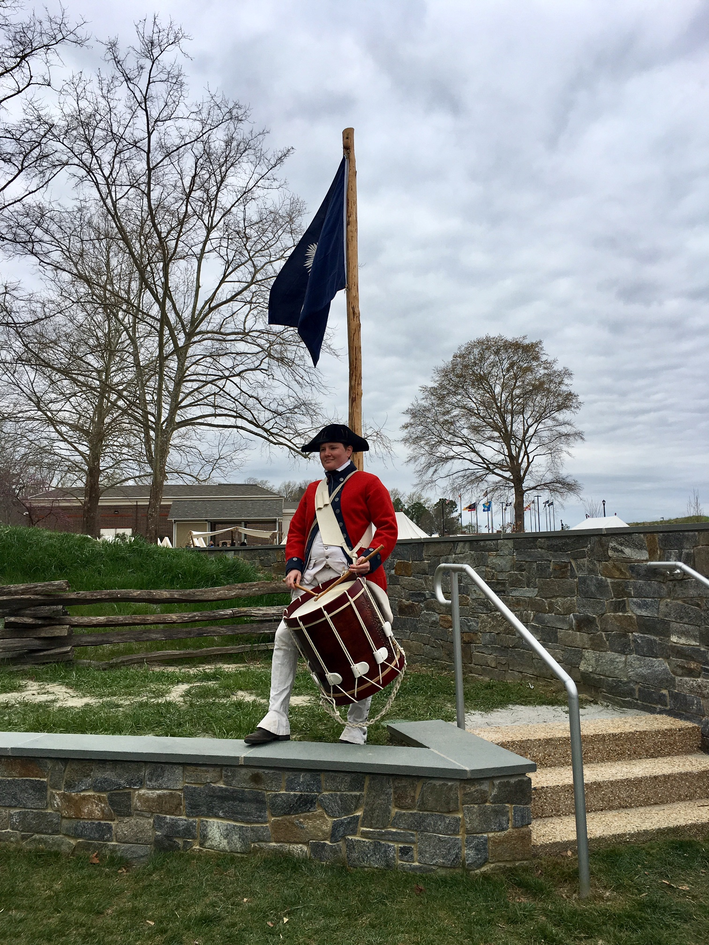
After lunch, many of the state representatives and state tourists attended a panel presentation in the Education Center Classrooms. Each panelist brought a display.
Members of the Panel included: Robert Dunkerly, National Park Service Historian, (Richmond, VA) Tray Dunaway, Historic Camden Foundation (Camden) Doug McIntyre Thomson Park Sullivan Island (Charleston) and David Reuwer, Southern Campaigns of the American Revolution (Camden).
The topics were fascinating:
1775-1776 Loyalists and Whigs 1777-1779 Archives, Archeology and Anecdotes 1780- 1781 Battles, Bravado and Blood 1781- 1782 Internecine Hatred and Isaac Hayne
But the day wasn’t over at 5:00 at the completion of the Panel. A reception on the Mezzanine overlooking the York River and the Circle of 13 Colony Flags was available for the representative and guest speakers from that day. The event was sponsored by your South Carolina Society, with a small donation to the Williamsburg Yorktown American Revolution Round Table.
The evening speaker was John “Jack” Buchanan, Author and Historian presented “Partisan War in the Carolinas”.
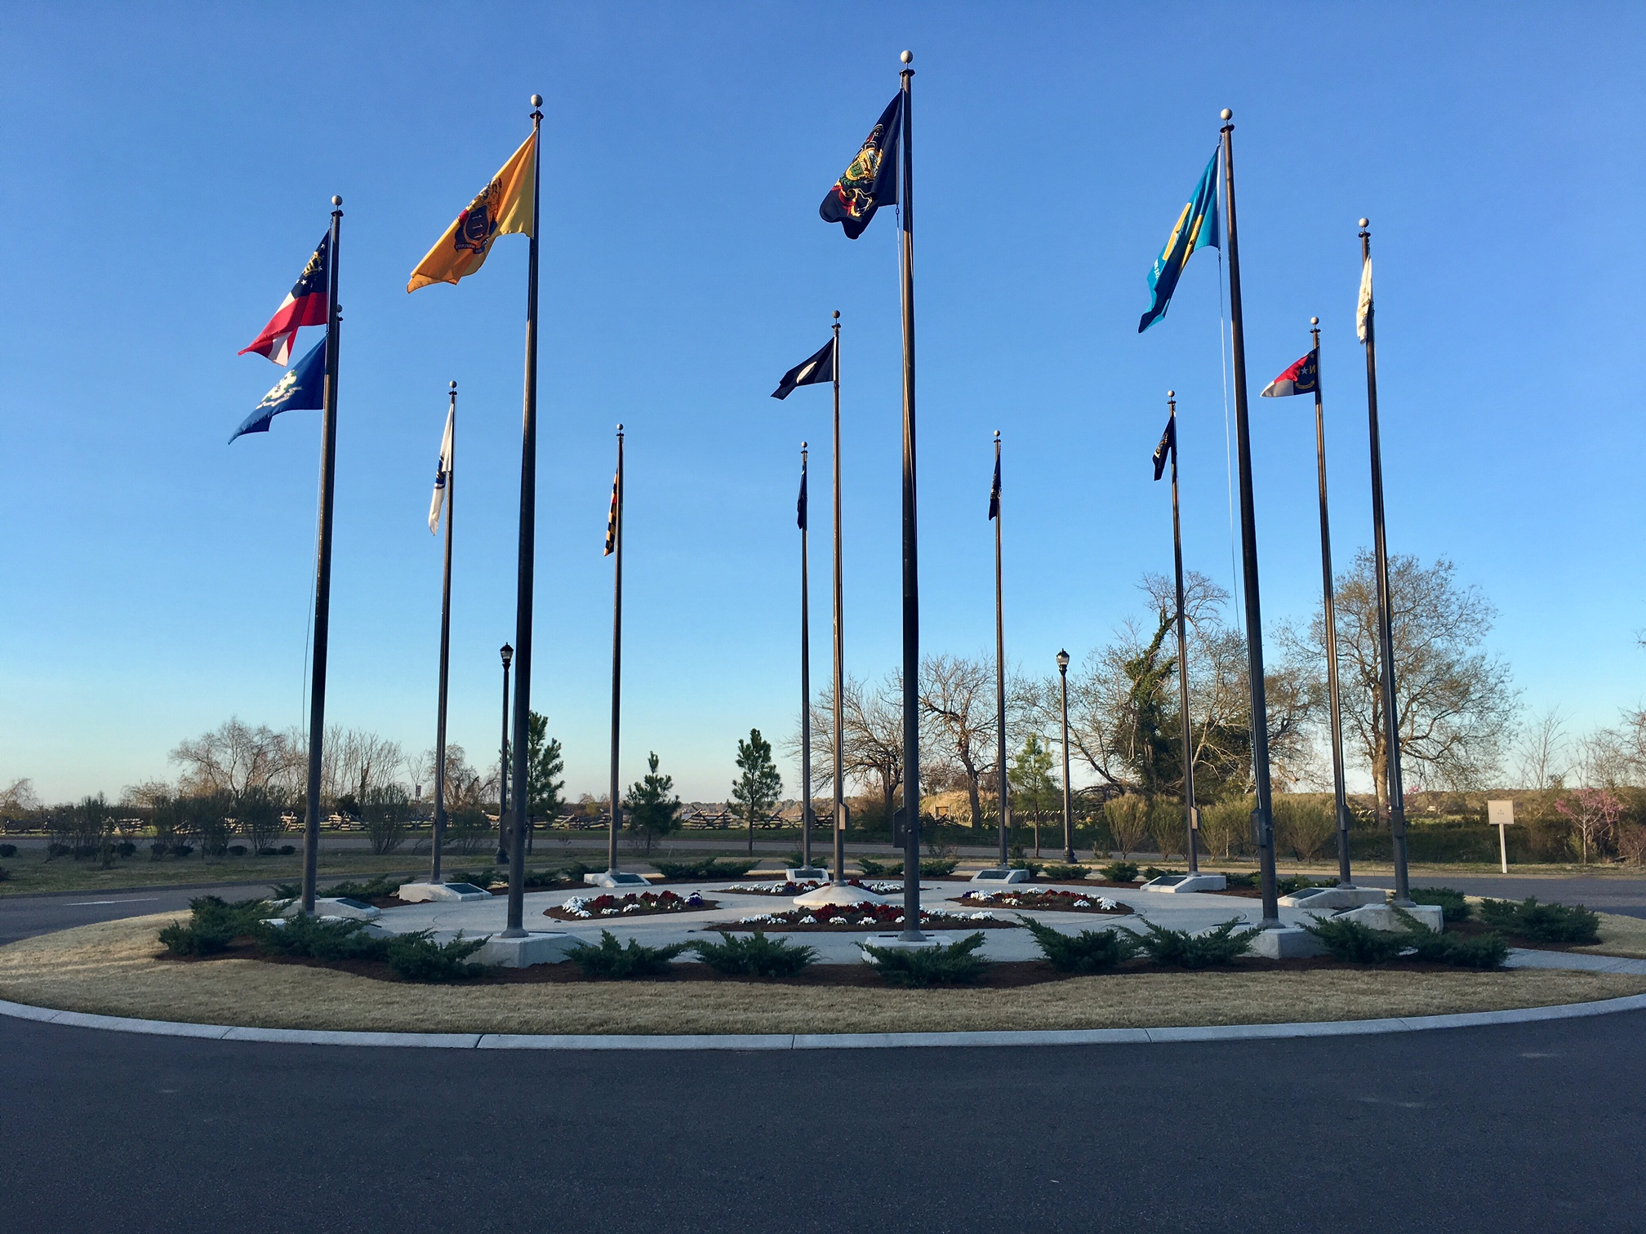
I could not let the moment go by without a photo with our General Society of the Sons of the Revolution, President Mitchell Bush.
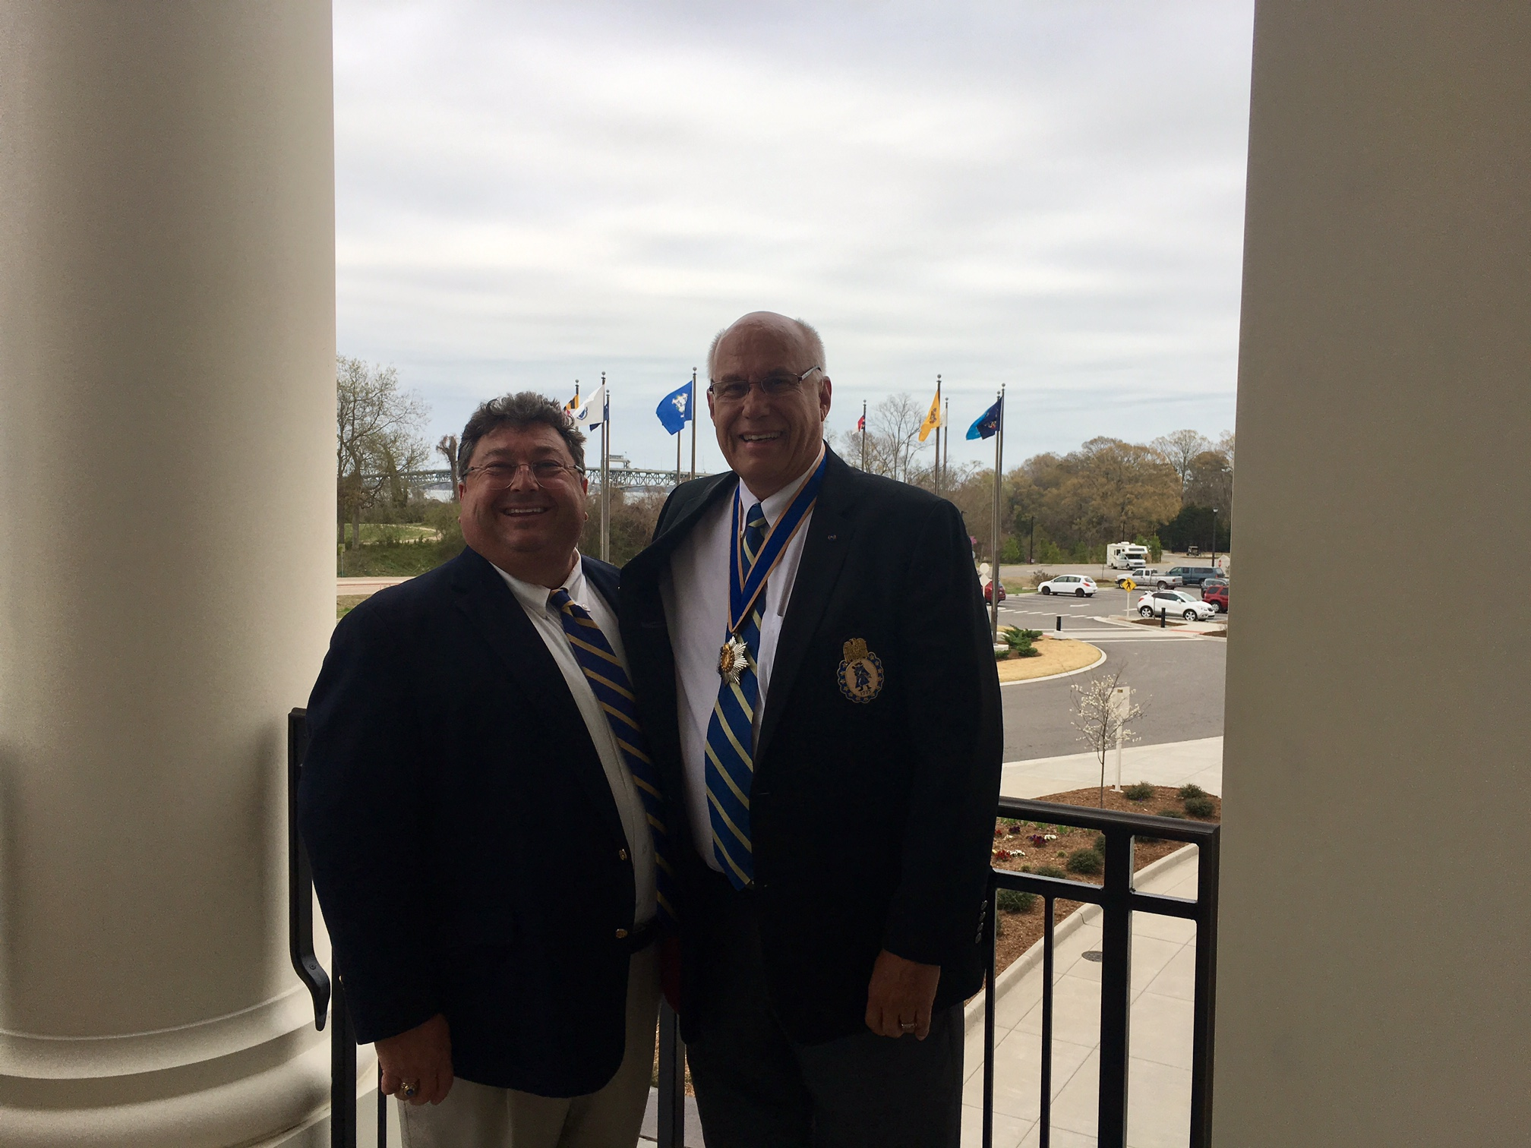
I sincerely thank the GSSR Headquarter staff in Williamsburg for their royal treatment of me and for our Society that day of March 30, 2017. It was a moment in my tenure that I will never forget. Thank you!
Update on the Progress of SRSC Hosting the GSSR Board of Managers

The GSSR Planning Committee for Triennials and Board of Managers has been very busy communicating to each other on the details of the September 28-October 1 BOM at the Francis Marion Hotel in Charleston, SC. There has been three revisions to the Meeting Registration and Agenda forms that will be rolled out in the Drumbeat. Recently the deadline of paying the deposit to the hotel was met, so it is time to confirm the schedule of activities outside of the daily executive committee and business meetings. The BOM Meeting delegates and guests will be excited to learn of the plans for the three day three night event in Charleston, SC.

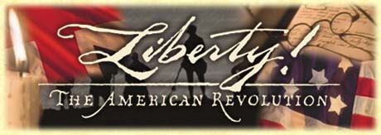

Events to Plan On
April 19 Grand Opening of the MOAR: Museum of the American Revolution in Philadelphia, PA
April 29 Battle of Fort Watson 236th Anniversary Commemoration (Santee National Wildlife Refuge)
May29 Memorial Day Remembering!
September 9 Battle of Eutaw Springs 236th Anniversary- will begin with a patriotic service at the Church of the Epiphany in Eutawville followed by wreath laying ceremony at the battle monument site. Lunch at Sweatman’s
September 28-October 1 SRSC Hosting of the GSSR Board of Managers at the Francis Marion Hotel. We need the participation of all members of the State Society.



