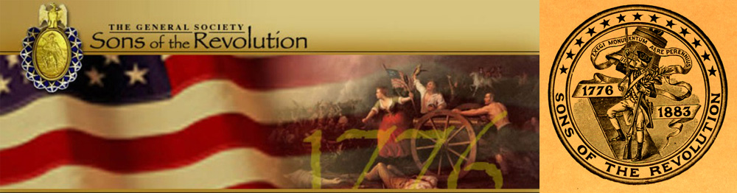
In The State of South Carolina

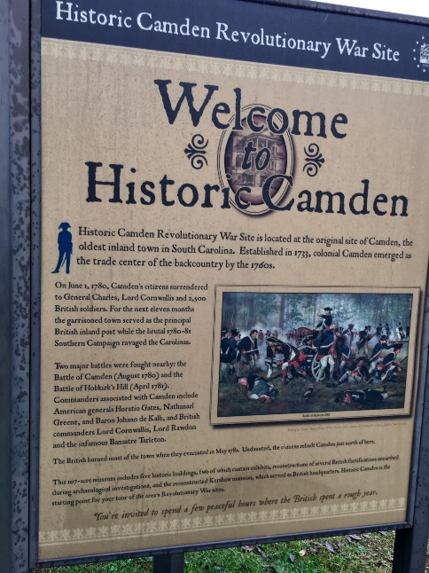

South Carolina Society Sons of the Revolution
Board of Managers Meeting
(Membership Invited)
November 5, 2016
Camden Archives and Museum 1314 Broad Street Camden, South Carolina
Whitlee Room 1:00- 3:00 pm
Meal to Follow (Hosted by the SCSR)

Agenda
Welcome- President Ivan Bennett
- Presentation of Awards
(Award of Merit and Certificate of Appreciation)
Invocation- Samuel T. Whatley, Chaplain
Pledge of Allegiance- Charles Swoope, Immediate Past President
Treasurer Report- Charles Swoope, Interim Treasurer
Secretary Report- Ivan Bennett, Secretary
Registrar Report- Charles Swoope, Registrar
- Membership Proposal- John Fitzgerald (Transfer to SC from GA)
(Requires Approval of the Board of Managers)
The Crescent Moon Newsletter Report- Ivan Bennett, Editor
SCSR Website (www.srsc1776.org) Report- Samuel Whatley II, Webmaster
Introductions of New Officers 2017-2018
- Society Vice President/ Treasurer- John Fitzgerald
- Regional Vice Presidents-
Upper State: Dr. Tom Weidner, Greenville, SC
Mid State: (TBA 2018) Samuel Reid, Jr. Esq., Orangeville, SC
Coastal State: Dr. Samuel Whatley, Charleston, SC
New Business
- Treasury Account (Currently at First Citizen, Columbia, SC)
Name on the Account- Reddick Bowman, Jr. Esq. (2001 President)
Signature on the Account- Charles Swoope (Interim Treasurer)
- Draft 2017 Society Budget
- Status of the SCSR Charter (unable to locate)
- Status to GSSR, “Sons of the Revolution in the State of South Carolina” approved by the GSSR BOM as a rightful organization and member of General Society of the Sons of the Revolution
- Proposal of SCSR By-Laws and Rules
- Application and update of IRS 501 C 3 (Prior to 2006, SCSR not required to submit tax returns whereas it made less than $1000/after 2006 new IRS law, whereas SCSR is required to register and file a post card return)- Not performed for the last 3 years and currently SCSR not recognized i.e. with the US Dept. of Revenue. The SC Sec of State does show SCSR active and the SC Dept. of Revenue also shows SCSR active
- Refile a new charter with the SC Sec. of State and reinstate SCSR with the US Dept. of Revenue (Immediate Past President Chuck Swoope is in communications with leadership from NCSR to assist with this issue)
- Proposal 2017 SCSR Dues (currently $40, propose raise to $45)- Process of notifying membership via email and regular mail/ GSSR will send us a roster of members for us to verify and send payment of $17.50/member due early 2017
Announcement and Information
- December 8-9 GSSR Board of Managers Meeting- Valley Forge Radisson (SCSR has submitted a letter of intent to host the 2017 BOM in Charleston, SC)
- Regional Events for balance of 2016 and 2017
- Articles for monthly issue of The Crescent Moon
- Suggestions for www.srsc1776.org website

Transfer of SCSR Flag from IPP Swoope to President Bennett
Next Meeting-Location and Date

