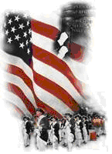 | The Crescent Moon
Fall Issue Number 2 | A publication of the Sons of the Revolution  In the State of South Carolina | December 13, 2015

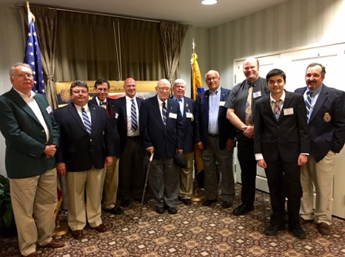
Christmas Social in Charleston, SC
December 11, 2015
~ Hosted by the South Carolina, SR

Left-Right
Member Reddick Bowman, GSSR General President Mitchell Bush, Member Michael Hull, GSSR Executive Director Jeff Lambert, Member Edward
Latimer, SC SR President Chuck Swoope,
SC SR Secretary Ivan Bennett, Member Samuel Whatley and Son, GSSR VP Region 3 and SC SR Treasurer, Jeff Jordan

The annual meeting was well attended at the Holiday Inn, Mt. Pleasant, SC. An attendance of 25 of members, wives, guests and VIPs was a successful gathering of stories and socializing.

Among the VIPs were two from the SC Historical Society, John Tucker and Doug MacIntyre both from Charleston area.
The Mayor of Johnsonville, SC. Steve Dukes, attended as he was invited by Ivan Bennett. Ivan had visited the Mayor the weekend prior for a fact finding purpose in determining how our State Society could assist in the Mayors interest in SR
Signage of his existing monument of General Francis Marion at the Witherspoon Ferry crossing on the Lynches River. Col. Francis Marion was commissioned at this spot on August 17, 1780 by George Washington to a General.
He commanded the Williamsburg Militia. His elusive disappearance after surprise attacks demoralized the enemy earning him the name of “Swamp Fox”. His hideout was on nearby Snow Island.
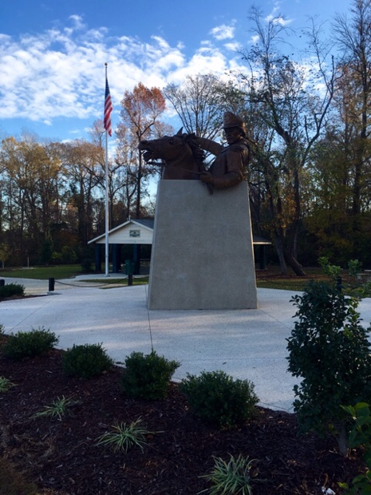
A Special Message from President Chuck Swoope
Fellow Patriots,
Happy New Year! We are concluding a dramatic year in which the world is moving closer to a bitter conflict in a fight for control of what we are to become. We have an election year ahead which we should all participate as free men to voice our support of this great nation. As members of the Sons of the Revolution, we were to perpetuate the memory of our ancestors who gave so much to give us our freedoms.
This new year, we as members of the South Carolina Society, want to share our great tradition of remembrance with our fellow citizens. There are planned programs throughout the year in many local parks and facilities. We need to attend to represent our Society. There are educational programs and local presentations that we can support. You need to let our Society know how we can help. We will offer activities each quarter in the upstate, middle state and lower state in which you can plan and support. Hopefully you will come together with your fellow patriots and recognize the importance of the struggle for freedom our Founding Fathers fought and died for. Help our State Society celebrate the One Hundredth Anniversary of our National Parks in 2016.May the good Lord bless you and keep you until we meet again.
Chuck Swoope, President
South Carolina Events January- July 2016
January 15-17: The 235th Anniversary of the Battle of Cowpens at Chesnee and Spartanburg, SC
Wreath Laying Ceremony by SC SR Representatives at the U.S. Monument Visitors Center Saturday January 16th
10:00 – 11:00 am
April 2-3: Ninety Six Crossroads Event at Ninety Six, SC
July 9-10: The Battle of Hucks Defeat at Brattonsville, SC

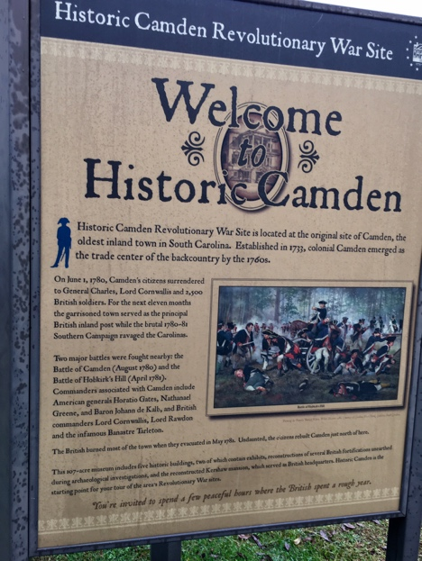

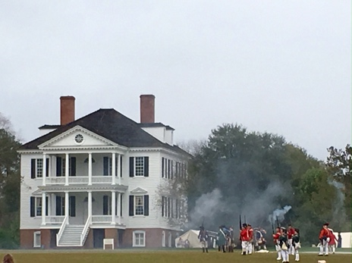

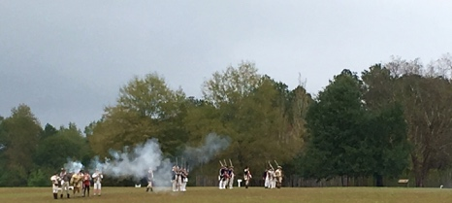

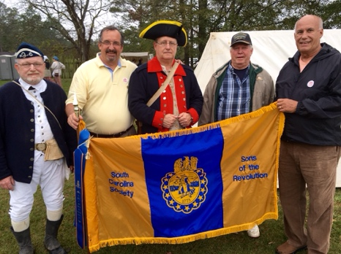

 | The Crescent Moon
Fall Issue Number 2 | A publication of the Sons of the Revolution  In the State of South Carolina | December 13, 2015

November 7-8 2015  Battle of Camden  SC Field Days Weekend  Jeff Jordan  GSSR VP Region 3  SC SR Treasurer  Chuck Swoope  President SC SR  Ivan Bennett  Secretary SC SR  GSSR  SOUTH  CAROLINA  SOCIETY  OFFICERS  CONTACT  INFORMATION  Charles Swoope  President  803-329-3439  Jeff Jordan  Treasurer  Registrar  803-356-4507  Ivan Bennett  Secretary  843-681-3144  843-295-9069 | SS

