state Report

  - South Carolina
January 19, 2016

oUR sTATE sOCIETY OF THE sONS OF THE rEVOLUTION Participated in The 235th Anniversary celebration of the battle of Cowpens
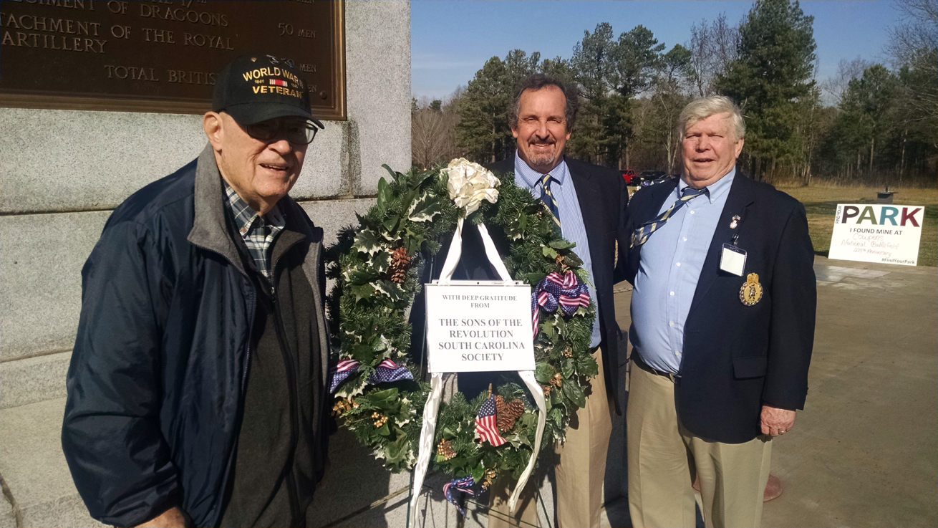
(Left to Right) Ed Latimer, SCSR Vice President, Jeff Jordan, SCSR Treasurer- Registrar, GSSR Vice President Region 3, SCSR President Chuck Swoope and Rev. Dr. Samuel Whatley, SCSR Chaplain (not pictured)

Saturday January 16, 2016
The South Carolina Society of the General Society of the Sons of the Revolution were in attendance at the Wreath Laying Ceremony at the U.S. Monument, Visitors Center, Cowpens National Battlefield. (http://www.nps.gov/cowp/index.htm)
A beautiful memorial wreath presented by SCSR President Chuck Swoope in honor of the momentous Battle of the Cowpens. The sign reads “With Deep Gratitude from The Sons of the Revolution South Carolina Society”
The SCSR has announced their Officers Elected for 2016
President Chuck Swoope
Vice President Edward Latimer
Secretary Ivan Bennett
Treasurer- Registrar Jeff Jordan
Chaplain Rev. Samuel Whatley
Goals for 2016:
To continue recruiting of new members and growing as a state society (2015=5)
To continue efforts to form a new chapter within our state society(CharlestonSC)
To continue efforts to form a state chapter of the Children of the Revolution CAR
To continue participation at our National Parks in South Carolina commemorating the 100th Anniversary of the National Park System in 2016 (Example: April 2-3 Ninety Six Crossroads at Ninety Six, SC)

