state Report

  - South Carolina
The 2020 Spring Quarterly Membership Meeting was held March 14 in Greenville at the UpCountry History Museum

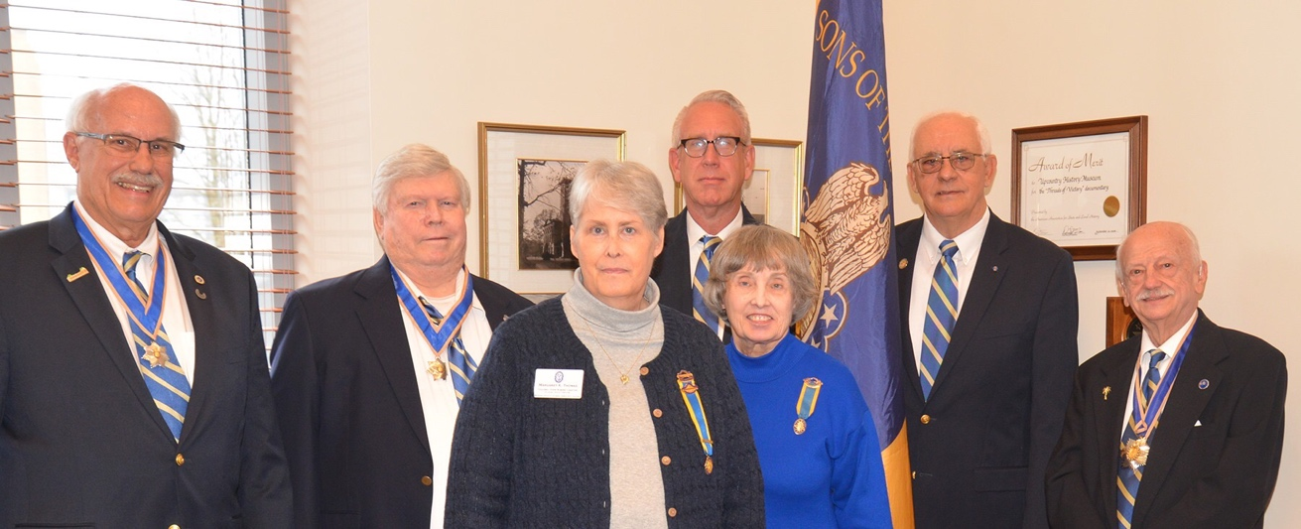
Ivan Bennett, Chuck Swoope, Margaret Thomas and Ellen Zaki (Colonial Dames 17th Century),
Jeff Murrie, Albert Futrell, Tom Weidner
Photo Credit Tom Hanson
The agenda set by President Weidner and business of the South Carolina Society was captured by SR Member Tomas Hanson
(Thomas Hanson Communications Greenville, SC). The video and photo gallery are available for viewing on Facebook SRSC 1776.
Protocol was presided by President Weidner. Invocation and Benediction was provided by Chaplain Thomas Hanson.
After Executive Committee reports were presented and approved, the business of the state society was engaged .
*Membership for 2020 is thirty nine members. One new member will be added by the end of March. Two prospects referred through the SCSR website.
*Four SCSR Events are scheduled in 2020: Ft. Hayes (Hayes Station Massacre), Ft. Lindley (2nd), Ft. Gramby (inaugural in Midstate Region) and Ft. Thickety (3rd)
*Five SCSR Streamers will be presented at each event (SAR, DAR, CAR, Colonial Dames and SR)
*SCSR ROTC Award Certificate (inaugural)will be presented at Goose Creek High School on April 22 at 11:00
*SCSR Merchandising Polo Shirts will get company with the introduction of baseball caps. Regional VP Bennett will present Ga SOR and Ky SOR shirts during his travels
*SCSR Newsletters have changed to a quarterly from monthly publication. The Crescent Moon will reach a milestone of forty issues with this Summer
*SCSR Facebook has 140 followers and growing
*The Greenville Chapter By Laws was approved and seven founding members endorsed the document to form our new chapter founded March 14
*The guests attending our quarterly membership meeting March 14 were Ellen Zaki, President Col. John Robbins Chapter Colonial Dames 17th Century and Margaret Thomas, Vice President . This summer SCSR and Colonial Dames 17th Century will plan a joint ceremony at the Perkins Family Chapel in Anderson County. In the month of December, at Wreaths Across America date, the SCSR and Colonial Dames 17th Century will join to lay wreaths on the 23 grave sites of Revolutionary War SC soldiers (General Andrew Pickens Regiment) at the Pickens Chapel Cemetery.
*SCSR has initiated a new program of donating children’s books on the Revolutionary War to elementary school libraries. The program is in honor of LTC Bradley Hudson, a member of SCSR, who provided seed money for a scholarship fund. Each member in each region of the state will select books and contact the elementary school to set up the opportunity to present books to the school libraries.
The South Carolina Sons of the Revolution maintains an active and current website and Facebook.
www.facebook.com/srsc1776 www.srsc1776.org
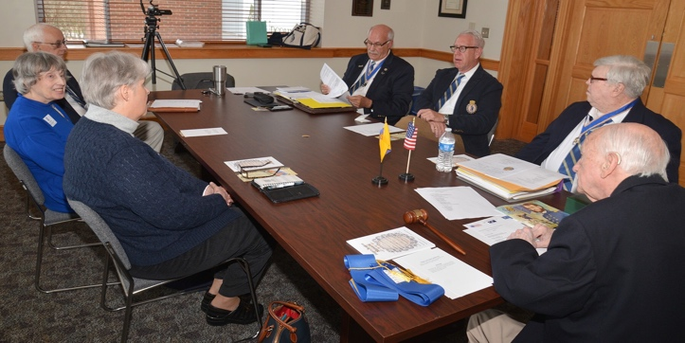
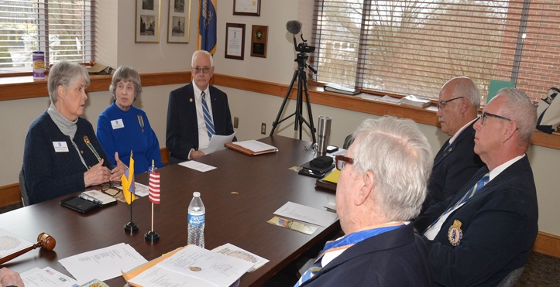
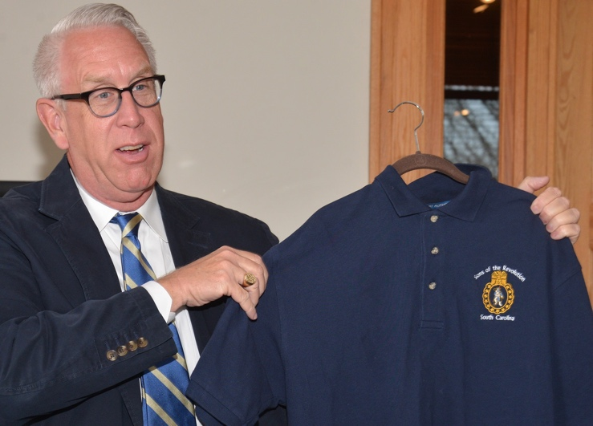
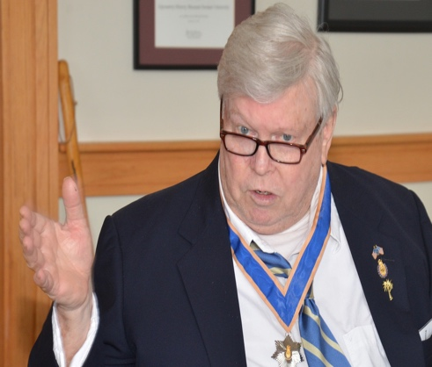
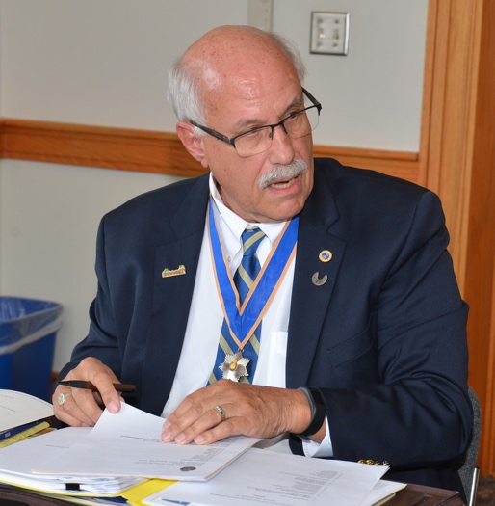
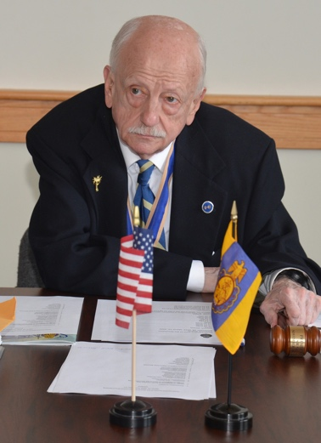
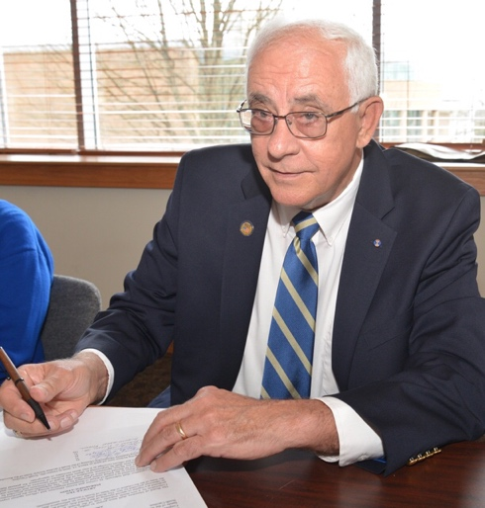

President Weidner. Treasurer Bennett. Registrar Swoope
Coastal Region VP Murrie. Vice President Futrell
________________________________________

First 2020 SCSR Event : Hayes Station Massacre @ Fort Hayes (Block House)
On March 7, 2020 a Memorial Commemorative Event of the Hayes Station Massacre where Col. Joseph Hayes and his Patriot Militia of less than 20 surrendered to a Loyalist force of 300 commanded by Major William “Bloody” Bill Cunningham who hanged and dismembered most of the captive Patriot after they surrendered leaving body parts scattered on the ground.
President Weidner reported 21 attendees. Two SAR Chapters and two DAR Chapters attended. SCSR streamers were presented to those who attended.
Submitted by Albert Futrell, SCSR Vice President

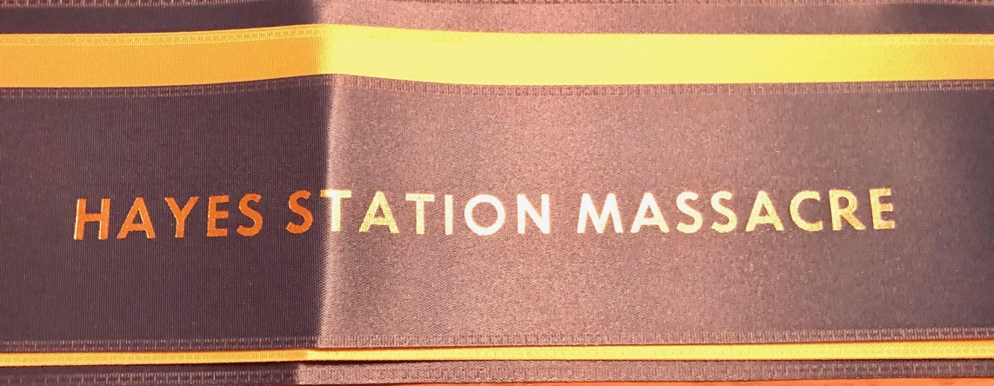
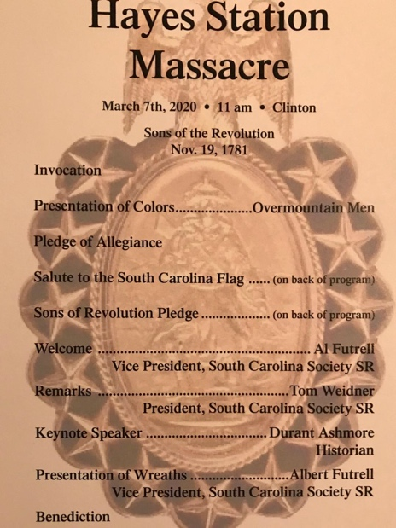

________________________________
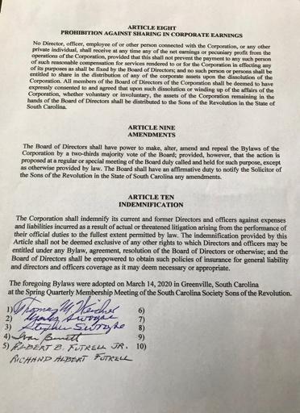
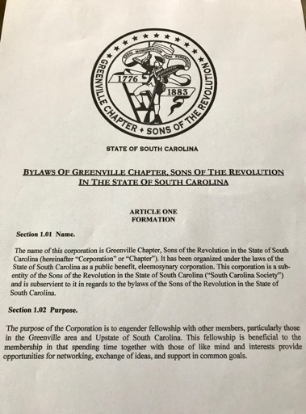
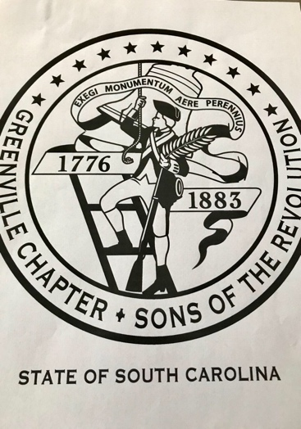
Greenville Chapter SCSR Approved March 14, 2020 in Greenville, SC
Seal Author: GA SOR Richard Ross. By Laws Author: SCSR Solicitor
Matthew Breen, Esq.
#######

Ivan Bennett - Submitted March 15, 2020 for Spring Issue GSSR Drumbeat.

