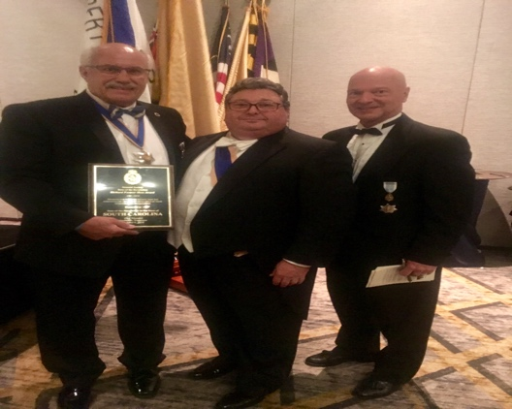

Annual Membership Meeting
South Carolina Society of the Sons of the Revolution
Winnsboro, South Carolina
November 10, 2018

AGENDA

- Welcome- Ivan Bennett, President
- Invocation- Tom Hanson
- Pledge of Allegiance- Dan Woodruff
- President Report- 2018 Triennial/Awards
- Vice President Report- December Events
- Secretary Report- Secretary Role 2019
- Treasurer Report- End of Year Budget 2018/ 2019 Dues
- Registrar Report- Induction of Members
- Region Vice President Reports- Coastal, Mid State, Up State
- Old Business-
- By-Laws and Corporate Governance Manual
- Membership Directory
- Quarterly Newsletter
- Website Presentation
- New Business-
- GSSR Region 3 Newsletter
- Chapters
- New Events 2019
- Nominations Election Report-
- Induction of Officers-
- 2019 President Vision for South Carolina Society-
- Adjourn

