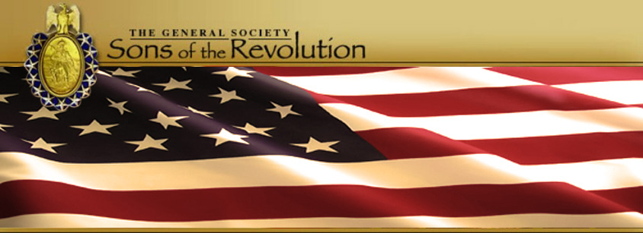
In The State of South Carolina

SCSR Annual Membership Meeting
Saturday, November 11, 2017
Museum of Revolutionary War
110 Academy Street
Simpsonville, South Carolina
Agenda
Noon: Check In at Museum
1:00 Presentation by Joe Epley “Battle of Kings Mountain”
1:45 Presentation of the 2017 Streamer of the Battle of Kings Mountain Anniversary – Regional VP Weidner to President Bennett
2:00 Light Lunch- Provided by the Museum of Revolutionary War
3:00 Business Meeting (By –Laws of the Sons of the Revolution in the State of South Carolina ref in the website, www.srsc.1776.org)
- Presentation of Colors- Mike Kelley, Color Guard Capt. or Eagle Scouts
- Pledge of Allegiance- Chuck Swoope
- Prayer-Tom Weidner
- Reading of the Minutes- November 5, 2016 Annual Membership Meeting ref in the website, www.srsc.1776.org
- Report of Officers, Board and Committees
President- (Bennett) Sharing of comments, notes and emails from GSSR BOM Members on SCSR Hosting the 2017 BOM, Charleston, SC
Treasurer- (FitzGerald) 2017 Treasurer Report, 2018 Budget and Audit Rep
Registrar- (Swoope) New Members since Camden SC #300-307
Historian- (Weidner) Scrapbook Sharing
Webmaster- (Whatley) First Year Features and Solicit New Features
Newsletter Editor- (Bennett) 2017 Articles and Solicit New Articles
Regional VPs- (Weidner Upstate) December 2 Battle of Cane Break, February 28 George Washington Birthday Ball @ Museum of Rev War
Committees- (Swoope) Nomination and Election Slate Announcement
- Unfinished Business
- New Business- Approval of Dues 2018, Induction of three regular members and one Honorary member, 2018 Chapter Petition Greenville/Simpsonville (need ten members to submit petition to General Society), Plans to coordinate wreath laying events with SAR sponsors (December 2, 2017 Battle of Great Cane Break and July 14, 2018 Battle of Hucks Defeat at Brattonsville, General Membership Meeting Site in 2018, Columbia, SC.
- Election of 2018 Officers and Members of the Board- (Swoope) Vote
Presentation to Samuel Whatley II in recognition of SRSC website
Presentation to Tom Weidner in gratitude for use of Museum of Rev War
Adjourn
Dinner- (Weidner) Shortfields, 111 N. Main Street (www.shortfields.com)

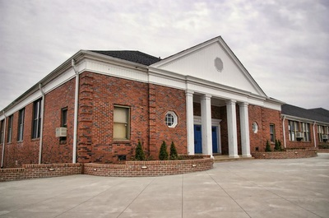
Museum of American Revolution
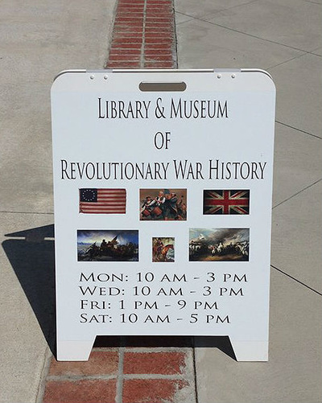
110 Academy Street, Simpsonville

