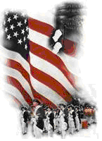 | The Crescent Moon
Winter Issue Number 5 | A publication of the Sons of the Revolution  In the State of South Carolina | March 15, 2016

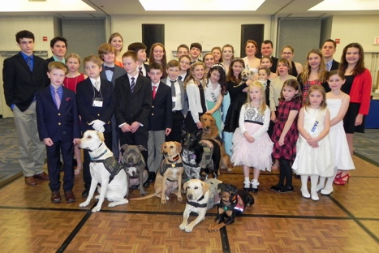
South Carolina Society Children of the American Revolution
72nd State Conference

February 26-28, 2016
Bay Watch Resort and Convention Center
North Myrtle Beach, South Carolina
The press release from Christine Burnette, Senior State President S.C.S.C.A.R. titled “Youth Organization Contributes Over $7000 to Myrtle Beach Service Dog Program”. State President Will Flint, announced his personal mission and campaign “Helping Our Heroes” benefiting the “Canine Angles Service Dogs” based in Myrtle Beach. The middle day agenda for the three day state conference was packed with procedure, officer reports, committee reports, and parliamentary etiquette. The evening banquet session was loaded too. After a delicious meal, awards were presented, officers inducted for 2016, Senior officers were recognized for 2016 all followed by a live auction and dancing to the DJ. It was the auction, live and silent that day, that help net $7000 for the Service Dog Program accumulated over the year.
The state membership is currently 250 children down from a high of 300. But unlike DAR, SAR and SR these members age out at 22 years and are only replaced by new children recruited from DAR and in some cases SAR and SR. Members can have dual membership in DAR and C.A.R. or when they turn 18 transfer to DAR. It is a perpetual challenge for the many societies of C.A.R in our state. It is our duty to assist each society with helping recruit members and leaders (both children and adult “seniors”).
The local societies in South Carolina are the following: Battleground (Spartanburg), Charlestown (Charleston), Col. James Williams (Gaffney), Col. Thomas Taylor (Irmo), Dicey Langston (Greenville), Fort Charlotte (Greenwood), Fort Mill (Fort Mill), Fort Pickens (Abbeville), Gamecock (Sumter), Gov. John Rutledge (Orangeburg), Hilton Head Island (HHI), Long Bay (Myrtle Beach), Martha Bratton (Rock Hill), McDavid Westmoreland (Simpsonville), Sergeant William Jasper (Mount Pleasant), Skyagunsta (Seneca), The Jonathan Adams (Columbia) and William Stroud (Aiken)
If any member of our State Society of the Sons of the Revolution are familiar with an area of a local society, then consider contacting the C.A.R. representative or the DAR Chapter Regent and offer your assistance in recruiting members and being a senior contributing to the mission. The mission is relevant to SC SR. It states that “The National Society Children of the American Revolution trains good citizens, develops leaders and promotes love of the United States of American and its heritage among young people.” C.A.R. is the “child” of DAR and therefore follows the DAR guidelines for admitting members, meetings held and activities of the society. DAR does not “govern” C.A.R. only “guides” it. The “society” not called chapters, is made up of both senior leaders and officer positions held by children. For every officer position there is a senior leader to help “guide” the society member in their duties.
The application process and approval follow the DAR guidelines. There is a membership fee, national dues that are paid on a yearly basis and state dues also on a yearly basis.
Two examples of the way DAR Chapters coordinate help with C.A.R. are in Aiken County (photo reference in the previous Crescent Moon February 27, 2016) and Hilton Head Island. The William Stroud Society has three DAR Chapter sponsors, all in Aiken County. Judi Romeo is the Senior Society President. The Hilton Head Island Society includes the area of two DAR Chapters in Bluffton and HHI. Susan Bennett is the Senior Society President.
Please consider your role in helping this organization grow and nurture our children and grandchildren. C.A.R. was founded April 5, 1895 and is the oldest patriotic youth organization in the United States. You can volunteer as C.A.R. Senior Leaders through your eligibility in DAR, SAR and SR. www.scsar.webs.com (state) www.nscar.org (national)
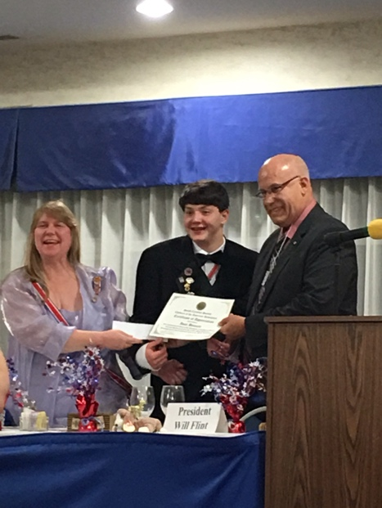Ivan Bennett, Secretary SC SR brings greetings and presents a check from SC SR to Christine Burnette, Sr. State President and Will Flint, State President of the South Carolina Society C.A.R.

