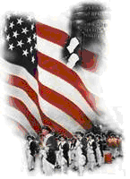 | The Crescent Moon  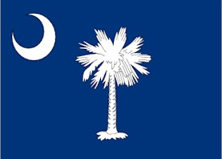
Summer Issue Number 20 | A publication of the Sons of the Revolution  In the State of South Carolina | July 1, 2017
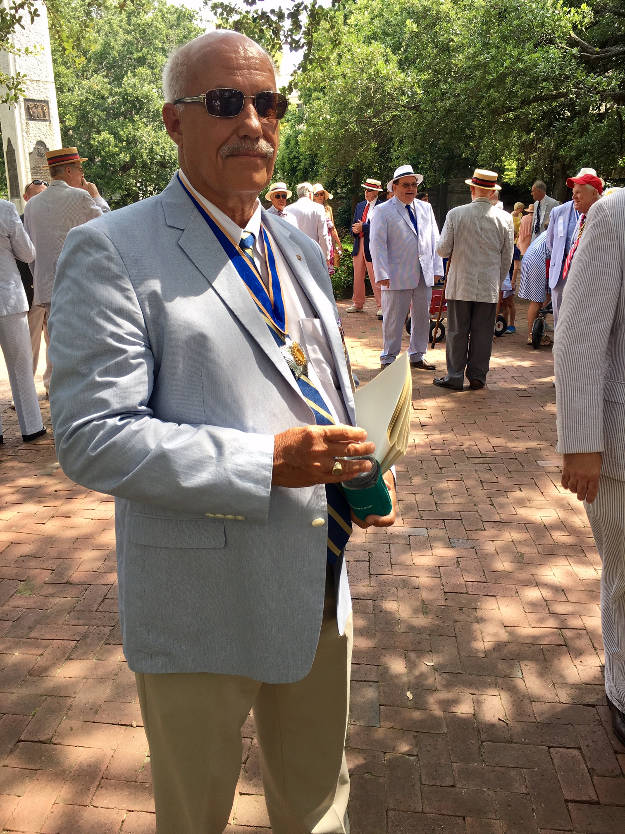

South Carolina Society
Sons of the Revolution
Participate in the 240th Carolina Day
Charleston, SC
June 28, 2017
~ Sponsored by the Palmetto Society of Charleston

The Palmetto Society was founded in 1777 with the purpose of marking the anniversary of the Battle of Sullivan’s Island and additionally, to support the widows and orphans of American soldiers in the Revolutionary War. A complete overview of the June 28, 2017 Carolina Day Agenda and the forty organizations that contributed and participated in the event can be located palmettosociety.org

President Ivan Bennett represented the
South Carolina Society Sons of the Revolution (1876) along with several organizations such as St. Andrew Society of Charleston (1729), Society of the Cincinnati of SC (1783), Sons of the American Revolution, Maj. General Moultrie Chapter (1889), South Carolina Daughters of the American Revolution, Ft. Sullivan Chapter (1890), South Carolina Daughters of the American Revolution, Rebecca Motte Chapter (1890), National Society of Colonial Dames of America in SC (1893), Children of American Revolution Long Bay Chapter (2004).
Ivan’s wife Susan (DAR) began the day with attending a church service at St. Michael’s Church then moved with the rest of the mostly men attendees in seersucker suites and while buck shoes, to the Washington Square Park across the street. At the ringing of the church bells at 11:30, the procession of 100+ began the parade march down Meeting Street to the spectators along the route waving their Moultrie flags or SC State flags. The parade concluded in White Point Garden under the large oaks and at the Sgt. Jasper Monument. At noon, there was an excellent and captivating speech of the Battle of Sullivan Island and Breach Inlet by Mayor Tecklenburg and Wreath Laying by the four major Societies who make up the Board: Society of the Cincinnati, National Society of Colonial Dames, SC Society Sons of the American Revolution, and Society of Colonial Wars in the State of SC. At the conclusion of the Carolina Day, members of the Second SC Regiment and Charleston Battalion of Artillery presented a musket salute.
Just in time to be included in the program and on the web site, the SC SR donated $175 for our contribution to the Carolina Day event. The major donors to Palmetto Society contributed $500.
This was a first time experience for our organization and it is President Bennett’s hope and desire that SC SR have several members in the future in attendance.
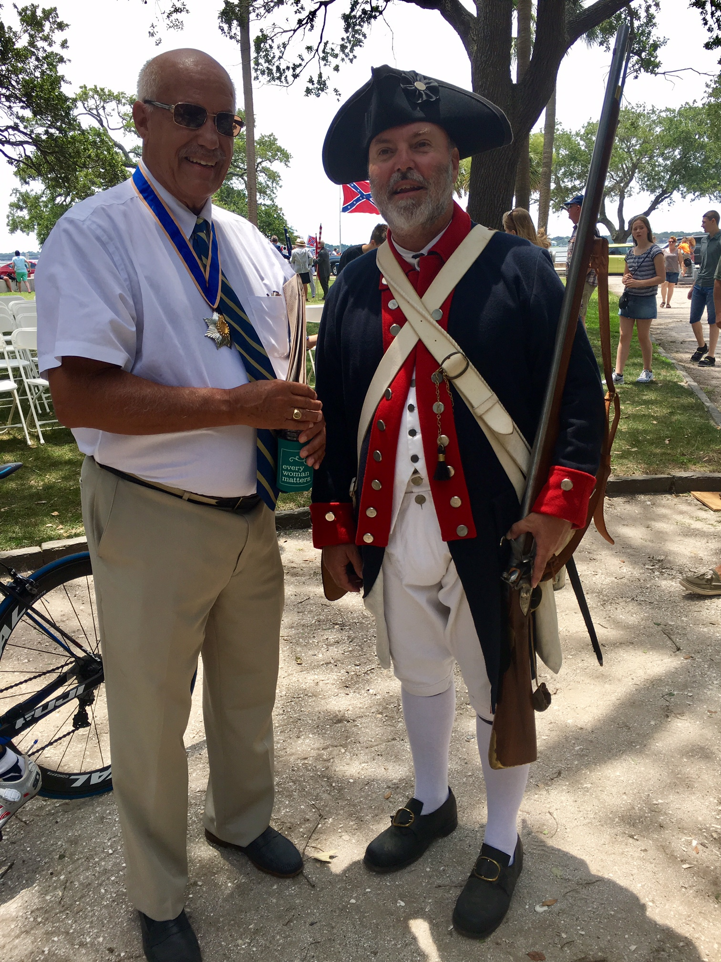

President Ivan Bennett sharing with Tony Youmans (Director of the Old Exchange and Provost Dungeon) the SCSR Tablet located on the Ashley River side of his building. It was placed there in 1899.

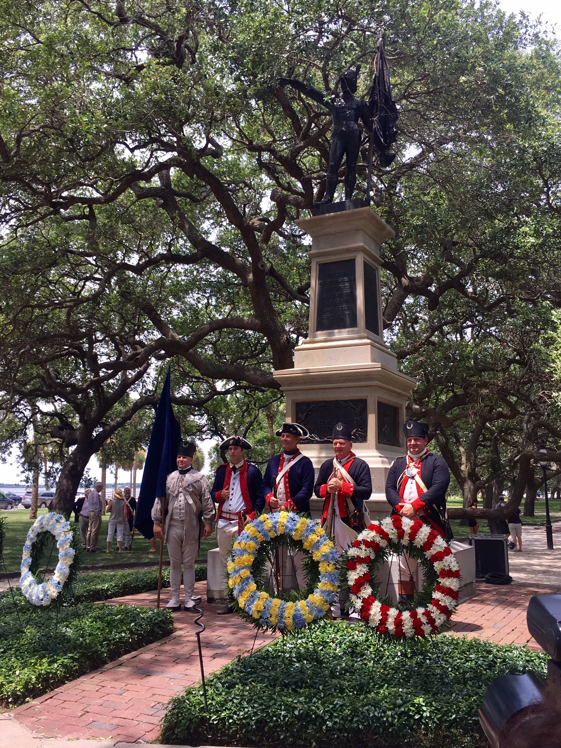
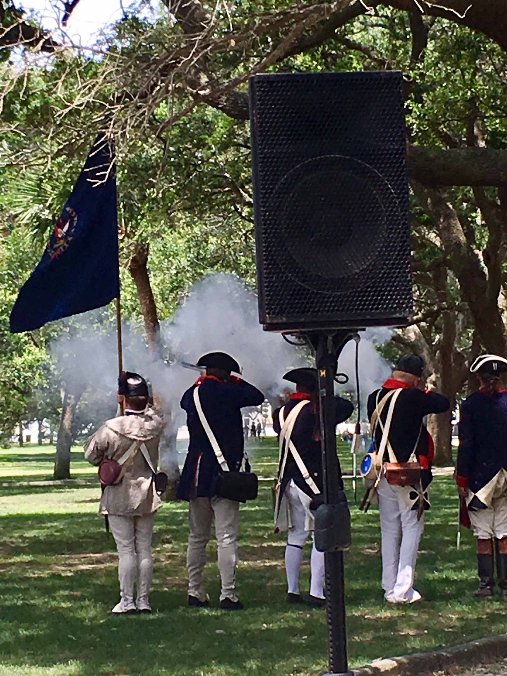
Calendar Event
July 15-16, 2017 Battle of Huck’s Defeat Visitor Center
The SRSC Board of Directors are convening a membership meeting for the purpose of discussing roles and responsibilities during the September 28-October 1 GSSR BOM Meeting at the Francis Marion Hotel in Charleston, SC Please plan to attend!
Introducing Three New Members to the South Carolina Society Sons of the Revolution in 2017
# 301 Michael James Kelley, Jr:
Compatriot Kelley’s ancestor is John George Huntzinger. Private Huntzinger was a member of Captain Westons Company, Berks Co. Militia, PA. He was born in Brunswick, Berks Co. PA on February 7, 1751. He died in Brunswick on September 6, 1802.
Compatriot Kelley was born on August 6, 1981 in Baltimore, MD. He served in the United States Marine Corps from 1999-2003 as an Air Traffic Controller, Lance Corporal.
Compatriot Kelley currently resides in Beaufort, SC with his wife and son MJ Kelley, who is the SRSC first Jr. Member and a member of the Hilton Head Island Society of the Children of the American Revolution.
Compatriot Kelley career includes:
Drill Master and Coach for Beaufort High School AFJROTC-Winner of 2016 Superintendents Cup, Parent Sponsor, Tri-M Music Honor Society at Beaufort Middle, Camp Commander, Sons of Confederate Veterans Camp 47, Governor of the Carolinas, Order of the First Families of Maryland and State Commander, Military Order of Foreign Wars.
He is a member of several other organizations: Military Order of World Wars, American Legion, Sons of Spanish American War Veterans, General Society War of 1812, Naval Order of the United States, Sons of Union Veterans of the Civil War, Maryland Society of the War of 1812, Maryland State Guard Association, Stat Guard Association of the United States.
In January, President Ivan Bennett with the approval of the Board promoted Compatriot Kelley to Regional VP Coastal Region. He has transferred our State SRSC flag to an official staff with crown and hooks for the many banners we have already received during President Chuck Swoope term and current President Ivan Bennett term. Compatriot Kelley has agreed to perform our color guard/flag bearing role when needed. Look for him in the September 8-9 Wreath Laying and 239th Anniversary of the Battle of Eutaw Springs, Eutawville, SC.
#302 William Edward Hooker III:
Compatriot Hooker’s ancestor is Robert Lide. Lt. Col. Lide served in the capacity of Captain and Major under Francis Marion and as a Lt. Col. in 1778. He also was a county court justice of Darlington County, SC and was a commissioner of Caveats, Cheraw District, SC.
Lt. Col. Lide was born in Roanoke, VA. On May 17, 1734. He lived in Darlington, SC where he died on March 12, 1802.
Robert Lide was married to Sarah Kolb, daughter of Col. Abel Kolb, who was killed by loyalist sympathizers while his family watched.
Compatriot Hooker was born on December 2, 1969 in Selma, Dallas Co., AL and is currently a citizen of Camp Springs, MD.
Compatriot Hooker is currently a Historical Architect and Cultural Resources Manager, VA NCA. His business address is Washington DC.
President Bennett admits he has not had the opportunity to meet Compatriot Hooker but has talked with him several times on the phone and via email. There have been opportunities when Mr. Hooker has traveled to Florence, SC but a little too far. There will be other opportunities, hopefully in Charleston during the September 28-October 1 GSSR BOM Meeting!
#303 Bradley W. Hudson:
Compatriot Hudson has recently completed a request for transfer of membership. He is transferring from the European State Society as of July 1, 2017. Major Hudson’s current address is Honolulu HI. His transfer request will be proposed and seconded during the July 15-16 Board Meeting in Brattonsville, SC. After it is signed by the SRSC Secretary, Bradley Hudson is a member.

