state Report

  - South Carolina
May 20-21, 2016 Johnsonville Heritage Festival at the River
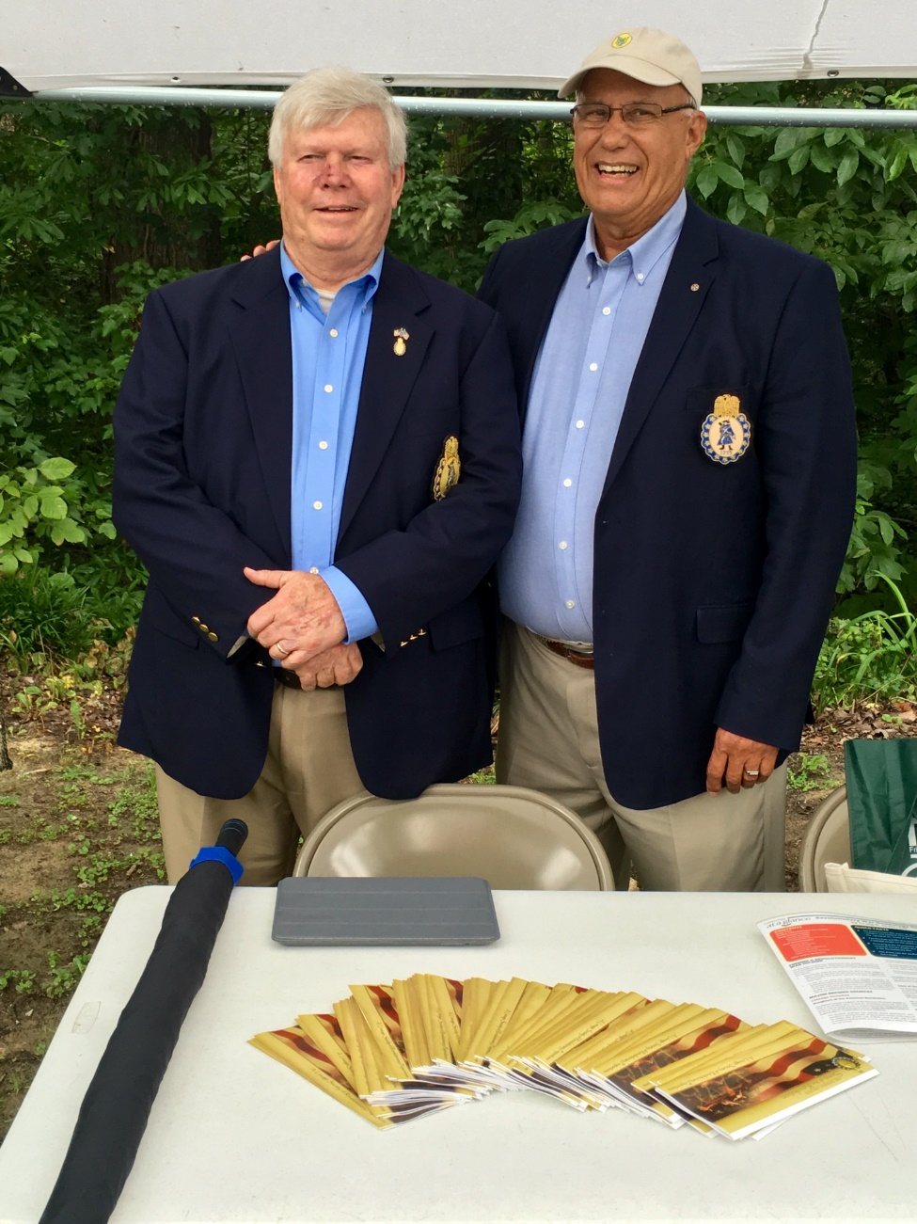
President Chuck Swoope and Secretary Ivan Bennett appear eager for new prospects at an annual membership drive in Johnsonville, South Carolina.
Battle of Hucks Defeat July 9, 2016
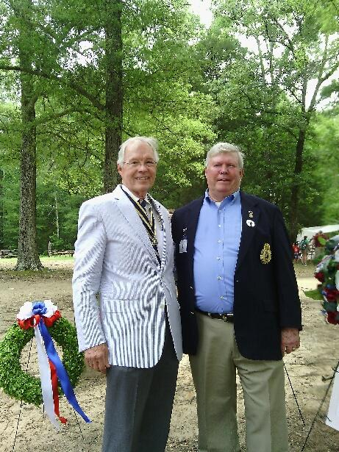
Wayne Cousar, President of the SCSAR & Chuck Swoope, President of the SCSR attend a wreath laying ceremony held in upper state region of South Carolina. Both Society Presidents posed for a unique photo while paying their respects to our patriotic ancestors. The event was sponsored by the SAR/DAR/CAR.

Southeast Regional Meeting of the National Society of C.A.R. July 12-13, 2016 in Greenville, South Carolina
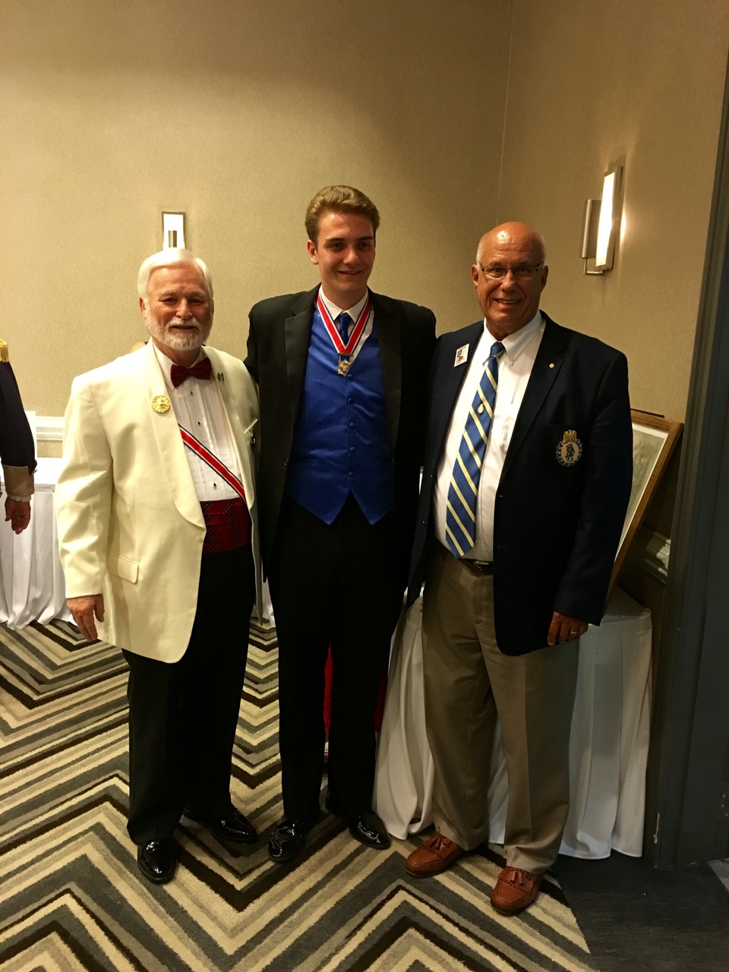
Senior Leader President Bob Thomas, Alabama Society of the Children of the American Revolution and National President Connor Jackson, Society of the Children of the American Revolution, pose for a photo with SCSR Secretary and SCSCAR Chairman of SAR/SR Relations with C.A.R. Ivan Bennett. Ivan brought greetings to the six states in attendance. Connor is from New Hampshire and currently enrolled in Syracuse University majoring in civil engineering.
South Carolina news on the horizon features recruitment, projects that are being planned and our interest in hosting the 2017 Board of Managers Meeting in our most historical city, Charleston.
Recruitment: Meet our newest member John Fitzgerald, who has transferred from GA SR Society due to relocating to Charleston. John is a welcome compatriot who is interested in creating a chapter centered in Charleston. The SC SR state society charter is in Columbia. The state society is spread out in three regions, upper state (9 members), mid-state (9 members) and coastal (8 members). An anticipated product of adding a chapter to the Charleston and coastal region is our sincere interest in attracting meetings and conferences to our region. The first effort is forming a planning committee of members and prospective members and submitting a letter of interest to the October Board of Managers during their New York City meeting. We hope all eligible attendees to the 2017 Board of Managers will support and welcome our proposal to sponsor you in Charleston, South Carolina.
