 | The Crescent Moon  
Fall Issue Number 13 | A publication of the Sons of the Revolution  In the State of South Carolina | December 1, 2016
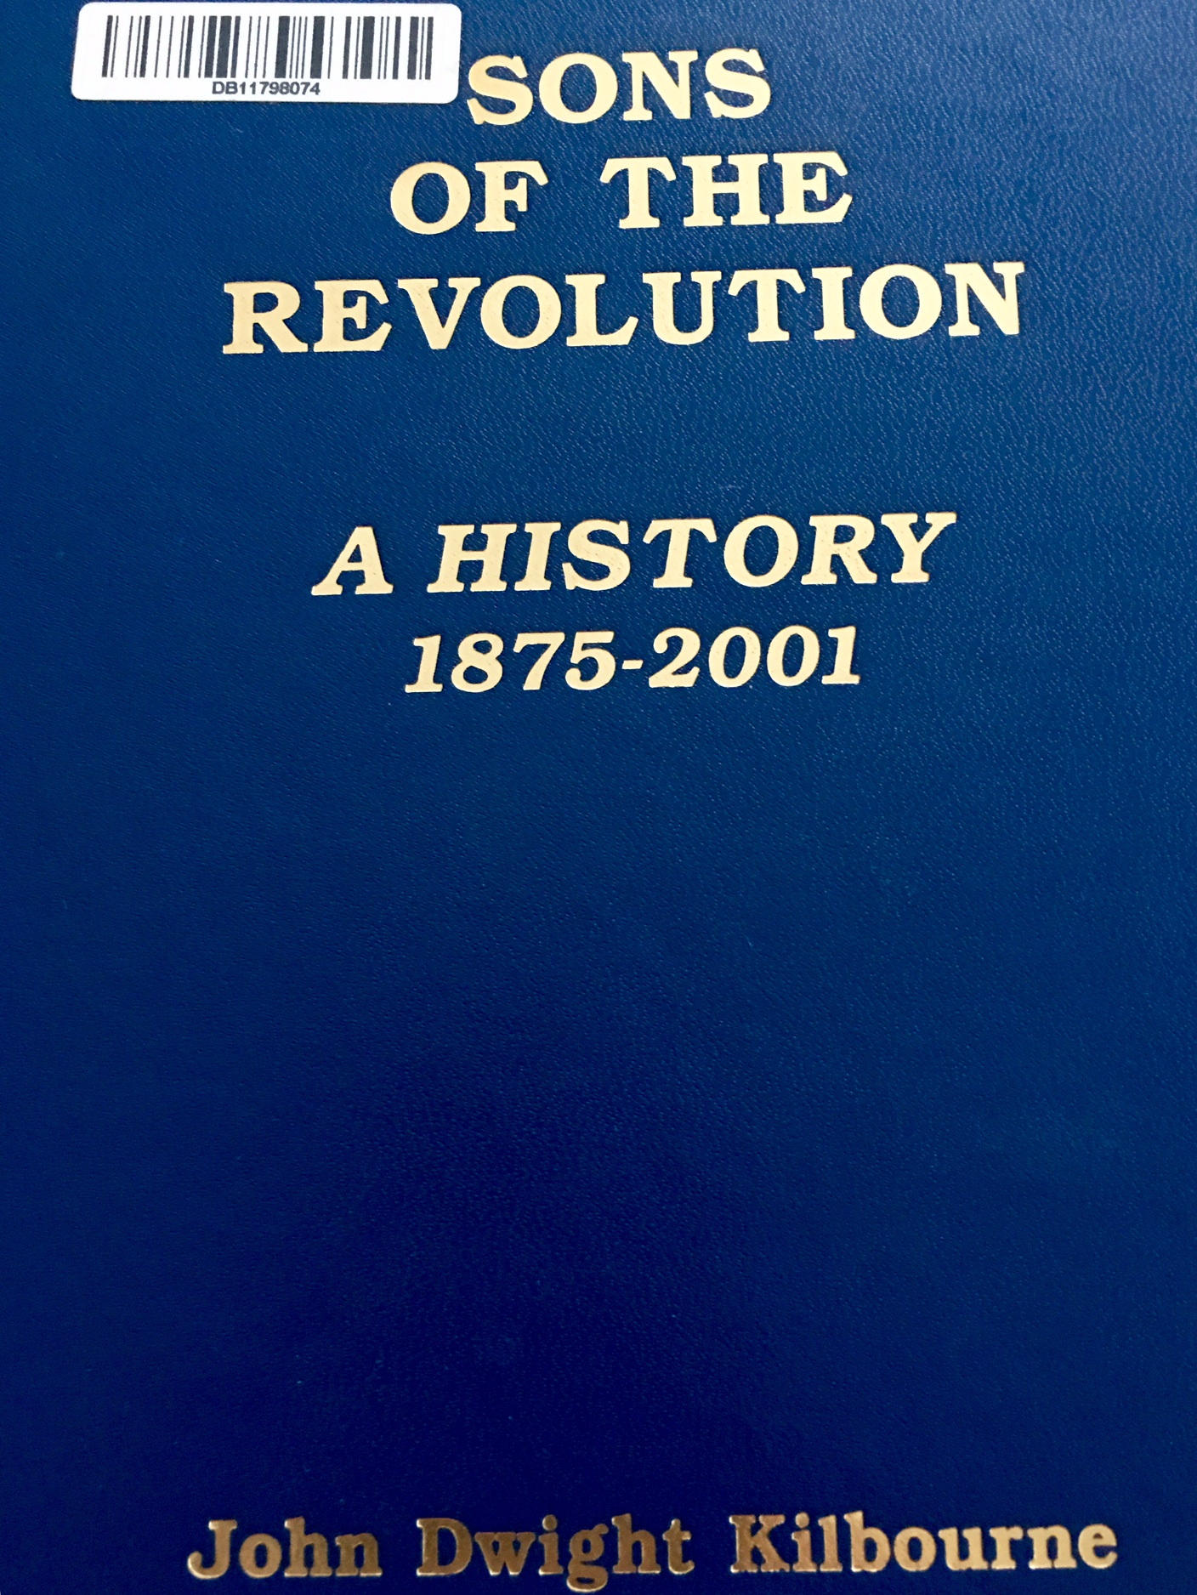
Sons of the Revolution
A History
By
John Dwight Kilbourne

The history of our society was produced by John Dwight Kilbourne, a member of the Pennsylvania Society of Sons of the Revolution. It was published by the General Society Sons of the Revolution in 2002. The GSSR Headquarters was located at Fraunces Tavern, 54 Pearl Street,
New York City, New York. The Executive Secretary was Cecelia Mahnken and the web site was
www.SR1776.org

In a previous issue of The Crescent Moon the history of the Sons of the Revolution in the State of South Carolina was reported, ending in 2001. In that issue a request went out to the membership to provide their own “moments” in our state society history.
Several responses were received
And appreciated by the editor.
The leadership of SRSC in 2010
was: Chuck Swoope-President, Jeff Jordan-Vice President, Ed Latimer
Treasurer,and Jack Meyer-Registrar
In a October 8, 2010 letter from
President Swoope cited the four
purposes of our society: “The
preservation of freedom, develop
awareness of our beginnings as a
nation, recall and proclaim the
sacrifices of our forefathers and
underscore the workings of our
constitutional system of govern-
ment with checks and balances.”

A Christmas Party was advertised
for December 16, 2011 from the
Board of Managers of the SRSC
inviting all members of the state
society to attend the social in Lexington, South Carolina.

As we move forward five years, the
leadership of SRSC is: Ivan Bennett
President/Secretary,John Fitzgerald-
Vice President/Treasurer, Chuck
Swoope- Registrar, Reverend Sam
Whatley- Chaplain, Thomas
Weidner- Historian, Sam Whatley II
Webmaster.
The leadership in the three regions
of South Carolina are: Thomas
Weidner (Greenville) Upper State,
TBA (Columbia) Mid State, Dr.
Sam Whatley (Charleston) Coastal.

A Winter Social is being planned in
January/ February in Charleston.VP
John Fitzgerald has offered to
host this annual event providing
food and drink for members and
guests. A speaker is on the agenda.

A Special Message from the Secretary
One of the first duties that I received as secretary a year ago was to the complete the semi-annual GSSR Trent Reports.The history of the report can be located in the SR: A History, referenced at the top of this issue of The Crescent Moon
At the 1967 Triennial a trophy was donated by the General President to be held by State Societies for “exceptional contributions to the purpose and good of the SR during the period since the preceding Triennial.” In the year 2000, the categories of competition were scaled down to 200+ (large) 100-199 (medium) and less 100 (small).
For our state society, our report was filed in January 2016. We recorded 300 points for issues of the newsletter, 400 points for attending the Triennial for a total of 700 points. In July 2016 our state society filed the semi-annual report and our total points increased to 3260.
The increase was due to 1) State Meeting 2) Six events 3) One $ Contribution 4) Six Newsletters 5) One Educational Activity 6) National Meeting. In January 2017 the category of web site will be added for increased points. Ivan Bennett, Editor

