 | The Crescent Moon
Fall Issue Number 23 | A publication of the Sons of the Revolution  In the State of South Carolina | October 2, 2017

GSSR Board of Managers Meeting
September28-October1
2017
Francis Marion Hotel
Charleston, SC
~ Hosted by the South Carolina Society, SR

Memories in Photos
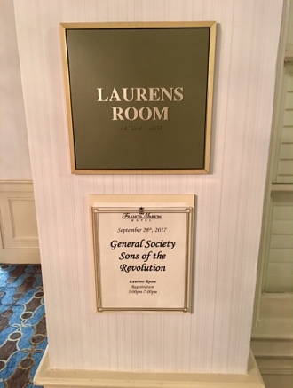
Registration: 9/28 and 9/29
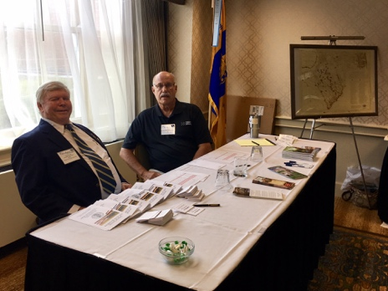
President Bennett and President Emeritus Swoope
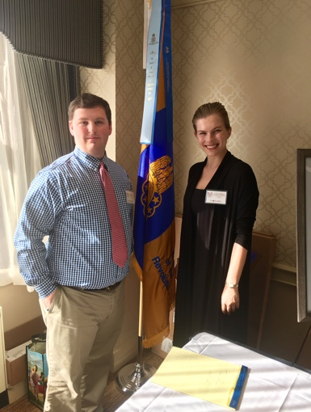
Registration 9/29: Cory and Dale, Graduate
Students College of Charleston Dept. of History
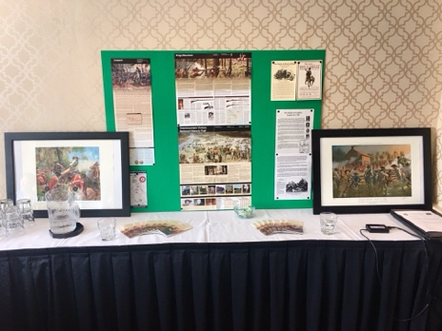
Display by Chuck Swoope for Registration
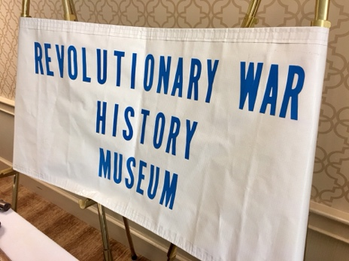
Display by Tom Weidner for Registration
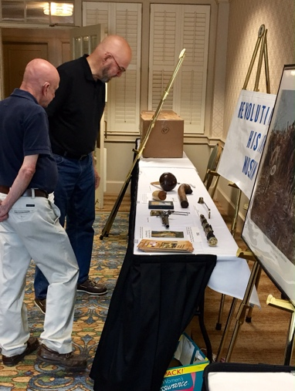
Tom Weidner and RI President
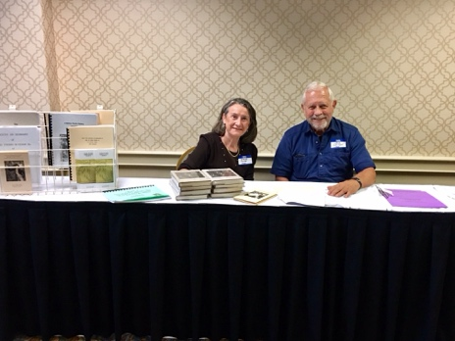
Registration Display by Three Rivers Genealogical Society, Lake City, SC
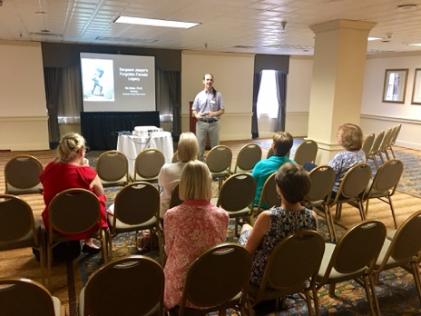
Presentation for Spouses by Dr. Nic Butler
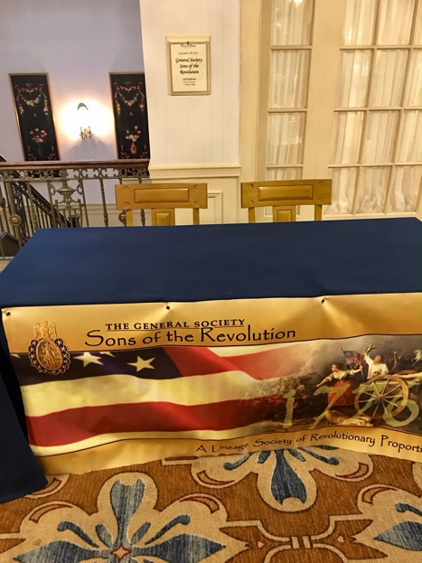
Business Session I Friday 9/29
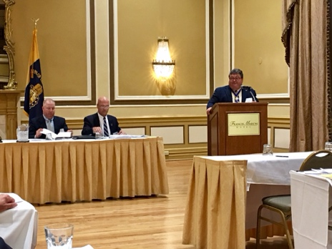
General President Bush Opens Business 9/29
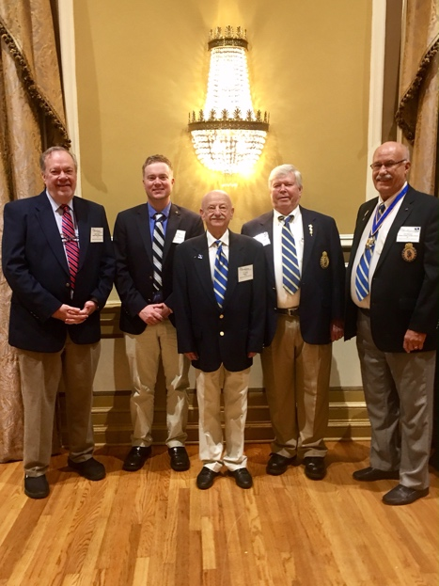
Five of Seven SC SR Members Group Photo 9/29
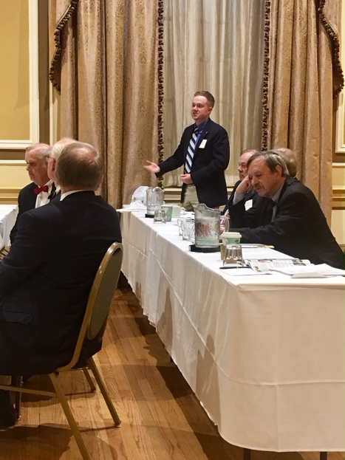
New Member Chris Overton exercising 1st Amend
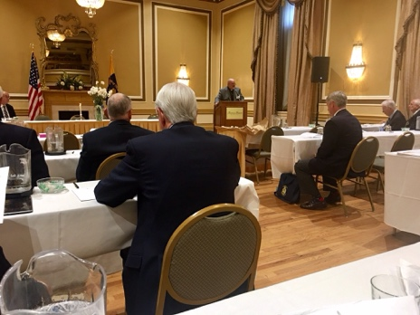
GSSR General Chaplain Ames at Memorial Service
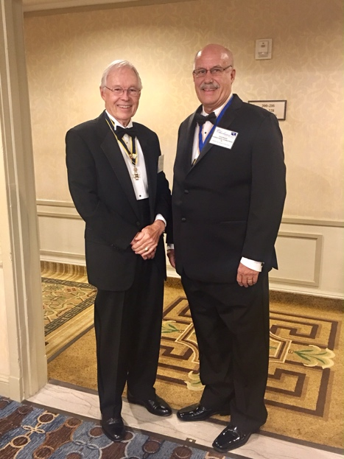
SCSR President Bennett/ SCSSAR PP Cousar
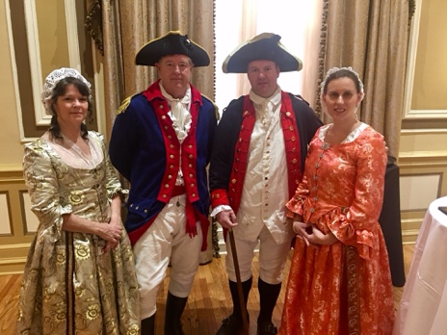
9/30 Banquet Guests Charleston Battalion Artillery Alan Stello (Left) Director of the Powder Magazine Museum, Cumberland St.
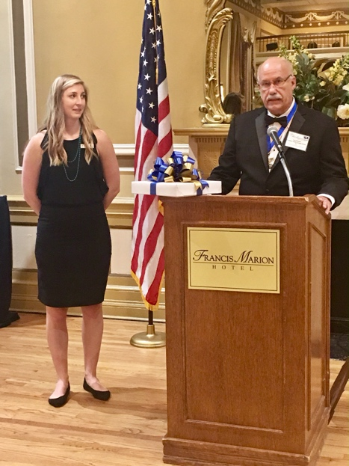
President Bennett presenting to Francis Marion Hotel Sales Manager Libby Hardy a token of his appreciation, She decreased his Learning Curve the past six months.
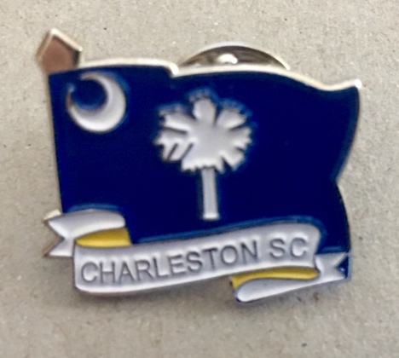
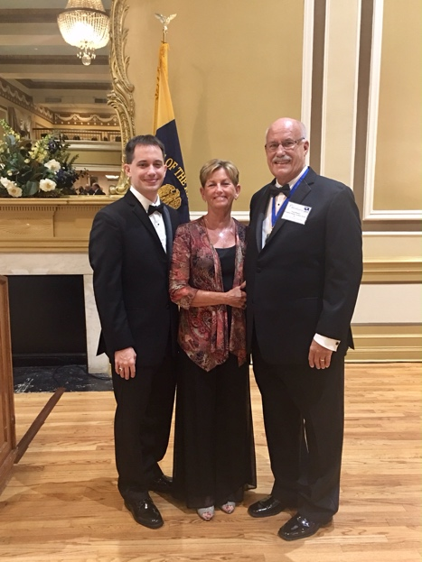
President Bennett, Susan Bennett and Joseph
Bennett (Nathalie not in photo) at the Banquet
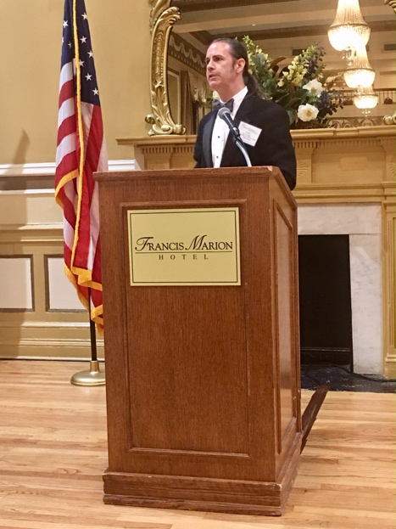
The Banquet Keynote Speaker, Dr. Nic Butler
Historical Consultant for the City of Charleston and the Charleston County School District. Since 2005, Nic has represented the Charleston County Public Library as the archivist and historian in residence
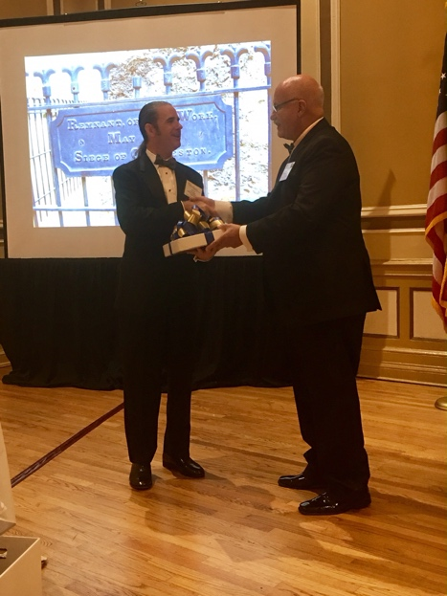
President Bennett presenting Dr. Butler with a
Token of his appreciation from the SCSR
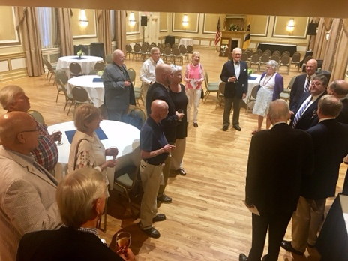
10/1 Sunday’s Church Service and traditional
Sherry Toast to conference attendees who had not
checked out earlier. Final comments offered by
General President Mitchell Bush

The Crescent Moon is a monthly publication of the South Carolina Society of the Sons of the Revolution.
The Editor is Ivan S. Bennett
Questions: ibennnett@aol.com
Phone: 843-681-3144
